Concept Library & Ontic Health

5/21/2020

Contents

1 Concept Library 2

1.1 Diagram: ConceptLibrary Diagrams 2

1.2 Diagram: Federated Concept Library 3

1.3 Diagram: Foundation 4

2 Concept Library::Abilities 5

2.1 Diagram: Ability 5

2.2 Diagram: Alter ability or control 6

2.3 Association Class Ability 6

2.4 Association Class Affected Available Resource 7

2.5 Class Alter Capability 8

2.6 Class Facilitator <<Role>> 8

2.7 Class Lose Ability 8

2.8 Class Obtain Ability 8

2.9 Association Class Strenthened Actor 8

2.10 Class Transfer Ability 9

2.11 Association Class Weakened Actor 9

3 Concept Library::Assertions 11

3.1 Diagram: Assertions 11

3.2 Association Class Assertion 11

4 Concept Library::Assessments 12

4.1 Diagram: Assessment 12

4.2 Class Assessed Entity <<Role>> 12

4.3 Class Assessment 12

4.4 Class Assessment Activity 13

4.5 Association Class Entity Assessment 13

5 Concept Library::Contact Information 14

5.1 Diagram: Contact Information 15

5.2 Class Communications Security Level <<Value>> 15

5.3 Class Contact Means <<Value>> 16

5.4 Association Class Contact Via 16

5.5 Class Contactable 17

5.6 Class Electronic Contact <<Value>> 17

5.7 Class Email Address <<Value>> 17

5.8 Class Internet Contact <<Value>> 18

5.9 Class Network Identifier <<Value>> 18

5.10 Class Postal Address <<Value>> 18

5.11 Class Postal Address Structured <<Value>> 18

5.12 Class Postal Address Text <<Value>> 19

5.13 Class Postal Code <<Value>> 19

5.14 Class Private Network Contact <<Value>> 20

5.15 Class Radio Contact <<Value>> 20

5.16 Class Social Network Contact <<Value>> 20

5.17 Class Telephone Area Code <<Value>> 20

5.18 Class Telephone Country Code <<Value>> 20

5.19 Class Telephone Number <<Value>> 21

5.20 Class Telephone Number Structured <<Value>> 21

5.21 Class Telephone Number Text <<Value>> 21

5.22 Class Website Contact <<Value>> 22

5.22.1 Enumeration Contact Availability 22

5.22.2 Enumeration Contact Purpose 22

6 Concept Library::Containment 24

6.1 Diagram: Containment 24

6.2 Diagram: Move Between Containers 25

6.3 Diagram: Physical Containment 26

6.4 Class Add To Container Event 26

6.5 Class Container <<Role>> 26

6.6 Association Class Containment 26

6.7 Class Containment Event 27

6.8 Class Physical Container <<Role>> 27

6.9 Association Class Physical Containment 27

6.10 Association Class Recieving Container 28

6.11 Class Relocation 28

6.12 Class Removal Event 29

6.13 Association Class Supplying Container 29

7 Concept Library::Control 30

7.1 Diagram: Computer Control 30

7.2 Diagram: Control 31

7.3 Diagram: Control Authority 32

7.4 Diagram: Custody 32

7.5 Class Authority <<Role>> 33

7.6 Association Class Control 33

7.7 Class Controlled Entity <<Role>> 34

7.8 Class Controlling Actor <<Role>> 34

7.9 Class Custodian <<Role>> 34

7.10 Association Class Custody 34

7.11 Class Leader <<Role>> 34

7.12 Association Class Leadership 34

7.13 Class Managed Entity <<Role>> 35

7.14 Class Owner <<Role>> 35

7.15 Association Class Ownership Control 35

7.16 Association Class Possession 35

7.17 Class Property <<Role>> 36

7.18 Association Class Subject to Authority 36

8 Concept Library::Credentials 37

8.1 Diagram: Credentials and Managed Identifiers 37

8.2 Association Actor Identifier of Credential 37

8.3 Association Class Attest to Ability 38

8.4 Class Credential 38

8.5 Class Identity Provider <<Role>> 39

8.6 Association Class Issue Credential 39

8.7 Class Managed Actor Identifier <<Value>> 39

8.8 Association Class Valid for Time Interval 40

9 Concept Library::Cyber 41

9.1 Diagram: Cyber 42

9.2 Diagram: Cyber Platforms 43

9.3 Diagram: Cyber Resource 44

9.4 Association Class Ability To Execute Software 44

9.5 Association Class Automated Capability 45

9.6 Association Class Automated Control 46

9.7 Class Automated Entity <<Role>> 46

9.8 Class Automation Type 47

9.9 Class Automaton 47

9.10 Class Communicating Device 47

9.11 Class Communications Link 47

9.12 Class Communications Network 47

9.13 Class Computer Control System <<Role>> 47

9.14 Class Computer System 48

9.15 Class Cyber Resource <<Union>> 48

9.16 Class Execution Platform <<Union>> 48

9.17 Association Class Information In Computer 48

9.18 Association Class Node of a Network 49

9.19 Class Software 49

10 Concept Library::Enterprises 50

10.1 Diagram: Enterprise 50

10.2 Class Enterprise 51

11 Concept Library::Entities 52

11.1 Diagram: Identifiable Entity 52

11.2 Diagram: Identifiable Entity Relationships 53

11.3 Association Class Impact 53

11.4 Association Class Temporally Related 54

12 Concept Library::Identifiers and Coordinates 56

12.1 Diagram: Identifiers 57

12.2 Class Coordinate <<Value>> 57

12.3 Class Coordinate System 57

12.4 Association System of Coordinate 58

13 Concept Library::Information 59

13.1 Diagram: Information Action 59

13.2 Diagram: Information Objects 60

13.3 Diagram: Metadata 60

13.4 Class Add Information 61

13.5 Class Atomic Information Object 61

13.6 Class Close Information 61

13.7 Class Confidence 61

13.8 Association Confidence in Assertion 61

13.9 Association Class Contained Information 62

13.10 Class Copy Information 62

13.11 Class Create Information 62

13.12 Class Delete Information 62

13.13 Class Document 63

13.14 Class Information Action 63

13.15 Class Information Object 63

13.16 Class Information Repository 63

13.17 Class Information Resource <<Union>> 64

13.18 Class Information Type 64

13.19 Class Modify Information 64

13.20 Class Open Information 64

13.21 Class Read Information 64

13.22 Class Remove Information 64

13.23 Class Structured Information Object 65

13.24 Class Transfer Information 65

14 Concept Library::Locations 66

14.1 Diagram: Location 66

14.2 Diagram: Location Identification 67

14.3 Association Address of Location 67

14.4 Association Coordinate of location 68

14.5 Association Designation of a Location 68

14.6 Class Location ID <<Value>> 68

14.7 Class Location Identifier <<Value>> 68

14.8 Association Class Physical Boundary 68

14.9 Class Physical Location 69

14.10 Class Physical Point 69

14.11 Class Point On Earth <<Value>> 69

14.12 Association Reference Point 70

14.13 Class Relative Coordinate <<Value>> 70

14.14 Class Spacial Coordinate <<Value>> 70

14.15 Association Topological Region 70

14.16 Class Topology 70

14.17 Class World Geodetic System <<Value>> 71

15 Concept Library::Meta Concepts 72

15.1 Diagram: SMIF Packages 73

16 Concept Library::Meta Concepts::Associations 75

16.1 Diagram: Associations 75

16.2 Class Association 76

16.3 Class Association Type 76

16.4 Class Binary Association 76

16.5 Class Binary Association Type 76

16.6 Class Restriction Type 77

17 Concept Library::Meta Concepts::Constraints 78

17.1 Diagram: General Rules 78

17.2 Diagram: Property Constraints 79

17.3 Diagram: Rules in Context 80

17.4 Diagram: Rules Summary 81

17.5 Diagram: Type Constraints 82

17.6 Class Conditional 83

17.7 Class Conditional Rule 83

17.8 Class Constraint 83

17.9 Association Constraint Covers 83

17.10 Class Covering Constraint 83

17.11 Class Disjoint 84

17.12 Class Enumerated 84

17.13 Class Equivalent 84

17.14 Class Multiplicity Constraint 85

17.15 Association Multiplicity Target 85

17.16 Class Property Constraint 86

17.17 Class Property Transitivity Constraint 86

17.18 Association Proposition Subsumption 86

17.19 Association Rule Constrains 86

17.20 Class Type Constraint 86

17.21 Association Unique Set 87

17.22 Class Uniqueness Constraint 87

18 Concept Library::Meta Concepts::Expressions 88

18.1 Diagram: Expressions 88

18.2 Class And Function 88

18.3 Class Binary Boolean Function 89

18.4 Class Binary Function 89

18.5 Class Boolean Function 89

18.6 Class Constant Reference 89

18.7 Association Constant Value 89

18.8 Class Current Context 89

18.9 Class Equality Function 90

18.10 Class Expression Context 90

18.11 Association Expression Evaluation 90

18.12 Class Expression Node 90

18.13 Class Function Call 91

18.14 Association Function Called 91

18.15 Class Function Type 91

18.16 Class Not Function 91

18.17 Class Object Operation Type 92

18.18 Association OO Target 92

18.19 Class Or Function 92

18.20 Class Traversal 92

18.21 Association Traverse Through 93

18.22 Class Xor Function 93

19 Concept Library::Meta Concepts::Facets 94

19.1 Diagram: Facets 94

19.2 Class Category Type 94

19.3 Association Facet Constraint 95

19.4 Association Facet Of Entity 95

19.5 Class Facet Type 95

19.6 Class Phase Type 96

19.7 Class Role Type 96

20 Concept Library::Meta Concepts::Identifiers 97

20.1 Diagram: Identifier Summary 97

20.2 Diagram: Identifiers 98

20.3 Association Identification 98

20.4 Class Identifier <<Value>> 99

20.5 Association Identifier in Namespace 99

20.6 Class IRI Identifier <<Value>> 100

20.7 Class Name <<Value>> 100

20.8 Class Namespace 100

20.9 Association Naming 100

20.10 Association Prefered Identification 101

20.11 Class Technical Identifier <<Value>> 101

20.12 Class Term <<Value>> 101

20.13 Class Text Identifier <<Value>> 101

20.14 Class Unique Identifier <<Value>> 102

20.15 Class Unique Text Identifier <<Value>> 102

21 Concept Library::Meta Concepts::Lexical Scope 103

21.1 Diagram: Lexical Scope 103

21.2 Class Conceptual Package 104

21.3 Association Definition 104

21.4 Class Include 104

21.5 Class Information Repository 104

21.6 Class Lexical Context 104

21.7 Class Lexical Reference 104

21.8 Class Lexical Scope 105

21.9 Class Logical Package 105

21.10 Class Model 105

21.11 Class Package 105

21.12 Class Physical Package 105

21.13 Class Prefix <<Value>> 106

21.14 Association Prefix Text 106

21.15 Association Repository Conteining Model 106

21.16 Association Scope of Reference 106

21.17 Association Scope Reference 106

21.18 Association Statement 107

22 Concept Library::Meta Concepts::Mapping 108

22.1 Diagram: Facades 108

22.2 Diagram: Mapping Rules 109

22.3 Class Computed Facade 109

22.4 Association Concrete Map End 110

22.5 Association Concrete Pattern Body 110

22.6 Class Facade 110

22.7 Association Map Rule Type Assertion 110

22.8 Association Mapped variable 110

22.9 Class Mapping 111

22.10 Class Match End 111

22.11 Class Match Rule 111

22.12 Association Match Rules 112

22.13 Association Reference Map End 112

22.14 Association Reference Pattern Body 112

22.15 Association Representation 112

22.16 Class Representation Rule 113

22.17 Association Represented Concept 113

22.17.1 Enumeration Assertion Strength 113

23 Concept Library::Meta Concepts::Metadata 114

23.1 Diagram: Metadata 114

23.2 Class Definition <<Value>> 114

23.3 Association Definition Relationship 115

23.4 Class Information Source <<Role>> 115

23.5 Class Metadata <<Value>> 116

23.6 Association Metadata relationship 116

23.7 Association Source of Information 116

23.8 Class Speech Act <<Value>> 116

24 Concept Library::Meta Concepts::Patterns 118

24.1 Diagram: Patterns 118

24.2 Class Computed 118

24.3 Association Exclusion 119

24.4 Class Expression Variable 119

24.5 Class Focus Variable 119

24.6 Class Part Variable 119

24.7 Association Pattern Bindings 119

24.8 Class Pattern Match 120

24.9 Association Pattern Matches 120

24.10 Class Pattern of Type 120

24.11 Class Pattern Variable 120

24.12 Association Pattern Variables 121

24.13 Class Proposition Variable 121

24.14 Association Qualified Proposition 121

24.15 Class Situation Pattern 121

24.16 Association Subject of Pattern Relationship 122

24.17 Association Subsetting 122

24.18 Class Type Pattern Variable 122

24.19 Class Variable Binding 122

24.19.1 Enumeration Variable Qualification 123

25 Concept Library::Meta Concepts::Properties 125

25.1 Diagram: Characteristics 125

25.2 Diagram: Properties 126

25.3 Diagram: Property Foundation 127

25.4 Class Abstract Property Owner 127

25.5 Class Annotation Property 127

25.6 Association Bound Individual 127

25.7 Association Bound Property 128

25.8 Association Bound Subject 128

25.9 Class Characteristic Binding 129

25.10 Class Characteristic Type 129

25.11 Class Computed Property Type 129

25.12 Class Concrete Property Type 130

25.13 Class Derived Property Type 130

25.14 Class Identifiable Property Owner 130

25.15 Class Owned Property Binding 130

25.16 Class Owned Property Type 130

25.17 Class Property Binding 130

25.18 Association Property Domain 131

25.19 Class Property Owner Type 131

25.20 Association Property Range 132

25.21 Class Property Restriction 132

25.22 Class Property Type 132

25.23 Association Property Type Ownership 133

25.24 Association Proxy Delegate 133

25.25 Class Proxy Property Type 133

25.26 Association Redefinition 133

26 Concept Library::Meta Concepts::Relationships 135

26.1 Diagram: Relationships 135

26.2 Class Relationship 135

26.3 Class Relationship Type 136

27 Concept Library::Meta Concepts::Top level 137

27.1 Diagram: Context 137

27.2 Diagram: Proposition 138

27.3 Diagram: Top Level 139

27.4 Class Actual Entity 139

27.5 Association Assertion 140

27.6 Class Context 141

27.7 Association Extent of Context 142

27.8 Class Fact 142

27.9 Class Identifiable Thing 142

27.10 Association Negation 143

27.11 Class Scoped Context 143

27.12 Class Thing <<Anything>> 143

28 Concept Library::Meta Concepts::Types 145

28.1 Diagram: Type-instance 145

28.2 Diagram: Types 146

28.3 Diagram: Types as Context 147

28.4 Class Entity Type 147

28.5 Association Extent of Type 148

28.6 Association Generalization 148

28.7 Class Intersection Type 149

28.8 Association Sufficient Generalization 149

28.9 Class Type 149

28.10 Class Union Type 150

29 Concept Library::Meta Concepts::Values 151

29.1 Diagram: Values 152

29.2 Diagram: Values Only 153

29.3 Class Base Unit Type 153

29.4 Class Quantity kind 153

29.5 Association Referenced System of Units 154

29.6 Class Scalar Quantity <<Value>> 154

29.7 Class Structured Value <<Value>> 154

29.8 Class Structured Value Type 154

29.9 Class System of Units 154

29.10 Class Unit Type 155

29.11 Class Unit Value <<Value>> 155

29.12 Class Value 156

29.13 Class Value Type 156

30 Concept Library::Objectives 158

30.1 Diagram: Objectives 158

30.2 Class Benefit 158

30.3 Class Consequence 159

30.4 Association Class Consequence of Situation 159

30.5 Class Desirability Assessment 160

30.6 Class Means <<Role>> 161

30.7 Association Class Means To End 161

30.8 Class Objective 161

30.9 Association Class Objective of Stakeholder 162

30.10 Class Opportunity 163

30.11 Class Stakeholder <<Role>> 164

30.12 Association Class Stakeholder Desirability 164

31 Concept Library::Observations 166

31.1 Diagram: Measurement 166

31.2 Diagram: Observations 166

31.3 Association Context of Observation 167

31.4 Association Class Measurement 167

31.5 Association Class Observation 167

31.6 Class Observation Tool <<Role>> 168

31.7 Class Observer <<Role>> 168

32 Concept Library::Occurrences 169

32.1 Diagram: Occurrences 169

32.2 Class Activity 169

32.3 Class Actor 170

32.4 Class Actual Activity 170

32.5 Class Actual Occurrence 171

32.6 Class Occurrence 171

32.7 Association Class Output 171

32.8 Association Class Performance 172

32.9 Association Class Usage 172

33 Concept Library::Organizations 174

33.1 Diagram: Organization 174

33.2 Association Class Membership 174

33.3 Class Mission Objective 175

33.4 Class Organization 175

33.5 Class Organizational Unit <<Role>> 176

33.6 Class Parent Organization <<Role>> 176

33.7 Association Class Part of Organization 176

33.8 Class Program 177

34 Concept Library::Organizations::Corporations 178

34.1 Diagram: Corporations 178

34.2 Class Incorporated Organization 178

34.3 Association Class Incorporation 178

35 Concept Library::Organizations::Geopolitical Organizations 180

35.1 Diagram: Geopolitical Entities 180

35.2 Class Country 180

35.3 Class Country ID <<Value>> 180

35.4 Class Geopolitical Entity 181

35.5 Class Geopolitical ID <<Value>> 181

35.6 Class Geopolitical Region <<Role>> 181

35.7 Association Class Governing Authority 181

36 Concept Library::Parthood 182

36.1 Diagram: Parthood 182

36.2 Class Composite <<Role>> 182

36.3 Class Part <<Role>> 182

36.4 Association Class Parthood 182

37 Concept Library::Permissions 185

37.1 Diagram: Permission 185

37.2 Association Class Permission 185

38 Concept Library::Persons 187

38.1 Diagram: Person 187

38.2 Diagram: Person Identifiers 188

38.3 Diagram: Person Name Representations 189

38.4 Class Access Identifier <<Value>> 189

38.5 Class Financial Identifier <<Value>> 189

38.6 Class Managed Person Identifier <<Value>> 190

38.7 Class Passport Identifier <<Value>> 190

38.8 Class Person 190

38.9 Association Class Person at location 190

38.10 Class Person Name <<Value>> 191

38.11 Class Person Structured Name <<Value>> 191

38.12 Association Class Residency 192

38.13 Class Social Security Number <<Value>> 192

39 Concept Library::Physical Entities 194

39.1 Diagram: Physical Entities 195

39.2 Class Animal 195

39.3 Class Conveyance 196

39.4 Class Device 196

39.5 Class Item 197

39.6 Class Managed Item Identifier <<Value>> 197

39.7 Class Physical Entity 197

39.8 Class Physical Feature 198

39.9 Class Physical Tool <<Role>> 198

39.10 Class Spatial Entity 198

39.11 Class Telecommunication Device 199

39.11.1 Enumeration Sex Kind 199

40 Concept Library::Places 201

40.1 Diagram: Place 201

40.2 Class Facility <<Role>> 201

40.3 Association Class Operating Location 201

40.4 Class Place <<Role>> 202

40.5 Association Class Place of Occurrance 202

40.6 Class Residence <<Role>> 203

41 Concept Library::Policies 204

41.1 Diagram: Policy 204

41.2 Association Class Assertion of Policy 204

41.3 Class Policy 205

42 Concept Library::Predictions 206

42.1 Diagram: Prediction 206

42.2 Association Class Prediction 206

42.3 Class Predictor <<Role>> 207

43 Concept Library::Processes 208

43.1 Diagram: Process 209

43.2 Class Atomic Occurrence 209

43.3 Class Composite Process <<Role>> 210

43.4 Association Class Invoke Process 210

43.5 Class Modus Operandi 210

43.6 Class Plan 210

43.7 Class Process 211

43.8 Class Process Action 211

43.9 Association Class Process Decomposition 211

43.10 Class Process Definition 212

43.11 Association Class When 213

44 Concept Library::Processes::Capabilities 215

44.1 Diagram: Capabilities 215

44.2 Class Capability <<Role>> 216

44.3 Class Create 216

44.4 Class Damage 216

44.5 Class Destroy 216

44.6 Class Disrupt Process 216

44.7 Class Entry Action 217

44.8 Class Exit Action 217

44.9 Class Pause Process 217

44.10 Class Possible Actions 217

44.11 Class Stop Process 217

45 Concept Library::Processes::Composite Conditions 218

45.1 Diagram: Composite Condition 218

45.2 Class AND Condition 218

45.3 Class Composite Condition 218

45.4 Class OR Condition 219

45.5 Class XOR Condition 219

46 Concept Library::Processes::Scenarios 220

46.1 Diagram: Scenarios 220

46.2 Class Goal State 220

46.3 Class Scenario 221

46.4 Class Scenario Step 221

46.5 Association Class Step in Scenario 221

47 Concept Library::Quantities and Units 223

47.1 Diagram: Quantities and units 224

47.2 Class Confidence Metric <<Quantity Kind>> 224

47.3 Class Count <<Quantity Kind>> 225

47.4 Class Currency Benefit Metric <<Quantity Kind>> 225

47.5 Class Harm-Benefit Metric <<Quantity Kind>> 225

47.6 Class Metric <<Quantity Kind>> 225

47.7 Class Probability Metric <<Quantity Kind>> 226

47.8 Class Time Coordinate <<Quantity Kind>> 226

47.8.1 <<Value>>Enumeration PentaScale <<Value>> 226

47.8.2 <<Value>>Enumeration TriScale <<Value>> 227

48 Concept Library::Quantities and Units::Quantity Kinds 229

48.1 Diagram: Quantity Kinds 229

48.2 Class Absorbed Dose (Radiation) <<Quantity Kind>> 229

48.3 Class Acceleration <<Quantity Kind>> 230

48.4 Class Amount of Substance <<Quantity Kind>> 230

48.5 Class Angle <<Quantity Kind>> 230

48.6 Class Area <<Quantity Kind>> 230

48.7 Class Color <<Quantity Kind>> 230

48.8 Class Concentration <<Quantity Kind>> 230

48.9 Class Concentration (amount of substance) <<Quantity Kind>> 231

48.10 Class Concentration (Mass) <<Quantity Kind>> 231

48.11 Class Concentration (Volume) <<Quantity Kind>> 231

48.12 Class Currency <<Quantity Kind>> 231

48.13 Class Dose Equivalent (Radiation) <<Quantity Kind>> 231

48.14 Class Duration <<Quantity Kind>> 231

48.15 Class Electric Current <<Quantity Kind>> 232

48.16 Class Electric Potential <<Quantity Kind>> 232

48.17 Class Energy <<Quantity Kind>> 232

48.18 Class Force <<Quantity Kind>> 232

48.19 Class Frequency <<Quantity Kind>> 232

48.20 Class Length <<Quantity Kind>> 233

48.21 Class Luminosity <<Quantity Kind>> 233

48.22 Class Mass <<Quantity Kind>> 233

48.23 Class Mass Density <<Quantity Kind>> 233

48.24 Class Physical Quantity <<Quantity Kind>> 233

48.25 Class Power <<Quantity Kind>> 234

48.26 Class Pressure <<Quantity Kind>> 234

48.27 Class Radiation Exposure <<Quantity Kind>> 234

48.28 Class Radioactivity <<Quantity Kind>> 234

48.29 Class Speed <<Quantity Kind>> 234

48.30 Class Temperature <<Quantity Kind>> 234

48.31 Class Volume <<Quantity Kind>> 235

49 Concept Library::Quantities and Units::Units 236

49.1 Diagram: Common Units 1 236

49.2 Diagram: Common Units 2 237

49.3 Class Acre <<Unit Value>> 237

49.4 Class Ampere <<Base Unit Value>> 237

49.5 Class Becquerel (Bq) <<Unit Value>> 237

49.6 Class Candela <<Base Unit Value>> 238

49.7 Class Celsius <<Unit Value>> 238

49.8 Class Compound Duration Value <<Unit Value>> 238

49.9 Class Concentration Percent <<Base Unit Value>> 238

49.10 Class Coulomb/kilogram (C/kg). <<Unit Value>> 238

49.11 Class Cubic Feet <<Unit Value>> 238

49.12 Class Cubic Inch <<Unit Value>> 239

49.13 Class Cubic Meter <<Base Unit Value>> 239

49.14 Class Cup (US) <<Unit Value>> 239

49.15 Class Curie (Ci) <<Base Unit Value>> 239

49.16 Class Day <<Unit Value>> 239

49.17 Class Degrees <<Unit Value>> 239

49.18 Class Fahrenheit <<Unit Value>> 239

49.19 Class Fluid Ounce (US) <<Unit Value>> 240

49.20 Class Foot <<Unit Value>> 240

49.21 Class Gallon (Imperial) <<Unit Value>> 240

49.22 Class Gallon (US) <<Unit Value>> 240

49.23 Class Gram <<Unit Value>> 240

49.24 Class Gray (Gy) <<Base Unit Value>> 240

49.25 Class Hertz <<Base Unit Value>> 240

49.26 Class Horsepower <<Unit Value>> 241

49.27 Class Hour <<Unit Value>> 241

49.28 Class Inch <<Unit Value>> 241

49.29 Class Joule <<Base Unit Value>> 241

49.30 Class Kelvin <<Base Unit Value>> 241

49.31 Class Kg per cubic meter <<Base Unit Value>> 241

49.32 Class Kilogram <<Base Unit Value>> 242

49.33 Class Kilogram per cubic meter <<Base Unit Value>> 242

49.34 Class Kilometer <<Unit Value>> 242

49.35 Class Kilometer per Hour <<Base Unit Value>> 242

49.36 Class Kilowatt hour <<Unit Value>> 242

49.37 Class Liquid Volume <<Quantity Kind>> 242

49.38 Class Meter <<Base Unit Value>> 242

49.39 Class Meter per second squared <<Base Unit Value>> 243

49.40 Class Mile <<Unit Value>> 243

49.41 Class Miles per Hour <<Unit Value>> 243

49.42 Class Millimeter <<Unit Value>> 243

49.43 Class Millisecond <<Unit Value>> 243

49.44 Class Minute <<Unit Value>> 243

49.45 Class Mole <<Base Unit Value>> 244

49.46 Class Mole Per Cubic Meter <<Base Unit Value>> 244

49.47 Class Month <<Unit Value>> 244

49.48 Class Newton <<Base Unit Value>> 244

49.49 Class Ounce-Mass (US) <<Unit Value>> 244

49.50 Class Pascal <<Base Unit Value>> 244

49.51 Class Pint (US) <<Unit Value>> 244

49.52 Class Pound-Force <<Unit Value>> 245

49.53 Class Pound-Mass (Imperial) <<Unit Value>> 245

49.54 Class Pound-Mass (US lb) <<Unit Value>> 245

49.55 Class PSI <<Unit Value>> 245

49.56 Class Quart (US) <<Unit Value>> 245

49.57 Class Radians <<Base Unit Value>> 245

49.58 Class Radiation Absorbed Dose (rad) <<Unit Value>> 245

49.59 Class Roentgen (R) <<Base Unit Value>> 246

49.60 Class Roentgen Equivalent Man (REM) <<Unit Value>> 246

49.61 Class Scalar Duration Value <<Unit Value>> 246

49.62 Class Second <<Base Unit Value>> 247

49.63 Class Sievert (Sv), <<Base Unit Value>> 247

49.64 Class Square Feet <<Unit Value>> 247

49.65 Class Square Meter <<Base Unit Value>> 247

49.66 Class Volt <<Base Unit Value>> 247

49.67 Class Watt <<Base Unit Value>> 247

49.68 Class Yard <<Unit Value>> 248

49.69 Class Year <<Unit Value>> 248

50 Concept Library::Resources 249

50.1 Diagram: Resource 249

50.2 Diagram: Resource Actions 250

50.3 Class Abuse Resource 250

50.4 Class Capture Resource 250

50.5 Class Damage Resource 250

50.6 Class Exceed Resource Capacity 250

50.7 Class Modify Resource 251

50.8 Class Performer <<Role>> 251

50.9 Class Resource <<Role>> 251

50.10 Class Resource Actions 251

50.11 Association Class Resource Dependency 251

50.12 Class Tool <<Role>> 252

51 Concept Library::Response 253

51.1 Diagram: Response 253

51.2 Association Class Initiation of Response 253

51.3 Class Response <<Role>> 254

52 Concept Library::Situations 255

52.1 Diagram: Actual Situations 255

52.2 Diagram: Situation Relationships 256

52.3 Diagram: Situation Timeframes 258

52.4 Diagram: Situations 259

52.5 Class Actual Situation 259

52.6 Class Actual State 260

52.7 Association Class Cause and Effect 260

52.8 Class Composite Situation 261

52.9 Class Current Situation 261

52.10 Class Discreet Thing 262

52.11 Association Class Effect 262

52.12 Association Class Enablement 262

52.13 Association Class Involvement 263

52.14 Association Class Negation Effect 264

52.15 Class Past Situation 265

52.16 Class Potential Situation 265

52.17 Class Situation 265

52.18 Class Situation Type 265

52.19 Class State 266

52.20 Association State of Entity 266

53 Concept Library::Social Agents 267

53.1 Diagram: Social Agent 267

53.2 Diagram: Social Agent Identifiers 268

53.3 Class Associate <<Role>> 268

53.4 Association Class Associated Actor 268

53.5 Class License Identifier <<Value>> 269

53.6 Class Local Identifier <<Value>> 269

53.7 Class Managed Social Agent Identifier <<Value>> 269

53.8 Class Member <<Role>> 270

53.9 Class Regional Identifier <<Value>> 270

53.10 Class Social Agent 270

53.11 Class Tax Authority Identifier <<Value>> 270

54 Concept Library::Systems 271

54.1 Diagram: System 271

54.2 Class Access Point 272

54.3 Class Boundary 272

54.4 Association Class Boundary of System 272

54.5 Association Class Opening in a Boundary 273

54.6 Association Class Point Of Entry 273

54.7 Class Subsystem <<Role>> 274

54.8 Class System 274

55 Concept Library::Time & Temporal Entities 275

55.1 Diagram: Time 276

55.2 Class Date and Time <<Quantity Kind>> 277

55.3 Class Date Coordinate <<Quantity Kind>> 277

55.4 Association Duration of Entity 277

55.5 Association Entity Exists for Interval 277

55.6 Association Finish 278

55.7 Association Overlaps in Time 279

55.8 Association Start 280

55.9 Class Temporal Composite <<Role>> 280

55.10 Class Temporal Entity 281

55.11 Association Temporal Order 281

55.12 Association Class Temporal Part 281

55.13 Class Temporal Region 282

55.14 Class Time Coordinate <<Quantity Kind>> 283

55.15 Class Time Interval <<Value>> 283

55.16 Class Time Point <<Value>> 284

55.17 Class Time Scale 284

55.18 Association Time Scale Granularity 284

55.19 Association Time Scale of Time Point 284

56 Concept Library::Time & Temporal Entities::ISO Time Scale 285

56.1 Diagram: ISO Time 285

56.2 Class Date Time Coordinate (ISO 8601) <<Unit Value>> 286

57 Concept Library::Time & Temporal Entities::XSD Time Scale 287

57.1 Diagram: XSD Time Scale 287

57.2 Class XSD Date <<Unit Value>> 287

57.3 Class XSD Date Time <<Unit Value>> 288

57.4 Class XSD Time <<Unit Value>> 288

58 Concept Library::Vendors and Producers 289

58.1 Diagram: Vendors and Producers 289

58.2 Class Client <<Role>> 289

58.3 Class Individual Product <<Role>> 289

58.4 Class Manufactured Thing <<Role>> 290

58.5 Class Producer <<Role>> 290

58.6 Class Product Kind 290

58.7 Association Class Product of Supplier 290

58.8 Association Class Production 291

58.9 Association Class Providing 291

58.10 Class Serial Number <<Value>> 292

58.11 Class Supplier <<Role>> 292

59 OnticHealthGeneric::Occurrences 293

59.1 Diagram: Occurrences 293

60 OnticHealthGeneric::Situations 295

60.1 Diagram: Situation Kinds 295

60.2 Diagram: Situation Temporal 296

60.3 Diagram: Situation Top 297

61 OnticHealthGeneric::Statements 298

61.1 Diagram: Statement Classification 298

61.2 Diagram: Statements 299

61.3 Class Assertive Statement 299

61.4 Class Author <<Role>> 300

61.5 Class Commissive Statement 300

61.6 Class Declaritive Statement 300

61.7 Class Directive Statement 300

61.8 Class Domain Situation 300

61.9 Class Expressive Statement 300

61.10 Class Listener <<Role>> 300

61.11 Class Negative Statement 301

61.12 Class Record 301

61.13 Class Representational Situation 301

61.14 Class Statement 301

61.15 Class Utterance 301

62 OnticHealthGeneric::Top level 302

62.1 Diagram: Context 302

62.2 Diagram: Types 303

# Concept Library

Concepts that are common across many domains and purposes such that they may be used as needed to federate and translate information into a threat, risk or other domain. Also known as "Micro theories" in logic.

## Diagram: ConceptLibrary Diagrams

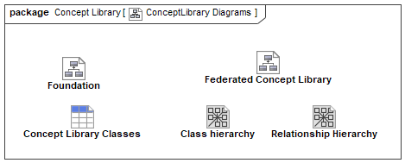

1. ConceptLibrary Diagrams

## Diagram: Federated Concept Library

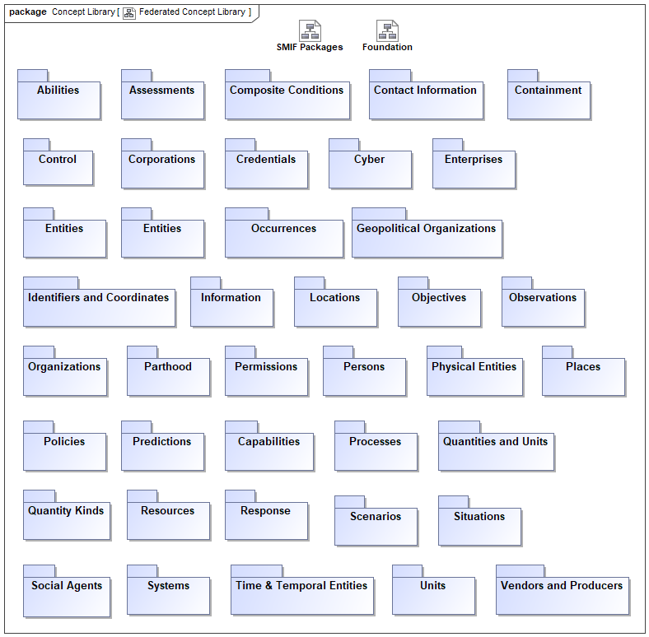

1. Federated Concept Library

Modules (as UML packages) defined as generic concepts under threat & risk. Each module focuses on a particular concept with dependencies on other modules. This forms a graph of "micro theories" that can be independently utilized.

## Diagram: Foundation

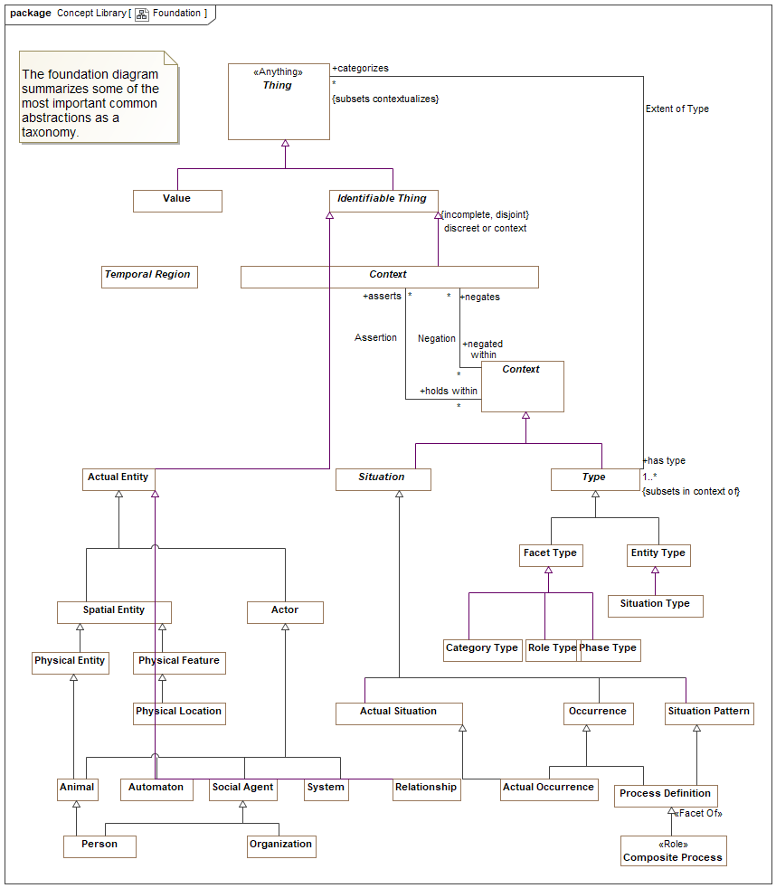

1. Foundation

# Concept Library::Abilities

The Ability module defines the basic concept of an *Ability* as the availability of a resource to an actor. The resource may be specific, such as $5000, a weapon, or general, such as the ability to teach math. Each Ability is a state indicating that it has a lifetime and can participate in all the state/situation and entity relations. *Credentials* may be physical or virtual and attest to the Ability.

Abilities may be created, enhanced, diminished, or eliminated with an *Alter Ability* Event. When an actor alters an Ability (of themselves or others) they are playing the role of a *Facilitator* who performs an *Alter Capacity*.

## Diagram: Ability

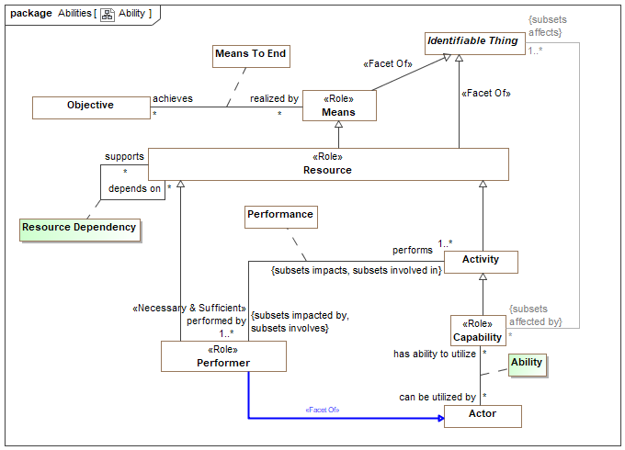

1. Ability

## Diagram: Alter ability or control

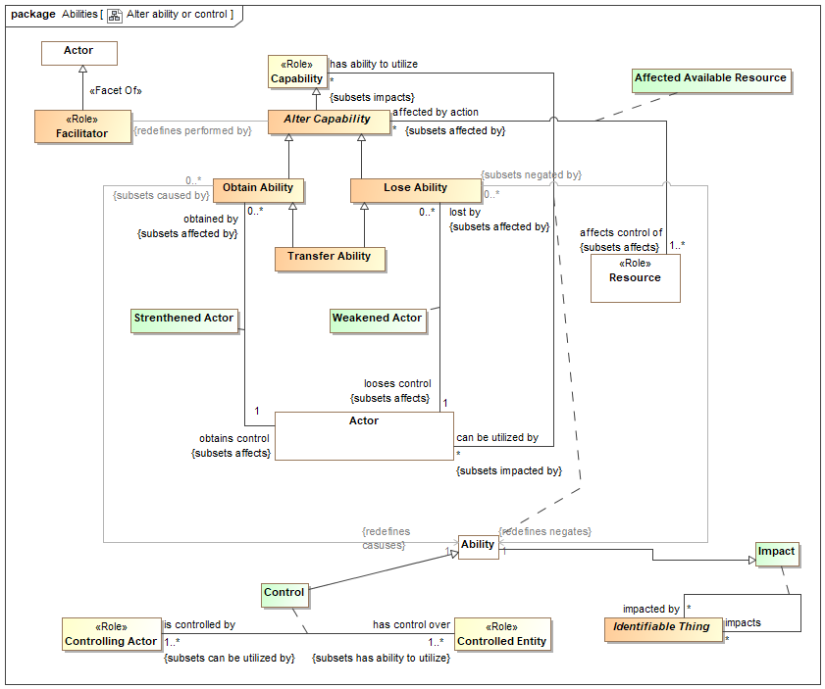

1. Alter ability or control

## Association Class Ability

An Ability is the availability of a resource to an actor to perform activities.

Note that as with any entity, an Ability can also be categorized as a resource and thus the subject of other relationships..

Note that resources can be physical (such as a hammer), activities, virtual or more abstract such as training or experience.

[ISO/IEC 17027:2014] ability: capacity to perform an activity

[NIEM] CapabilityType:

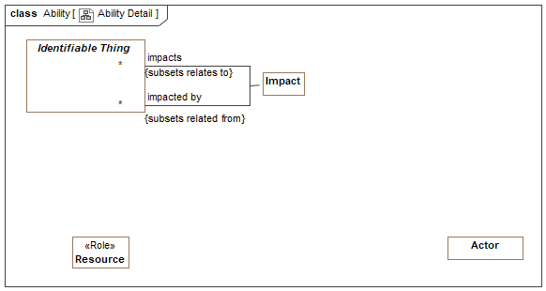

1. Ability Detail

Direct Supertypes

Impact, Resource

Association Ends

can be utilized by : Actor [*]



The actor having the ability to utilize a resource for a purpose.

has ability to utilize : Capability [*]



A resource an actor can employ as part of a capability.

## Association Class Affected Available Resource

An alter ability action affects an actors control over one or more resources. This relationship defines the set of resources impacted by an alter ability action.

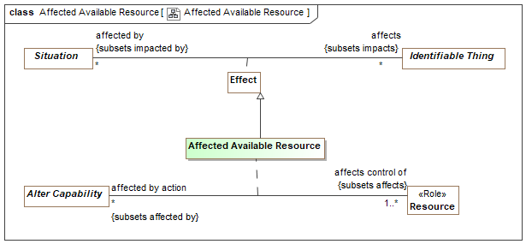

1. Affected Available Resource

Direct Supertypes

Effect

Association Ends

affects control of : Resource [1..*]



Resource that an alter ability action impacts in terms of its availably to actors.

affected by action : Alter Capability [*]



Actions which impact the availability of a resource to actors.

## Class Alter Capability

The Event of providing or removing abilities (including control) by impacting the resources available to an actor.

Direct Supertypes

Capability

## Class Facilitator <<Role>>

An actor able to provide an ability to another actor. e.g., Joe has supervisor rights to a database.

Direct Supertypes

Actor

## Class Lose Ability

An Event that reduces of the ability of an actor.

Direct Supertypes

Alter Capability

## Class Obtain Ability

An Event that increases the resources available to an actor.

Direct Supertypes

Alter Capability

## Association Class Strenthened Actor

The act of obtaining control of an entity.

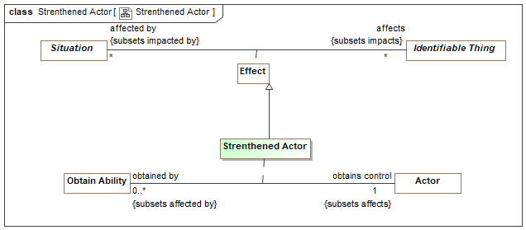

1. Strenthened Actor

Direct Supertypes

Effect

Association Ends

obtains control : Actor [1]



Control obtained by a obtain control action.

obtained by : Obtain Ability [0..*]



Method by which control is obtained.

## Class Transfer Ability

The purposeful or accidental transfer of ability or control from one actor to another. Such transfer of ability or control may be by agreement or force.

Direct Supertypes

Lose Ability, Obtain Ability, Occurrence

## Association Class Weakened Actor

Relationship describing how an actor reduces the resources available to an actor.

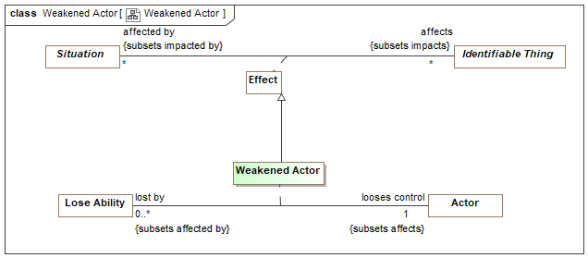

1. Weakened Actor

Direct Supertypes

Effect

Association Ends

looses control : Actor [1]



Control that is lost as a result of a lose control Event.

lost by : Lose Ability [0..*]



Action that causes a loss of control.

# Concept Library::Assertions

## Diagram: Assertions

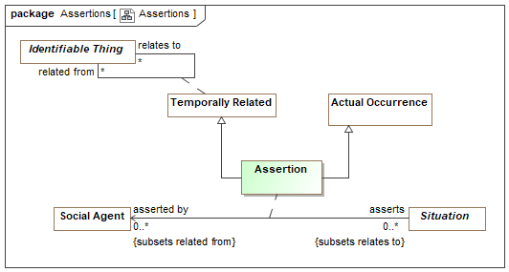

1. Assertions

## Association Class Assertion

The act of making a claim that something is true.

Direct Supertypes

Actual Occurrence, Temporally Related

Association Ends

asserts : Situation [0..*]



A situation asserted to be true by a social agent.

asserted by : Social Agent [0..*]



A social agent claiming the truth of a situation.

# Concept Library::Assessments

Concepts relating to the structured evaluation of an entity or entities.

## Diagram: Assessment

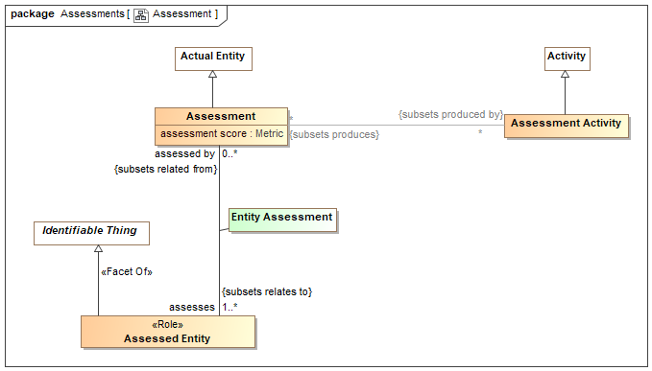

1. Assessment

The evaluation or estimation of the nature, quality, or ability of someone or something.

[BMM] Assessment: judgment that an influencer affects the employment of means and/or the achievement of ends

## Class Assessed Entity <<Role>>

Role of an entity that is assessed.

Direct Supertypes

Identifiable Thing

## Class Assessment

An evaluation, appraisal, or assessment of something or someone.

[NIEM] AssessmentType: The act of evaluating or estimating the nature, ability, or quality of something. {Note: In NIEM the assessment and activity are combined}

Direct Supertypes

Actual Entity

Attributes

assessment score : Metric



An evaluation score of an assessment.[NIEM]

## Class Assessment Activity

An activity that results in an assessment - An evaluation, appraisal, or assessment of something or someone. An assessment frequently as an artifact, a report of the assessment.

[NIEM] AssessmentType: The act of evaluating or estimating the nature, ability, or quality of something.

Direct Supertypes

Activity

## Association Class Entity Assessment

Entities assessed is a relationship between an assessment activity and an entity being assessed that is the topic of an assessment report.

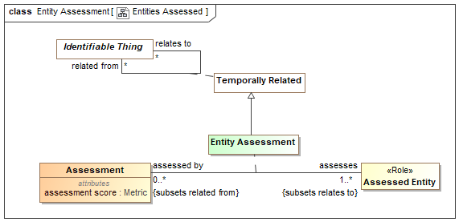

1. Entities Assessed

Direct Supertypes

Temporally Related

Association Ends

assesses : Assessed Entity [1..*]



Entity assessed by an assessment activity

assessed by : Assessment [0..*]



Entity performing an assessment.

# Concept Library::Contact Information

The definition of various ways to contact an entity. Subtypes of contact information supply specific formats.

## Diagram: Contact Information

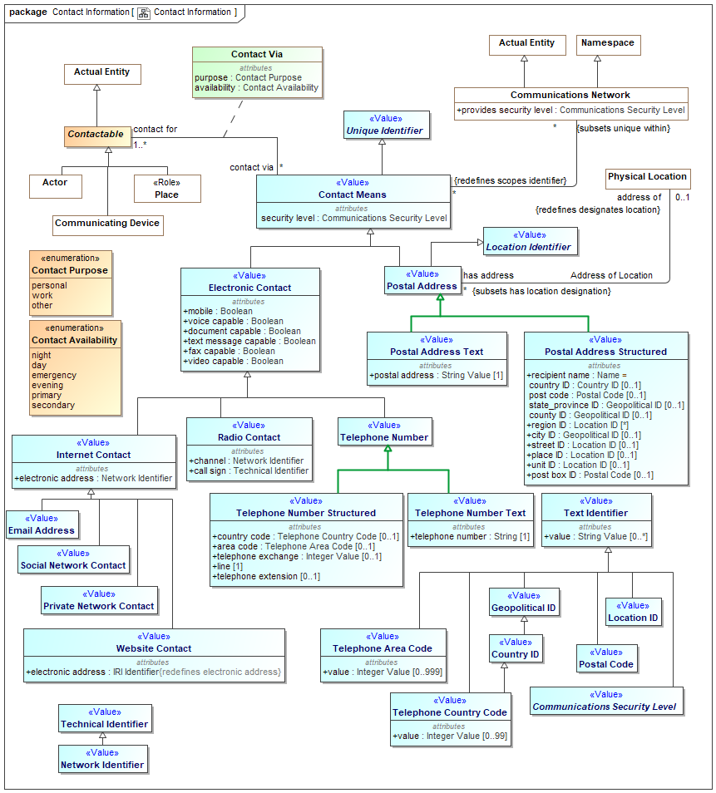

1. Contact Information

## Class Communications Security Level <<Value>>

An abstract type for levels of security in communications.

Direct Supertypes

Text Identifier

## Class Contact Means <<Value>>

Anything that may be used to communicate with an individual.

[FIBO] AddressingScheme

[NIEM] ContactMeans & ContactInformationType

Direct Supertypes

Unique Identifier

Attributes

security level : Communications Security Level



The level of security asserted as provided by the subject contact means. May default to the security level of the communications network.

## Association Class Contact Via

Information relative to communicating with an entity.

[NIEM] ContactInformationAssociationType

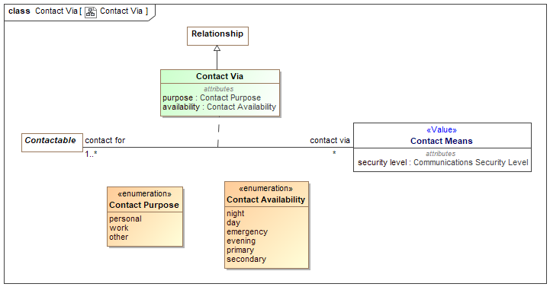

1. Contact Via

Direct Supertypes

Relationship

Association Ends

contact via : Contact Means [*]



A way to contact an actor or place.

[FIBO] hasAddress (More specific concept - restricted to Postal Address)

contact for : Contactable [1..*]



An actor or place for which the contact information may be used to contact that entity.

Attributes

purpose : Contact Purpose



Purposes for contacting an entity, primarily work and personal.

[NIEM] ContactPurpose

availability : Contact Availability



An enumeration of the times contact information may be used.

[NIEM] ContactInformationAvailability

## Class Contactable

Anything that can be send or receive information or be the proxy for things that can send or receive information, e.g., people, organizations and places.

Direct Supertypes

Actual Entity

## Class Electronic Contact <<Value>>

Contact information that enables communications with or via an actor or telecommunications device by electronic means.

[FIBO] VirtualAddress: an address identifying a virtual, i.e. non-physical location

Direct Supertypes

Contact Means

Attributes

mobile : Boolean



Indicator that a contact method is mobile - not fixed to a location.

voice capable : Boolean



An indication that a contact method is voice capable.

document capable : Boolean



An indication that a contact method is capable of receiving documents, e.g., email.

text message capable : Boolean



An indication that a contact method is capable of receiving text messages of limited length.

fax capable : Boolean



Contact method for a communications device that is fax capable.

video capable : Boolean



An indication that a contact method is video capable.

## Class Email Address <<Value>>

Contact information for the delivery of mail via an electronic network.

[NIEM] ContactEmailId (of <electronic contact>)

Direct Supertypes

Internet Contact

## Class Internet Contact <<Value>>

[NIEM] A means of contact that provides for the digital electronic transmission of information via the Internet or a private network.

Direct Supertypes

Electronic Contact

Attributes

electronic address : Network Identifier



Electronic address by which to contact an entity via the Internet.

## Class Network Identifier <<Value>>

A value used to identify a node in an electronic network.

[NIEM] ElectronicAddressType

Direct Supertypes

Technical Identifier

## Class Postal Address <<Value>>

An address able to be used to deliver physical mail which may or may not represent a static physical location.

[FIBO] PPostalAddress: a physical address where postal communications can be addressed, for any kind of organization or person.

[NIEM] AddressType

Direct Supertypes

Contact Means, Location Identifier

## Class Postal Address Structured <<Value>>

A structured representation of a postal address.

Direct Supertypes

Postal Address

Attributes

recipient name : Name =



Name of the recipient in a postal address which defaults to the name of the entity having the address. Should default to the contact for "has name".

[NIEM] AddressRecipientName

country ID : Country ID [0..1]



Postal country identifier.

post code : Postal Code [0..1]



[OGC] An address component which represents the identification of a subdivision of addresses and postal delivery points in a country, region, or city for postal purposes.

[NIEM] LocationPostalCode

state_province ID : Geopolitical ID [0..1]



Postal state identifier for a geopolitical regions.

[NIEM] LocationState

county ID : Geopolitical ID [0..1]



Postal county identifier.

[NIEM] LocationCounty

region ID : Location ID [*]



Postal region identifier.

[NIEM] AddressUrbanizationName

city ID : Geopolitical ID [0..1]



Postal city identifier.

[NIEM] LocationCityName

street ID : Location ID [0..1]



Postal street identifier.

[NIEM] AddressDeliveryPoint

place ID : Location ID [0..1]



Postal identifier for a specific place: House, building, facility, etc.

unit ID : Location ID [0..1]



Postal province identifier.

[NIEM] AddressSecondaryUnitText

post box ID : Postal Code [0..1]



A code defined for the purposes of delivering physical mail to a specific addresses.

[NIEM] AddressPrivateMailboxText

## Class Postal Address Text <<Value>>

A textual representation of a postal address.

Direct Supertypes

Postal Address

Attributes

postal address : String Value [1]



Textual postal address for the delivery of mail.

[NIEM] AddressFullText

## Class Postal Code <<Value>>

A code defined for the purposes of delivering physical mail to a set of addresses. "Zip code" in the U.S.

[OGC] An address component which represents the identification of a subdivision of addresses and postal delivery points in a country, region or city for postal purposes.

[FIBO] PostalCodeArea

Direct Supertypes

Text Identifier

## Class Private Network Contact <<Value>>

Contact identifiers valid within a private network.

Direct Supertypes

Internet Contact

## Class Radio Contact <<Value>>

Identifier for contact via radio.

[NIEM] ContactRadioType

Direct Supertypes

Electronic Contact

Attributes

channel : Network Identifier



Radio channel used for communications.

[NIEM] ContactRadioChannelText

call sign : Technical Identifier



Radio or user call sign used for radio communications.

[NIEM] ContactRadioCallSignID

## Class Social Network Contact <<Value>>

Contact information to be used via a social network.

[NIEM] InstantMessageType

--InstanceMessengerServiceName = <has name>

--InstanceMessengerScreenId = "electronic address"

Direct Supertypes

Internet Contact

## Class Telephone Area Code <<Value>>

A three-digit number that identifies one of the telephone service regions into which the US, Canada, and certain other countries are divided and that is dialed when calling from one area to another.

Direct Supertypes

Text Identifier

Attributes

value : Integer Value [0..999]



3 digit area code.

## Class Telephone Country Code <<Value>>

2 digit Telephone codes for contacting people and organizations within countries.

Direct Supertypes

Country ID, Text Identifier

Attributes

value : Integer Value [0..99]



Country code digits.

## Class Telephone Number <<Value>>

A way to contact an actor via a telephone.

[NIEM] TelephoneNumberType

Direct Supertypes

Electronic Contact

## Class Telephone Number Structured <<Value>>

Structured representation of a telephone number.

[NIEM] NANPTelephoneNumberType & InternationalTelephoneNumberType

Direct Supertypes

Telephone Number

Attributes

country code : Telephone Country Code [0..1]



Telephone country code.

[NIEM] TelephoneCountryCodeID

area code : Telephone Area Code [0..1]



Telephone area code.

[NIEM] TelephoneAreaCodeID

telephone exchange : Integer Value [0..1]



Number identifying a telephone exchange.

[NIEM] TelephoneExchangeID

line [1]



Telephone line number.

[NIEM] TelephoneLineID

telephone extension [0..1]



Telephone extension number.

## Class Telephone Number Text <<Value>>

Unstructured (text) representation of a telephone number.

[NIEM] FullTelephoneNumberType

Direct Supertypes

Telephone Number

Attributes

telephone number : String [1]



Textual telephone number.

[NIEM] TelephoneNumberFullID

## Class Website Contact <<Value>>

A website that can be used to contact an individual.

Direct Supertypes

Internet Contact

Attributes

electronic address : IRI Identifier



Electronic address by which to contact an entity via a website.

[NIEM] ContactWebsiteURI

### Enumeration Contact Availability

A data type for a period of time or a situation in which an entity is available to be contacted with the given contact information.[NIEM]

package Concept Library::Contact Information

public enum Contact Availability

{night, day, emergency, evening, primary, secondary}

Literals

night



Late night contact.

day



Daytime contact.

emergency



Emergency contact.

evening



Late day or early night contact.

primary



Primary contact.

secondary



Secondary or alternate contact.

### Enumeration Contact Purpose

Possible purposes for contact information.[NIEM]

package Concept Library::Contact Information

public enum Contact Purpose

{personal, work, other}

Literals

personal



Personal communications.

work



Work communications.

other



Communications other than work or personal.

# Concept Library::Containment

## Diagram: Containment

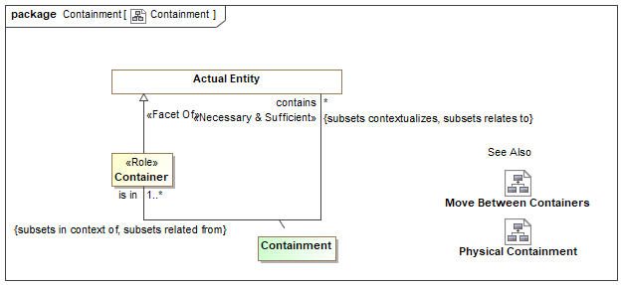

1. Containment

## Diagram: Move Between Containers

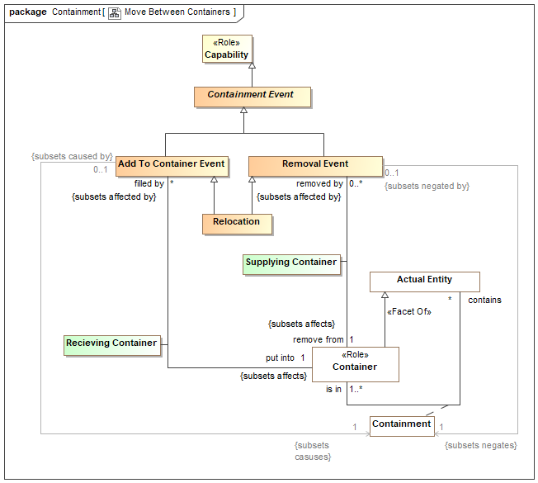

1. Move Between Containers

## Diagram: Physical Containment

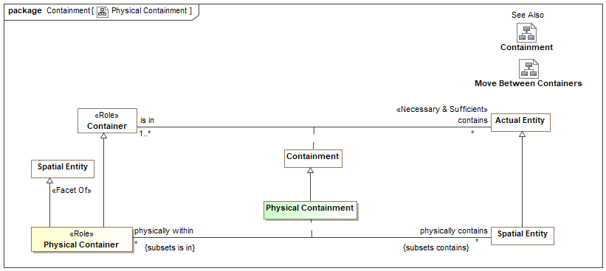

1. Physical Containment

## Class Add To Container Event

An event that puts things into containers or locations. This results in a new containment relationship.

Direct Supertypes

Containment Event

## Class Container <<Role>>

Role of something as a container for other things. Containers & Containment may be physical or virtual.

Direct Supertypes

Actual Entity

## Association Class Containment

Relationship between a container and a contained thing.

Containment may or may not correspond to a part-of relationship. In some cases both the container (a jar) and what it contains (jelly beans) may be considered parts of a whole (a jar of jelly beans).

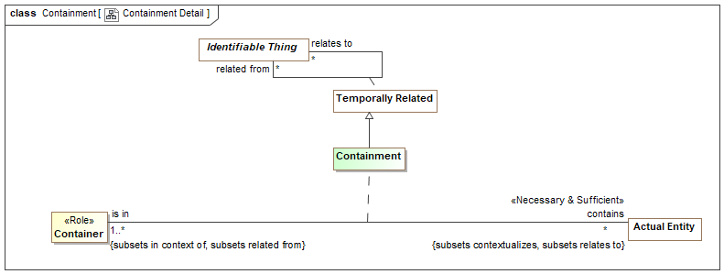

1. Containment Detail

Direct Supertypes

Temporally Related

Association Ends

contains : Actual Entity [*]



A thing contained within a container.

is in : Container [1..*]



A container which holds one or more contained things.

[FIBO] isLocatedAt: a property linking something to a location or place, which might be physical or virtual

## Class Containment Event

An event impacting containment of the <contained thing>. Subtypes include "Put Into Event", "Removal Event" and "Relocation".

Direct Supertypes

Capability

## Class Physical Container <<Role>>

A physical thing or location that contains other physical things or locations.

[DOLCE] Spacial Location

Direct Supertypes

Container, Spatial Entity

## Association Class Physical Containment

Location of something physically within a container, including locations.

Direct Supertypes

Containment

Association Ends

physically contains : Spatial Entity [*]



A physical entity contained by another physical entity.{Transitive}

physically within : Physical Container [*]



Physical container in which the subject physical entity is contained.{transitive}

al

## Association Class Recieving Container

Relationship between a fill action and the container that is filled with something.

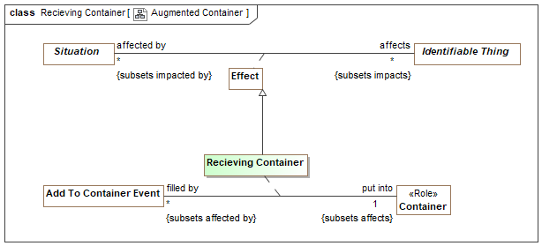

1. Augmented Container

Direct Supertypes

Effect

Association Ends

put into : Container [1]



Container that receives something by a fill action.

filled by : Add To Container Event [*]



Action that puts or moves something into a container or location.

## Class Relocation

The transfer (send/receive) of something between containers or locations. As an Event, the move may be initiated by an actor different from the sender/receiver or may not be caused by an actor.

Examples include movement of a vehicle from one location to another or movement of supplies between warehouses.

Direct Supertypes

Add To Container Event, Removal Event

## Class Removal Event

An event that removes things from containers or locations. This results in the termination of a containment relationship.

Direct Supertypes

Containment Event

## Association Class Supplying Container

Relationship between a removal action and the container it removes something from.

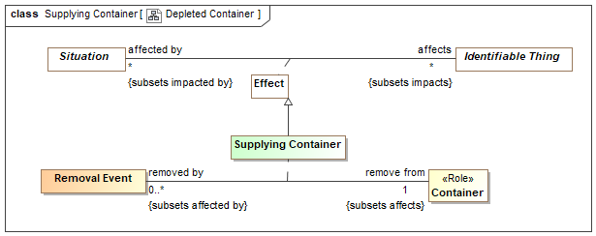

1. Depleted Container

Direct Supertypes

Effect

Association Ends

remove from : Container [1]



Container (or location) that contained something that is removed.

removed by : Removal Event [0..*]



Action that removes something from a container or location.

# Concept Library::Control

Concepts relating to actor's control over resources.

## Diagram: Computer Control

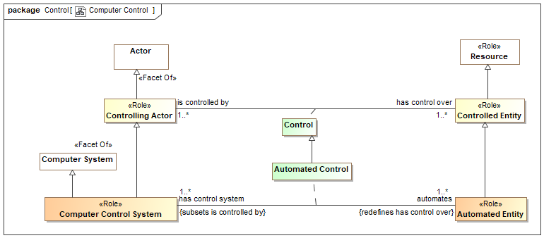

1. Computer Control

## Diagram: Control

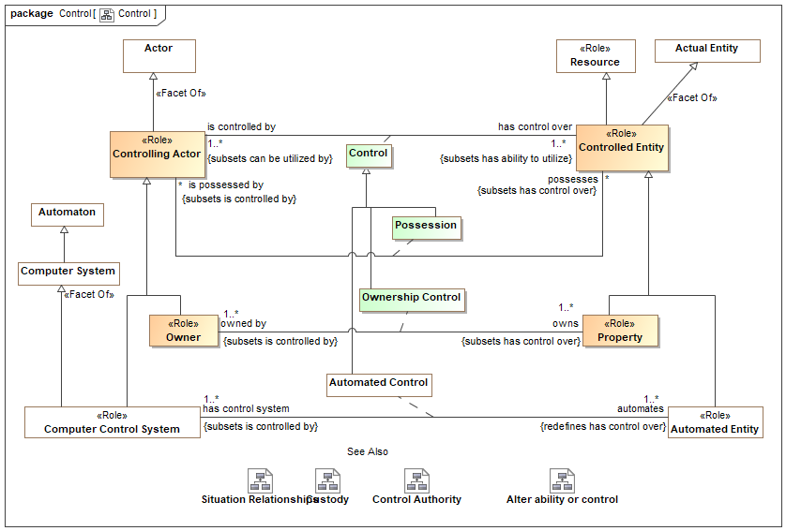

1. Control

This diagram shows that control is a kind of ability and that possession, ownership and automated control are kinds of control. For each kind of control there are specific kinds of roles involved.

## Diagram: Control Authority

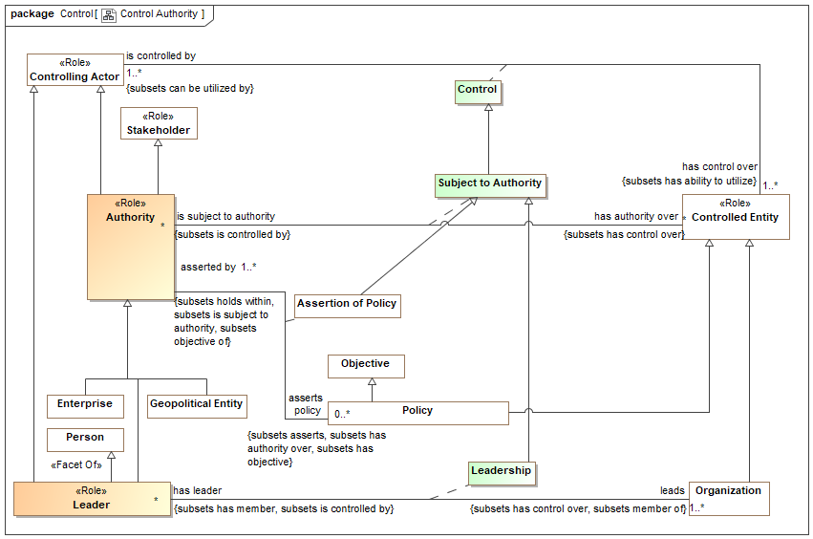

1. Control Authority

## Diagram: Custody

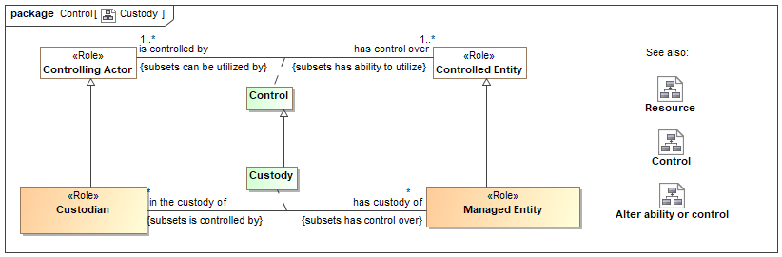

1. Custody

Custody provides a general framework for tracking the control, provenance and life cycle of items and information such that the history, trust and provenance may be ascertained. Custody provides for secure supply chains in that the life-cycle or items, information and their parts may be traced.

Custody is the relation between a Custodian and a Managed Entity (Something for which the provenance is interesting).

Trust in a managed entity may also be influenced by the actors that have a capability to impact the resource.

## Class Authority <<Role>>

An actor with authority over resources such that it can assert policy or behavior.

[ISO 15779:2011] organization, office, or individual responsible for approving equipment, installations or procedures

Direct Supertypes

Controlling Actor, Stakeholder

## Association Class Control

The use or influence of an actor over an entity. This includes subtypes of control representing possession, ownership, leadership. and custody.

[FIBO] Control: the possession by a party, direct or indirect, of the power to direct or cause the direction of the management and policies of a thing, whether through the ownership of voting shares, by contract, or otherwise.

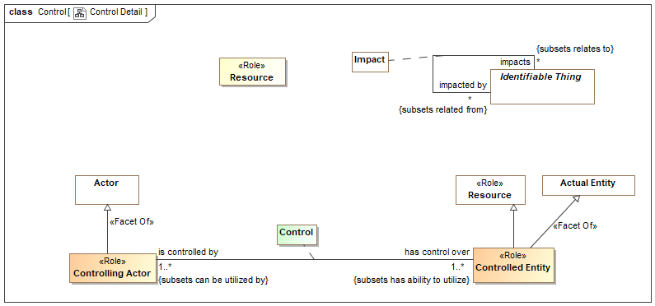

1. Control Detail

Direct Supertypes

Ability

Association Ends

has control over : Controlled Entity [1..*]



Entity which an actor controls in some way - by authority or by possession, by force, etc.

[FIBO] controls

is controlled by : Controlling Actor [1..*]



Actor which controls a controlled entity in some way.The nature of control may be refined in subtypes.

[FIBO] isControlledBy

## Class Controlled Entity <<Role>>

Role of an entity that is controlled by a controlling actor.

[FIBO] ControlledThing: thing over which some party exercises some form of control in some context

Direct Supertypes

Actual Entity, Resource

## Class Controlling Actor <<Role>>

Role of an actor that asserts control over any entity.

[FIBO] ContollingParty: Party which exercises some form of control in some context.

Direct Supertypes

Actor

## Class Custodian <<Role>>

An actor who has responsibility for or looks after some managed entity. A Custodian <has custody of> a managed entity via the Custody relation.

Direct Supertypes

Controlling Actor

## Association Class Custody

The act of a custodian protecting or taking care of a managed entity.

Direct Supertypes

Control

Association Ends

has custody of : Managed Entity [*]



The entity a custodian has custody of.

in the custody of : Custodian [*]



The custodian of a managed entity.

## Class Leader <<Role>>

A person who leads or commands a group, organization, or country.

Direct Supertypes

Authority, Controlling Actor, Person

## Association Class Leadership

An person leading or governing an organization.

Direct Supertypes

Control, Membership, Subject to Authority

Association Ends

leads : Organization [1..*]



An organization a person leads.

has leader : Leader [*]



A person leading or directing an organization.

## Class Managed Entity <<Role>>

Any entity for which the custody of or access to the entity is managed such that it can be trusted or protected. A managed entity is in the custody of a custodian via the Custody relation.

Direct Supertypes

Controlled Entity

## Class Owner <<Role>>

Role of an actor that owns property.

[FIBO] Owner: A party in the ownership role; one that owns something. The thing owned is an Asset to that Party.

Direct Supertypes

Controlling Actor

## Association Class Ownership Control

Relationship defining the ownership of property by an owner.

[FIBO] Ownership: Ownership is the context in which some Party is said to own some Independent Thing. The Party is defined as such due to its being the owning party to that Thing.

Direct Supertypes

Control

Association Ends

owns : Property [1..*]



Property owned by an owner.

[FIBO] owns: to have (something) as one's own, possess

owned by : Owner [1..*]



Owner of an entity as property.

[FIBO] isOwnedBy: identifies the party that owns the asset.

[NIEM] ItemOwner

## Association Class Possession

A relationship defining the physical possession of an item.

Direct Supertypes

Control

Association Ends

possesses : Controlled Entity [*]



A controlled entity in the physical possession of a controlling actor.

is possessed by : Controlling Actor [*]



The actor that possesses the subject controlled entity.

[NIEM] ItemPossessor

## Class Property <<Role>>

Role of an entity which has an owner.

[FIBO] Asset: A thing held by some party and having some value.

Direct Supertypes

Controlled Entity

## Association Class Subject to Authority

The relationship between an authority and what it has authority over.

Direct Supertypes

Control

Association Ends

has authority over : Controlled Entity [*]



Resource an authority has authority over - may influence in some by setting policy or defining requirements.

[FIBO] governs

is subject to authority : Authority [*]



The authority that has some control over a resource.

[FIBO] isGovernedBy

# Concept Library::Credentials

Concepts relating to identity and credential management.

## Diagram: Credentials and Managed Identifiers

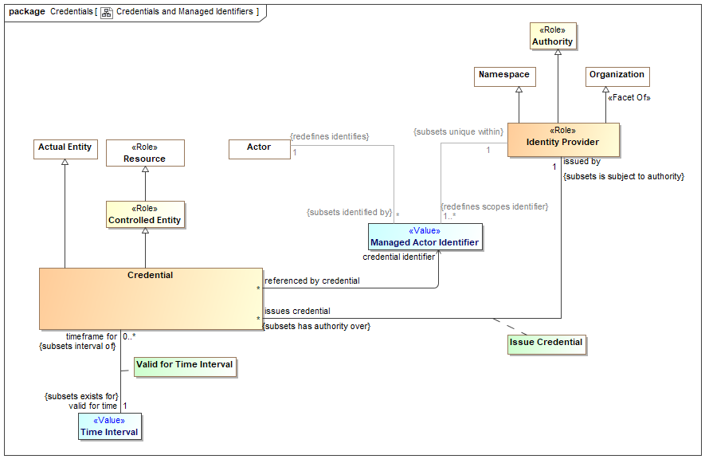

1. Credentials and Managed Identifiers

## Association Actor Identifier of Credential

Association Ends

credential identifier : Managed Actor Identifier



Managed identifier used by a credential to identify the credential and/or actor.

referenced by credential : Credential [*]



A credential that use the subject managed identifier to identify the credential or actor.

## Association Class Attest to Ability

Relationship between a credential and the abilities it attests to. Note that ability is a relationship between an actor and a resource, so the credentialed individual is the actor in this relationship, the actor is identified by an identifier referenced by the credential.

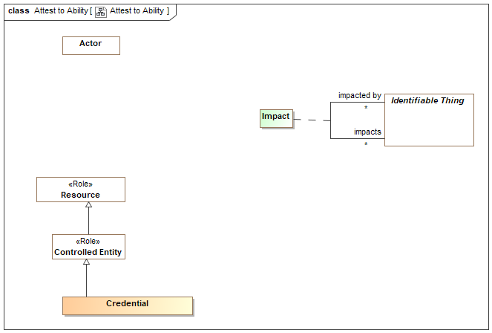

1. Attest to Ability

Direct Supertypes

Impact, Relationship

Association Ends

attests to : Ability [0..*]



A statement of a credentialed capability - that an actor has the stated ability to utilize a resource.

has credential : Credential [0..*]



A physical or logical record of an assertion that a particular actor has a particular ability.

## Class Credential

A credential is an attestation of qualification, competence, or authority issued to an individual by a third party with a relevant or de-facto authority or assumed competence to do so. Credentials can be physical (a house key), documents (a certificate) or virtual (a PKI key) and may be valid for a specific time frame and in specific context.

Direct Supertypes

Actual Entity, Controlled Entity

## Class Identity Provider <<Role>>

Role of an organization that validates identity and issues curated identifiers and credentials for entities.

Direct Supertypes

Authority, Namespace, Organization

## Association Class Issue Credential

Issuance of and the assertion of the validity of a credential by an identity provider.

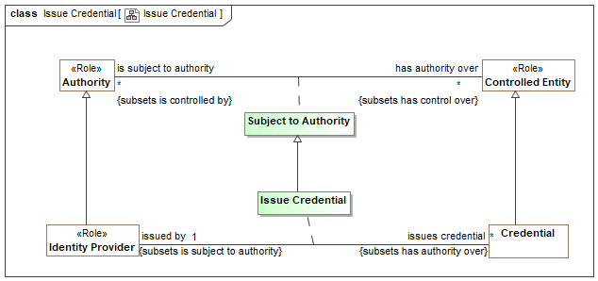

1. Issue Credential

Direct Supertypes

Subject to Authority

Association Ends

issues credential : Credential [*]



Credential issued by an identity provider. By issuing the credential the identity provider is asserting the validity of the credential.

issued by : Identity Provider [1]



The identity provider issuing a credential By issuing the credential the identity provider is asserting the validity of the credential.

## Class Managed Actor Identifier <<Value>>

An identifier managed by an identity provider who asserts the validity of the identifier. This includes technical/cyber identities as well as traditional identifiers such as passport numbers and corporate IDs. Identities can also be provided for systems, such as a SSL certificate.

Direct Supertypes

Unique Identifier

## Association Class Valid for Time Interval

Relationship describing the time interval for which a credential is valid.

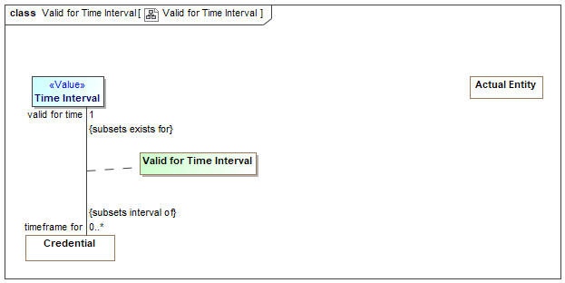

1. Valid for Time Interval

Direct Supertypes

Entity Exists for Interval

Association Ends

valid for time : Time Interval [1]



Time interval over which a credential is valid (can be used to provide evidence for an ability).

timeframe for : Credential [0..*]



Credential that is validated within the <valid for time> interval.

# Concept Library::Cyber

The Cyber package defines instances and subtypes of generic concepts specific to Cyber - computers, software and networks.

## Diagram: Cyber

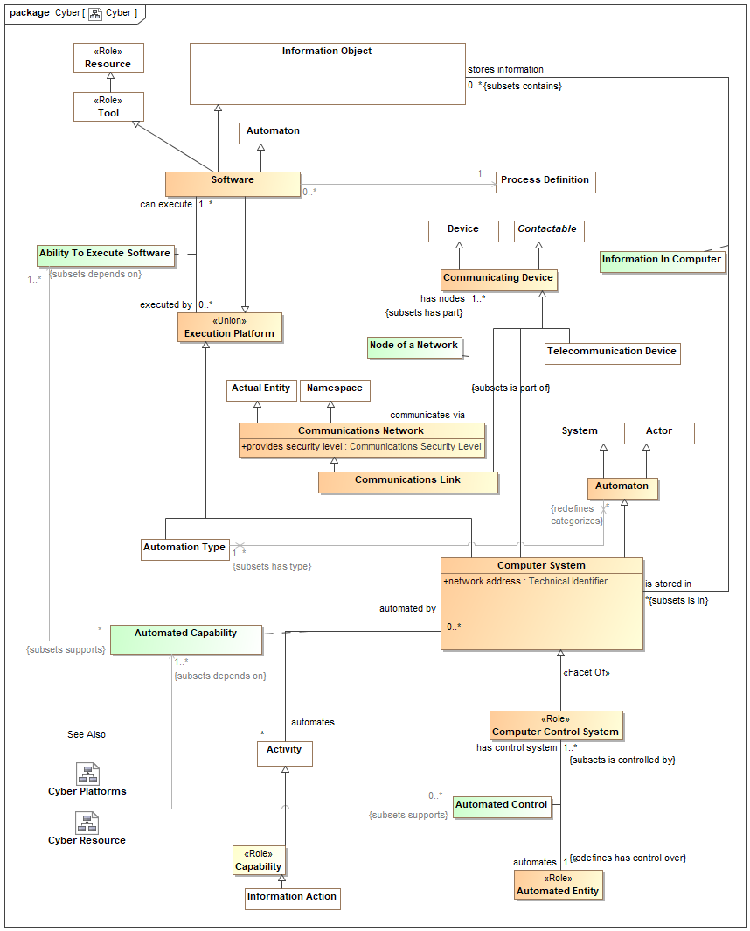

1. Cyber

## Diagram: Cyber Platforms

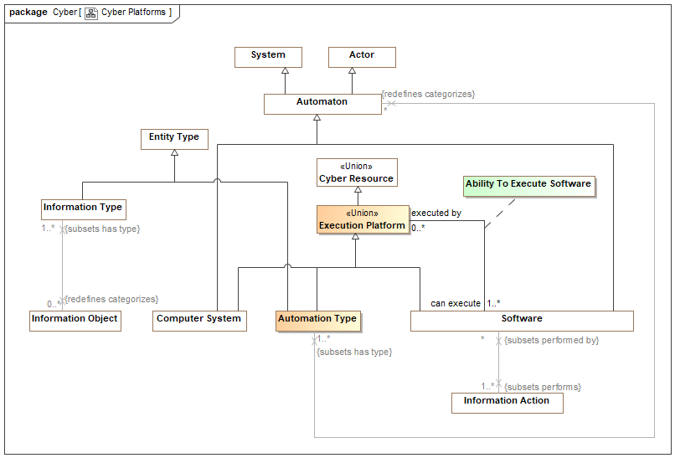

1. Cyber Platforms

## Diagram: Cyber Resource

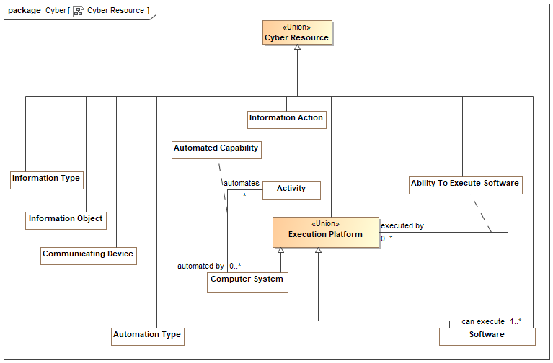

1. Cyber Resource

## Association Class Ability To Execute Software

Relationship between software and platforms that can execute that software. Platforms include specific computers , types of computers and software.

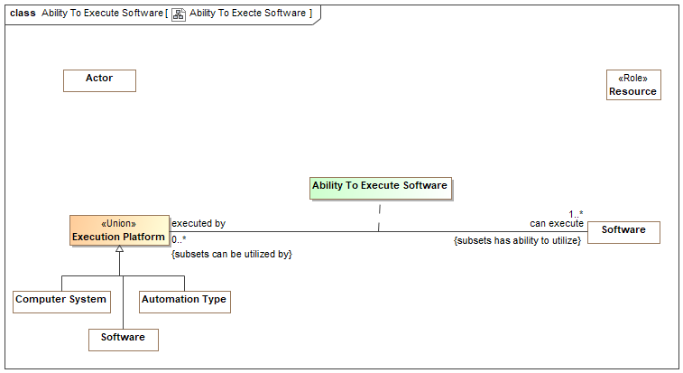

1. Ability To Execte Software

Direct Supertypes

Ability, Cyber Resource

Association Ends

executed by : Execution Platform [0..*]



A computer platform (software, computer type or specific computer) able to execute specific software.

can execute : Software [1..*]



Software a computer system, other software or computer type is able to execute.

## Association Class Automated Capability

Capability of a specific computer system to automate activities.

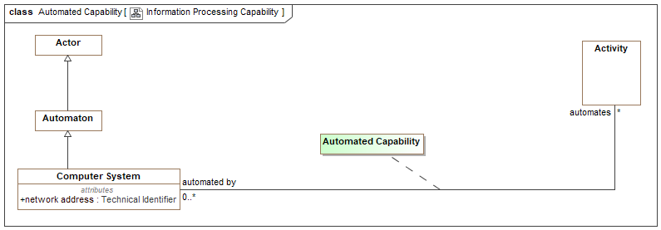

1. Information Processing Capability

Direct Supertypes

Cyber Resource

Association Ends

automates : Activity [*]



Activities a computer may automate.

automated by : Computer System [0..*]



Computer system capable of automating an activity.

## Association Class Automated Control

Control of an entity by an automated control system - a computer and related software.

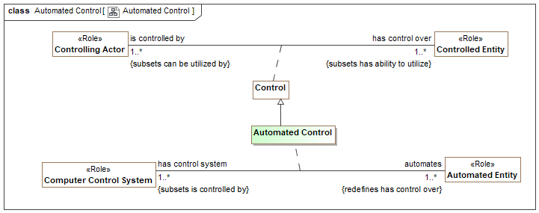

1. Automated Control

Direct Supertypes

Control

Association Ends

automates : Automated Entity [1..*]



Entity that is controlled by a computer system.

has control system : Computer Control System [1..*]



Control system for an automated entity. e.g., an automated machine or facility.

## Class Automated Entity <<Role>>

Any actual entity all or partially controlled by automation.

Direct Supertypes

Controlled Entity

## Class Automation Type

A categorization of computers and software across any dimension - chip type, operating system, language, manufacturer, virtual machine, etc. The automation type may be used to establish software compatibilities and vulnerabilities. Note that any automation may be categorized by multiple automation types.

Direct Supertypes

Cyber Resource, Entity Type, Execution Platform

## Class Automaton

A machine or group of machines (most often a computer system, robot, or computerized swarm combined with software), or software that can perform actions in accordance with a process without another actor directing each step of the process.

Distinguished from simple tools which facilitate an actor performing a process but have no innate ability to follow such a process.

Automation is distinguished from "legal entity" and "stakeholder", roles of some actors which indicates the ability to enter into legally binding agreements or have objectives (at this time no Automatons are legal entities or stakeholders but the model does not preclude the possibility).

Direct Supertypes

Actor, System

## Class Communicating Device

A device able to communicate or facilitate communications across a network.

Direct Supertypes

Contactable, Cyber Resource, Device

## Class Communications Link

A physical or virtual link between communications devices allowing them to communicate.

Direct Supertypes

Communicating Device, Communications Network

## Class Communications Network

A physical or electronic system intended to facilitate communications between entities. Includes communications channels, computer networks, physical mail and RF networks.

Direct Supertypes

Actual Entity, Composite, Namespace

Attributes

provides security level : Communications Security Level



The level of security asserted for the subject communications network.

## Class Computer Control System <<Role>>

A computer control system is a device, or set of devices, that manages, commands, directs or regulates the behavior of other devices or systems. Industrial control systems are used in industrial production for controlling equipment or machines.

Direct Supertypes

Computer System, Controlling Actor

## Class Computer System

An identifiable and physical computer system that acts as an automaton agent performing processes.

[ISO/IEC 10514-1:1996] The combination of hardware and, optionally, firmware and software (e.g. operating system) that enables the execution of software.

Direct Supertypes

Automaton, Communicating Device, Container, Cyber Resource, Execution Platform

Attributes

network address : Technical Identifier



Electronic address which allows communication with a computer system as a node on a network.

## Class Cyber Resource <<Union>>

Resources that, together, make up information systems capabilities and may be vulnerable to attack or used in an attack.

## Class Execution Platform <<Union>>

Computer hardware or software that provides the capability of executing software. This includes processors, operating systems and virtual machines.

Direct Supertypes

Cyber Resource

## Association Class Information In Computer

Relationship defining information stored in a computer system.

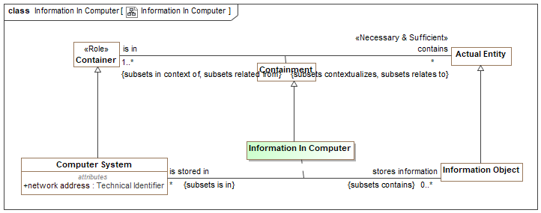

1. Information In Computer

Direct Supertypes

Containment

Association Ends

stores information : Information Object [0..*]



Information stored in a computer.

is stored in : Computer System [*]



System storing an information object.

## Association Class Node of a Network

Relationship between a network and nodes that may communicate on that network.

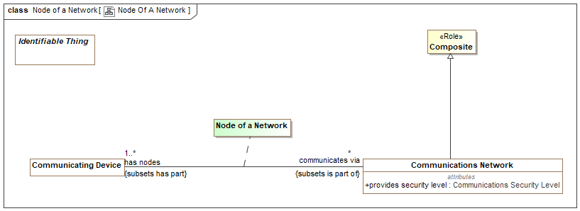

1. Node Of A Network

Direct Supertypes

Parthood

Association Ends

communicates via : Communications Network [*]



The network used by a communications device to send and receive information.

has nodes : Communicating Device [1..*]



The communicating nodes of a communications network. Nodes are able to communicate with each other across the network.

## Class Software

Programs and other operating information used by a computer to control its function through the definition of a process.

Direct Supertypes

Automaton, Cyber Resource, Execution Platform, Information Object, Tool

# Concept Library::Enterprises

In a generic sense, an enterprise is any organization or collection of organizations that has a common set of goals and/or a single bottom line. An enterprise, by that definition, can encompass a Military Department, DoD as a whole, a division within an organization, an organization in a single location, or a chain of geographically distant organizations linked by a common management or purpose. An enterprise today is often thought of as an extended enterprise where partners, suppliers, customers, along with their activities and supporting systems, are included in the Architectural Description. [DoDAF 2.0] section 51, Defining the Enterprise

The concept of enterprise builds on the concept of a system.

## Diagram: Enterprise

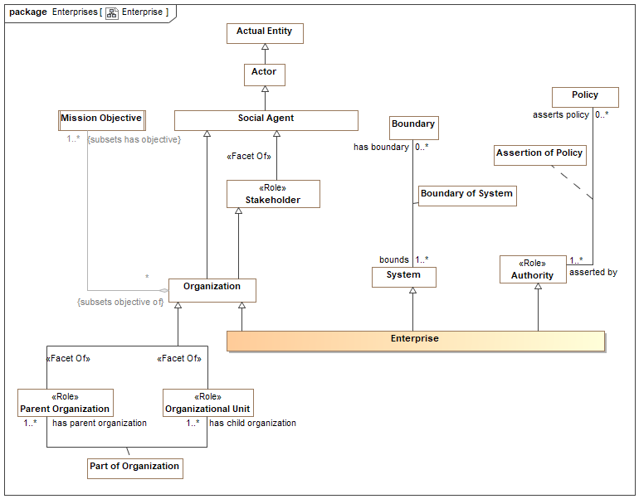

1. Enterprise

## Class Enterprise

An enterprise is a stakeholder organization, organized as a system, with a mission, members, and authority over resources to accomplish its mission(s). An enterprise provides context for operations and analysis. An enterprise may have parts - its divisions or departments.

[BMM] Organizational Unit:

Direct Supertypes

Authority, Organization, System

# Concept Library::Entities

The foundation library provides fundamental concepts that apply to most domains or areas of concern. These fundamental concepts are specialized, combined and related for more specific concerns, such as risk management.

These fundamental concepts provide for links between domains, systems, organizations, cultures and stakeholders.

Unless stated otherwise, these concepts are intended to be mixed together to fully describe something in the "real world".

The foundation builds on the conceptual model defined in [SIMF] (Semantic Information Modeling for Federation), which is included by reference. By using SIMF we avoid redundant definitions of concepts and also allow for easy extension of threat/risk by using the SIMF modeling capabilities.

Note that something may be classified by any number of types (e.g., a transfer of custody that is an actual situation that happened in the past).

## Diagram: Identifiable Entity

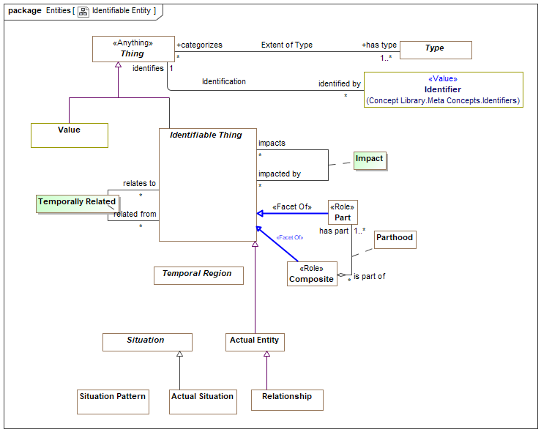

1. Identifiable Entity

The above is a summary diagram intended to show significant classes used in the concept library.

## Diagram: Identifiable Entity Relationships

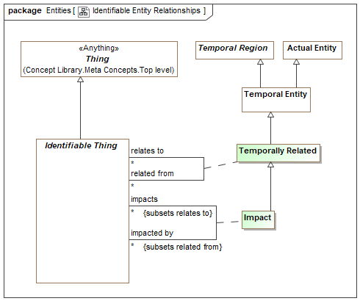

1. Identifiable Entity Relationships

## Association Class Impact

Relationship between some entity and another on which it has some kind of impact or effect.

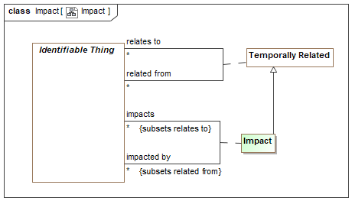

1. Impact

Direct Supertypes

Temporally Related

Association Ends

impacts : Identifiable Thing [*]



Entity that the subject entity impacts in any way.

impacted by : Identifiable Thing [*]



Entity that is impacted by another in any way..

Attributes

likelihood : Probability Metric



Metric representing the probability that the <negated by> situation will prevent the <negates> situation

## Association Class Temporally Related

Temporally Related defines relationships as first-class entities that are "situations" that may have conditions, context or a time frame. "Related" is the implicit supertype of all entity relationships such that any relationship can be traced between entities. Note that the generalization to Temporally Related may not be shown on diagrams.

Note that in UML relationships that are "definitional" and not expected to be time or contextually dependent are shown as regular UML associations where as potentially contextual or time-bound relationships are shown as association classes. This is a notational convention and does not have semantic intent to avoid early commitment to such considerations.

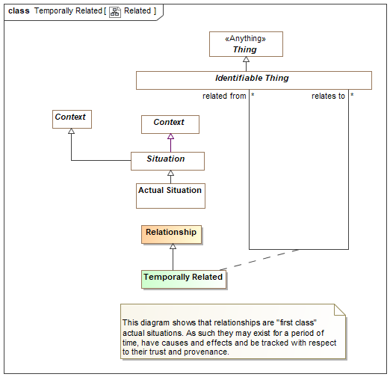

1. Related

Direct Supertypes

Relationship, Temporal Entity

Association Ends

relates to : Identifiable Thing [*]



A generic relationship to capture arbitrary relationships that do not have more specific meaning. <relates> is the implicit supertype of all relationships between entities (not including metadata). Note that to remove diagram clutter, subsets of "relates" may not show the subset on all diagrams.

related from : Identifiable Thing [*]



# Concept Library::Identifiers and Coordinates

Identification connects identifiers with the entity they identify. Identifiers are values, that is they are immutable "data". An entity may be assigned different identifiers over time and may have many at any one time.

The base Identifier class (defined in SIMF) identifies a set of entities and is not assumed to be unique or to identify only one entity. For example, a name is an identifier but many people could have the same name and a person could have multiple names. Identifiers and the relation to an entity may be contextual.

Identifiers should not be confused with Identity, which is an abstracton of individuality that provide the foundation for identifiers.

The class of Unique Identifiers is more typical of I.T. systems and managed identifiers, such as driver's license numbers. A unique identifier is assumed unique within exactly one Namespace.

Subtypes of Identifier may be specific to identifying particular kinds of entities. For example, a Location Identifier (such as an address or GPS coordinate) is specific to identifying locations.

Note that as with all concepts, identifiers are independent of representation. Since names are so often textual, we also define a representation of names - "Textual Name".

The generic library of identifiers extends the SIMF identifiers with the concepts of coordinates.

## Diagram: Identifiers

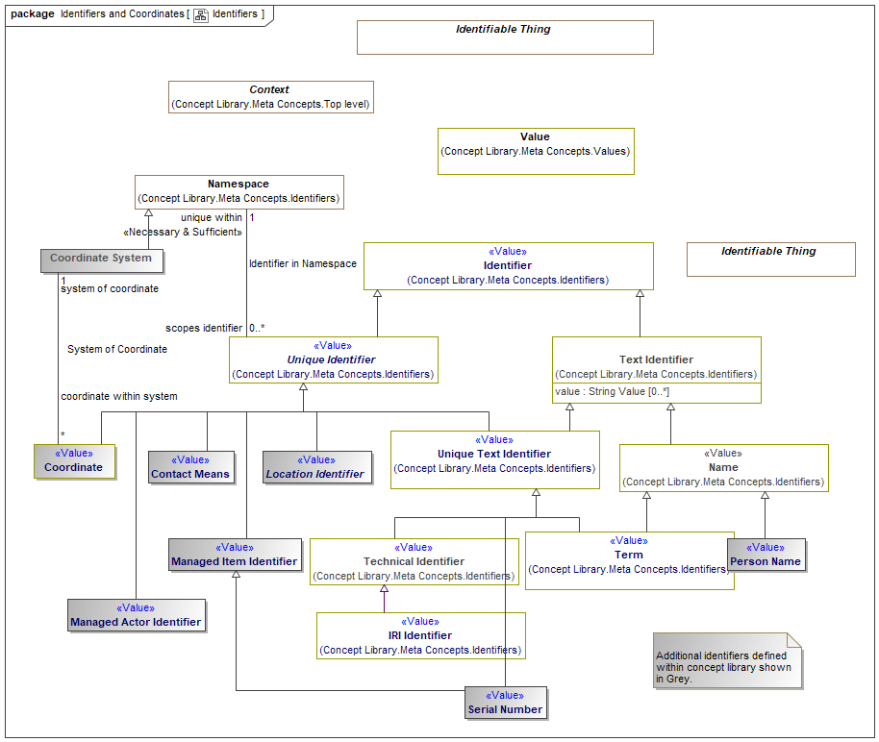

1. Identifiers

## Class Coordinate <<Value>>

Any set of magnitudes that serve to define the position of a point, line, or the like, by reference to a coordinate system.

Direct Supertypes

Unique Identifier

## Class Coordinate System

A reference system for a coordinate. e.g., WGS-84.

[OGC] Set of mathematical rules for specifying how coordinates are to be assigned to points.

Direct Supertypes

Namespace

## Association System of Coordinate

Relationship between a coordinate and a system of coordinates that defines how the coordinate is to be interpreted.

Association Ends

system of coordinate : Coordinate System [1]



The set of rules and reference points used for interpreting a coordinate.

coordinate within system : Coordinate [*]



A particular coordinate identifying an entity within the scope of a coordinate system.

# Concept Library::Information

Concepts relating to information (including data) about entities.

## Diagram: Information Action

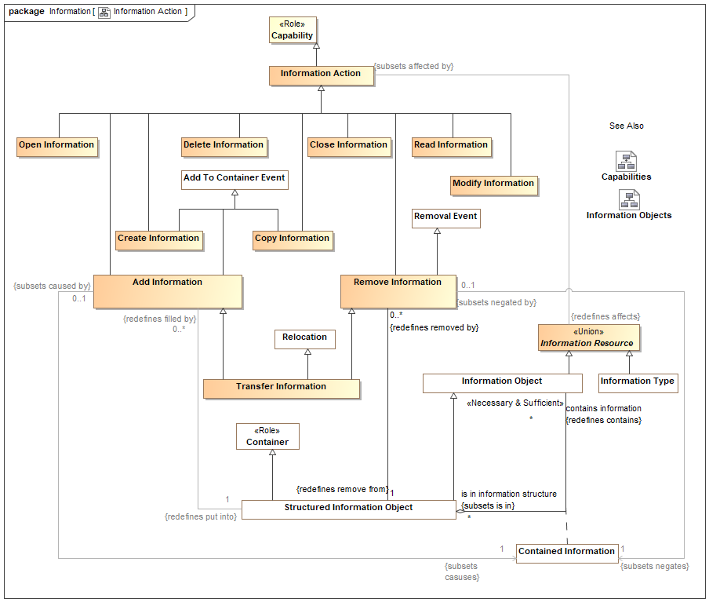

1. Information Action

## Diagram: Information Objects

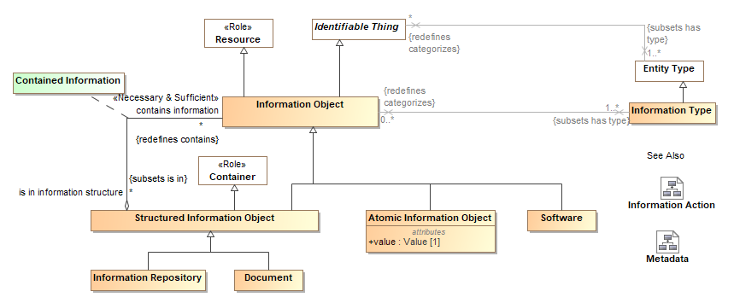

1. Information Objects

## Diagram: Metadata

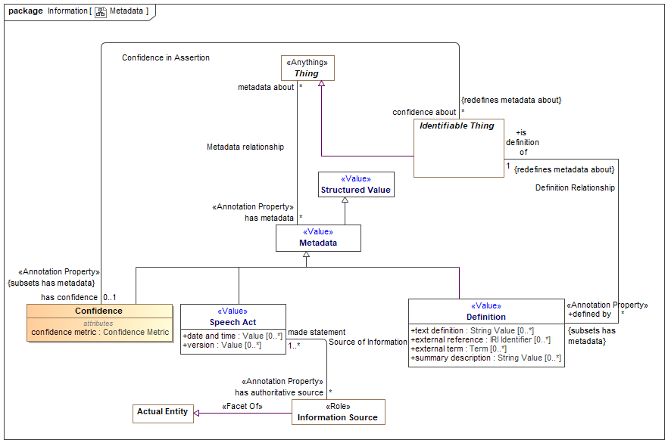

1. Metadata

## Class Add Information

An action to add information to a repository or information structure.

Direct Supertypes

Add To Container Event, Information Action

## Class Atomic Information Object

An atomic information object is a managed piece of information composed entirely of a single value. e.g. an MP3 representation of a song. Note that different viewpoints and abstractions may not agree on what is "atomic". e.g. a music editor may consider a song a series of samples.

Direct Supertypes

Information Object

Attributes

value : Value [1]



Atomic value associated with an atomic information object.

## Class Close Information

An action that removes information from visibility.

Direct Supertypes

Information Action

## Class Confidence

A statement and measure of the confidence in any fact or set of facts about an entity.

Direct Supertypes

Metadata

Attributes

confidence metric : Confidence Metric



A metric reflecting confidence in an assertion condition or effect.

## Association Confidence in Assertion

A relationship relating a degree of confidence with the topic or subject of that confidence. Confidence is metadata about statements in a model; the degree of belief in those statements.

Association Ends

confidence about : Identifiable Thing [*]



Subject of confidence; the facts, situations or subject that confidence is being evaluated for.

has confidence : Confidence [0..1]



Confidence is a metric quantifying the belief that the facts asserted about the entity are true and valid.

## Association Class Contained Information

Relationship connecting an information container with what it contains.

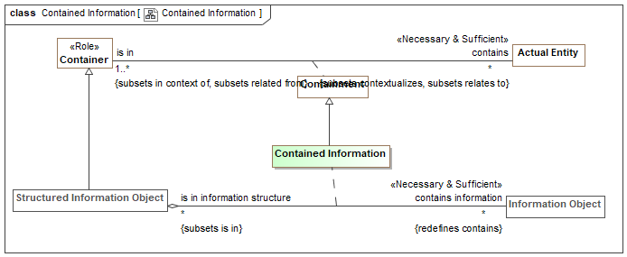

1. Contained Information

Direct Supertypes

Containment

Association Ends

contains information : Information Object [*]



An information object structurally contained in another.

is in information structure : Structured Information Object [*]



Structural containment of an information object within an information object.

## Class Copy Information

An Information Action to duplicate information in another location or container.

Direct Supertypes

Add To Container Event, Information Action

## Class Create Information

An action that creates information.

Direct Supertypes

Add To Container Event, Create, Information Action

## Class Delete Information

An action to delete information, erase it or render it inaccessible.

Direct Supertypes

Destroy, Information Action

## Class Document

A collection of information about a topic, frequently containing some analysis or summary, intended for use by a stakeholder.

Direct Supertypes

Structured Information Object

## Class Information Action

An action that impacts information objects.

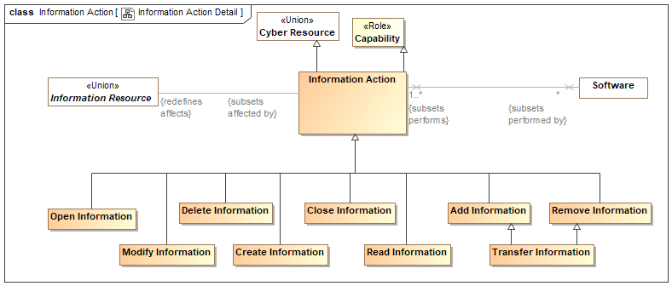

1. Information Action Detail

Direct Supertypes

Capability, Cyber Resource

## Class Information Object

A representation of information, data, facts, assertions or statements about something.

As information may be copied while retaining its identity, the same information copied onto new physical media may be considered the same object. Where the individual representation of information is of concern another object should be used to represent the individual physical thing than holds the information.

As information is a resource it may depend on other resources.

[FIBO] Document

[NIEM] DocumentType

Direct Supertypes

Actual Entity, Cyber Resource, Identifiable Thing, Information Resource, Resource

## Class Information Repository

A resource in which information is stored and can then be retrieved.

Direct Supertypes

Structured Information Object

## Class Information Resource <<Union>>

Information objects or types that can be manipulated by an information action.

## Class Information Type

A categorization of information across any dimension - content, format, source, sensitivity, etc. e.g. a schema. The information type may be used to establish software capabilities and vulnerabilities.

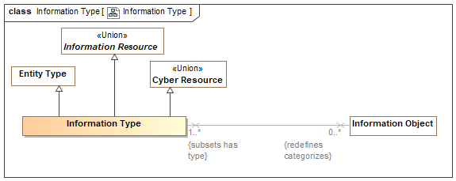

1. Information Type

Direct Supertypes

Cyber Resource, Entity Type, Information Resource

## Class Modify Information

Action to change information (for good or bad reasons).

Direct Supertypes

Information Action

## Class Open Information

Action to gain visibility to some information, e.g., Open a file or an envelope.

Direct Supertypes

Information Action

## Class Read Information

An action to read, access, or understand some information.

Direct Supertypes

Information Action

## Class Remove Information

An action to remove information from some repository or composite information structure.

Direct Supertypes

Information Action, Removal Event

## Class Structured Information Object

An information object that contains sub-elements. e.g., a "record".

Direct Supertypes

Container, Information Object

## Class Transfer Information

The transfer of information from one information store to another.

Direct Supertypes

Add Information, Relocation, Remove Information

# Concept Library::Locations

Concepts related to locations and places.

## Diagram: Location

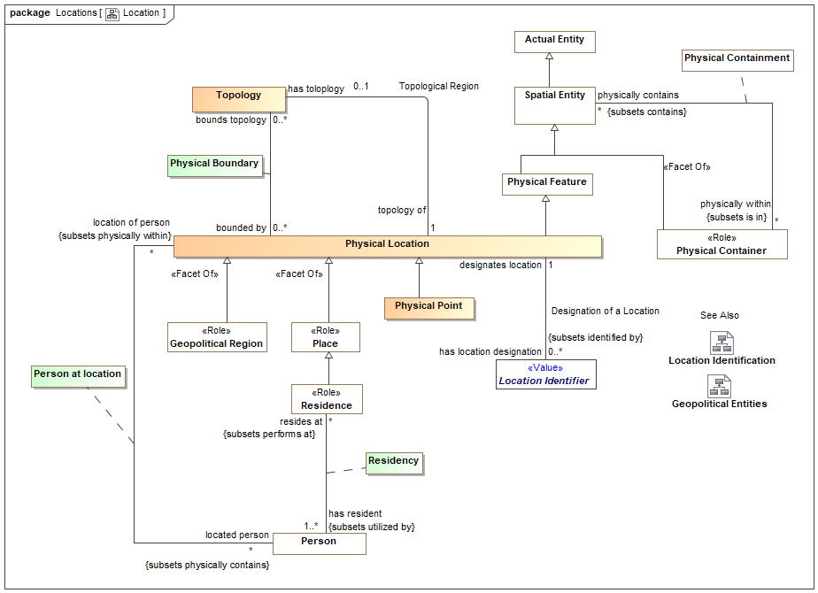

1. Location

## Diagram: Location Identification

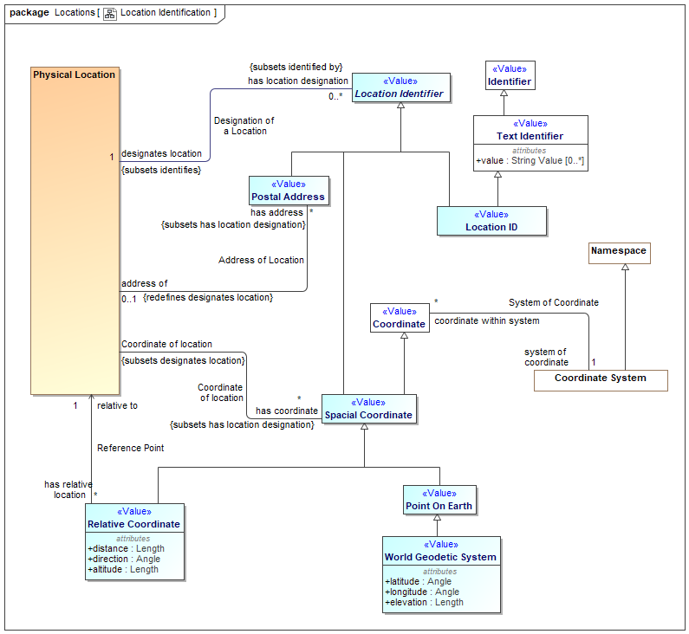

1. Location Identification

## Association Address of Location

identification of a location by an address. Note that there are postal addresses that do not identify a location, so this relation is optional. However, most postal addresses do identify a location thus this relation is possible.

Association Ends

has address : Postal Address [*]



A postal address of a physical location.

address of : Physical Location [0..1]



Location identified by an address.

## Association Coordinate of location

Relationship between a physical location and the coordinate that defines its position.

Association Ends

has coordinate : Spacial Coordinate [*]



A coordinate that identifies a location.

Coordinate of location : Physical Location



Coordinate of location based on coordinate system.

## Association Designation of a Location

Relationship defining the location identified by a location identifier.

Association Ends

designates location : Physical Location [1]



The physical location identified or described by a location identifier..

has location designation : Location Identifier [0..*]



A description or identifier that designates a particular location.

## Class Location ID <<Value>>

A code, ID or name for a physical location.

Direct Supertypes

Location Identifier, Text Identifier

## Class Location Identifier <<Value>>

Any identifier able to uniquely identify a physical location

Syn. spatial reference - description of position in the real world [OGC]

Direct Supertypes

Unique Identifier

## Association Class Physical Boundary

Boundary describing the topology of a location.

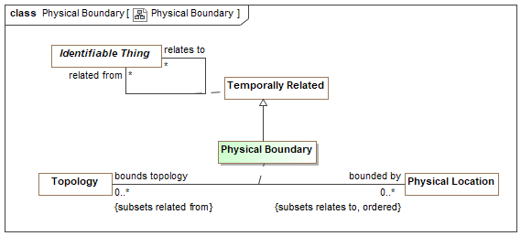

1. Physical Boundary

Direct Supertypes

Temporally Related

Association Ends

bounded by : Physical Location [0..*]



The edge points of a topology where each successive pair of features (as well as the first and last points), connected by lines, describes a boundary.

bounds topology : Topology [0..*]



A location identified by geographic boundaries.

## Class Physical Location

A point or extent in physical space.

[NIEM] A geospatial location.

[FIBO] PhysicalLocation: A location in physical space

Direct Supertypes

Physical Feature

## Class Physical Point

A dimensionless physical point in space or on the surface of the earth such as a corner or center point.

Direct Supertypes

Physical Location

## Class Point On Earth <<Value>>

A point that defines a location on earth where the point is within the bounds of <designates location>.

Direct Supertypes

Spacial Coordinate

## Association Reference Point

Reference point for a relative location

Association Ends

relative to : Physical Location [1]



Where the position of something is relative to a location, the reference location.

has relative location : Relative Coordinate [*]



## Class Relative Coordinate <<Value>>

A coordinate described relative to another. e.g., 5 miles west of the empire state building.

Direct Supertypes

Spacial Coordinate

Attributes

distance : Length



Distance as part of a relative coordinate that, when combined with angle, identifies a point <relative to> another point.

direction : Angle



An angle as part of a coordinate.

altitude : Length



Measure of how much something is above <relative to> something else, usually the earth.

## Class Spacial Coordinate <<Value>>

Any point that uniquely identifies a spacial location relative to a coordinate system.

One of a sequence of n numbers designating the position of a point in n-dimensional space [OGC]

Direct Supertypes

Coordinate, Location Identifier

## Association Topological Region

Physical location described by a topology.

Association Ends

topology of : Physical Location [1]



Location described by a topology.

has toloplogy : Topology [0..1]



Topology that describes a physical location in terms of physical boundaries.

## Class Topology

A record of a contiguous 1, 2 or 3 dimensioned area defined by geographic features and points.

[NIEM] AreaType

## Class World Geodetic System <<Value>>

The World Geodetic System defines a reference frame for the earth, for use in geodesy and navigation. The latest revision is WGS 84 dating from 1984. [WGS-84]

[NIEM] Location2DGeospatialCoordinateType or Location3DGeospatialCoordinateType (With elevation)

Direct Supertypes

Point On Earth

Attributes

latitude : Angle



Latitude based on the prime meridian.

[FIBO] hasLatitude

longitude : Angle



Longitude based on the prime meridian.

[FIBO] hasLogitude

elevation : Length



Height above nominal sea level.

# Concept Library::Meta Concepts

## Diagram: SMIF Packages

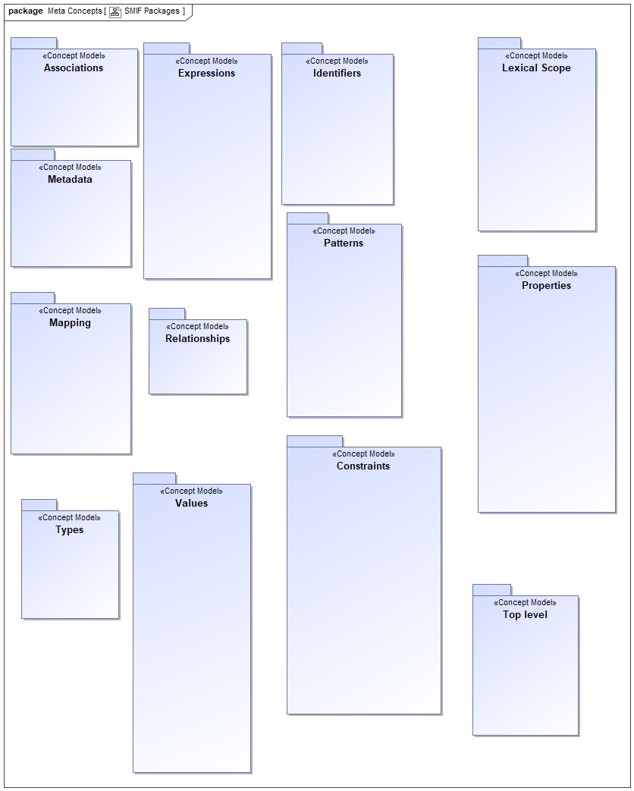

1. SMIF Packages

# Concept Library::Meta Concepts::Associations

An association asserts a formal condition involving related things, the association ends. An association may be asserted within a context as true or false within that context. Each association has a number of bindings of which are immutable for that association.

Associations are differentiated from relationships in that associations are fully dependent on the things they relate. These are known as "formal", "thin", "internal" or "intrinsic" relations in much of the literature.

## Diagram: Associations

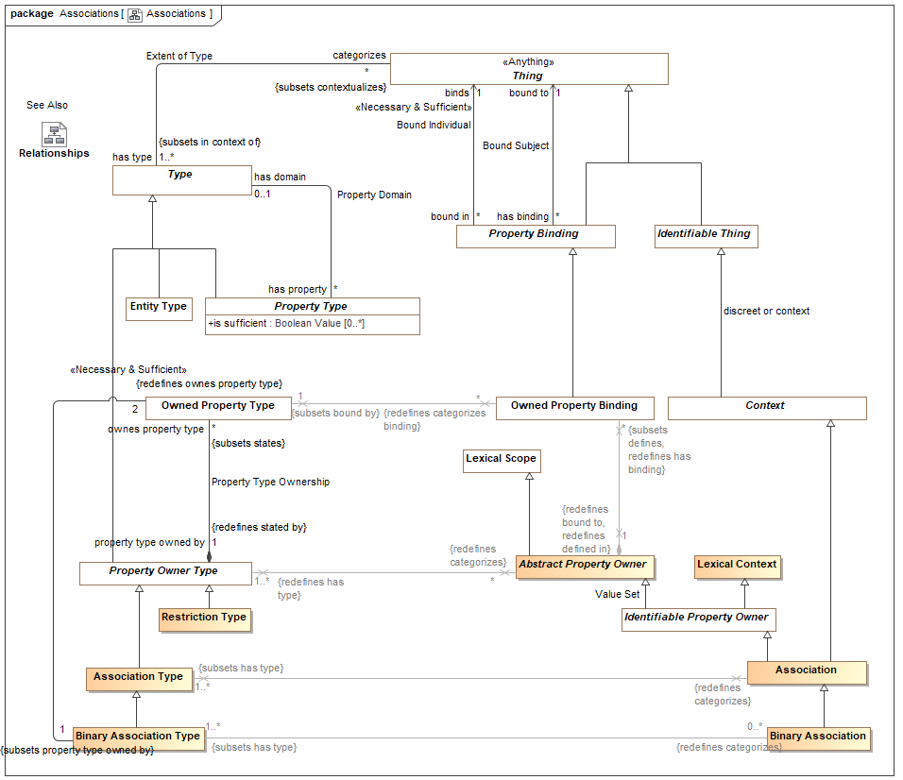

1. Associations

## Class Association

An association makes a logical statement involving related things, the association ends. An association may be asserted within a context as true or false within that context. Each association type has a number of bindings of which are immutable for that association.

An association may be true or false within its context and is atomic in its truth value.

Associations are differentiated from relationships in that associations are not situations - they are not temporal and do not change over time. Associations may be a consequence of relationships or other situations or may be derived from qualities of associated ends.

Associations can "own" owned property bindings as their "ends".

See also: Relationship

[Guizzardi] Intrinsic Relation

[UML] Link

[DOLCE] Formal Relation

[ORM] Fact

Direct Supertypes

Context, Identifiable Property Owner, Situation

## Class Association Type

A type of Association (See Association for details) which defines a set of "Association Property Types" which are the types of association property bindings. Associations are not situations - the are not temporal things. This does not prevent subtypes of associations from being situations.

[Guizzardi] Intrinsic Relation Type

[UML] Association

[OWL] For binary associations, may be considered a pair of properties that are Inverse Object Properties.

[ORM] Fact Type

Direct Supertypes

Property Owner Type

## Class Binary Association

A binary association is an association with exactly 2 property bindings corresponding to exactly 2 owned property types.

Direct Supertypes

Association

Associations

<<Restriction>> : Binary Association Type [1..*] *Subsets*: has type:Type



## Class Binary Association Type

A binary association type is an association type having exactly two owned property types (association ends).

Direct Supertypes

Association Type

Associations

<<Restriction>> : Binary Association [0..*] *Redefines*: categorizes:Thing



: Owned Property Type [2] *Redefines*: ownes property type:Owned Property Type



## Class Restriction Type

A restriction type restricts another type, frequently an association, by holding only constraints. All properties owned by a restriction type must be property restrictions.

Direct Supertypes

Property Owner Type

# Concept Library::Meta Concepts::Constraints

Rules define constraints or behaviors that are asserted in specified context.

## Diagram: General Rules

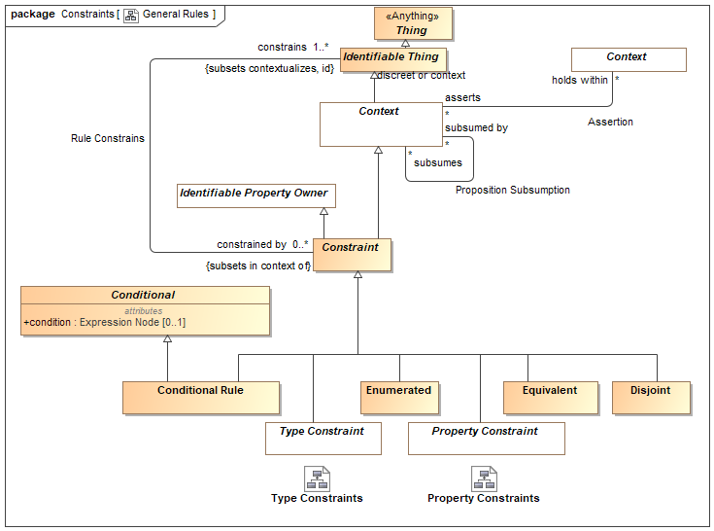

1. General Rules

## Diagram: Property Constraints

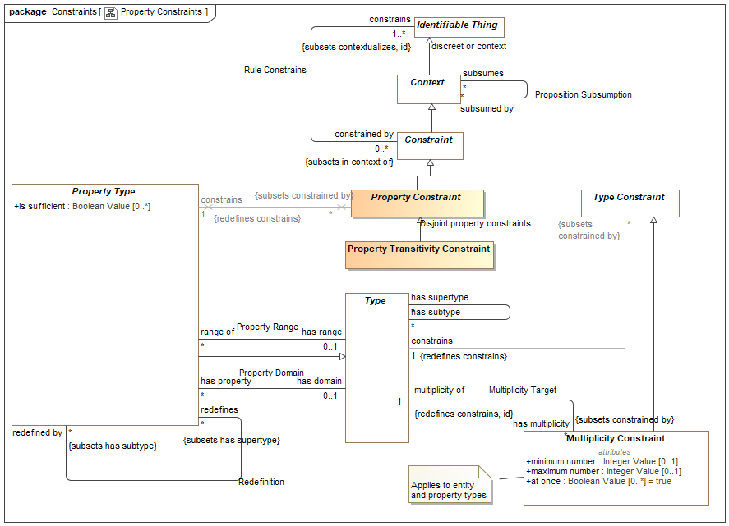

1. Property Constraints

This diagram focuses on rules about properties.

## Diagram: Rules in Context

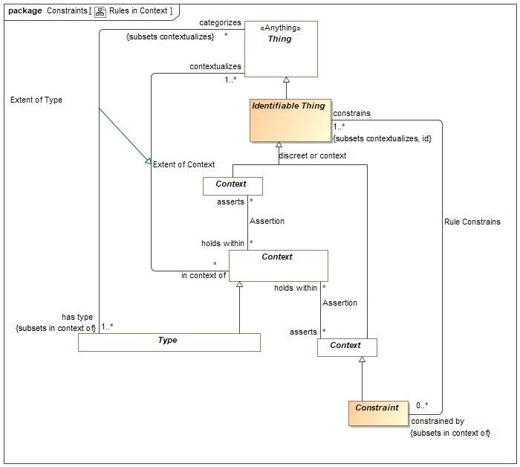

1. Rules in Context

This diagram shows how rules are propositions that may be asserted within any context to apply to any other context, thus realizing the "open world assumption".

## Diagram: Rules Summary

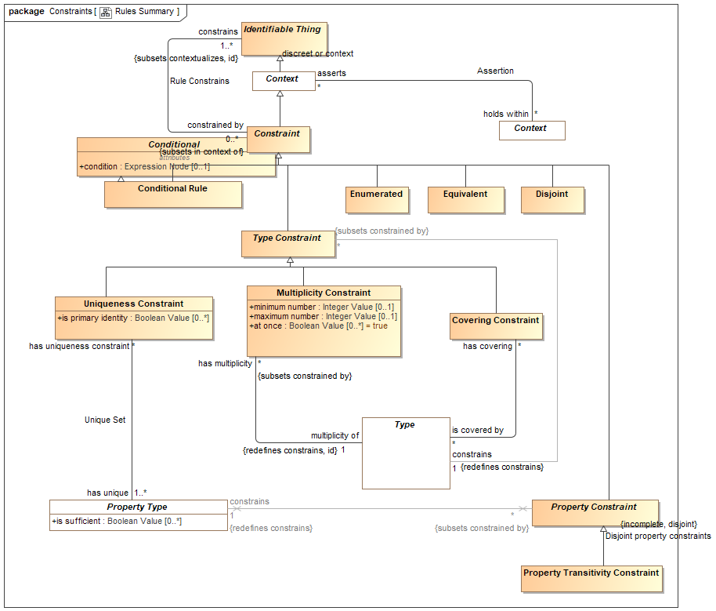

1. Rules Summary

This diagram shown a summary of the primary rules.

## Diagram: Type Constraints

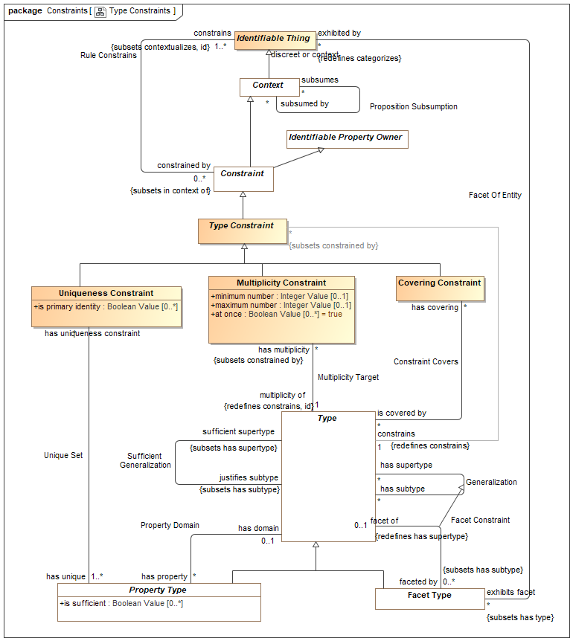

1. Type Constraints

This diagram focuses on rules about types (note that property types are also types).

## Class Conditional

Anything with a condition defined by an expression.

Attributes

condition : Expression Node [0..1]



Condition that must be TRUE for an element to be asserted. All values other than "TRUE" are FALSE.

## Class Conditional Rule

A rule with a general expression as a condition that applies to what the rule <constrains>. Where asserted, the condition must be true.

[UML] Constraint where "context" corresponds with <holds within> and "constrainedElement" corresponds with "constrains". "specification" corresponds with "condition".

Direct Supertypes

Conditional, Constraint

## Class Constraint

A constraint is a rule enumerating a specific set of constrained entities as identified by <constrains>.

Direct Supertypes

Context, Identifiable Property Owner

## Association Constraint Covers

Relationship defining the types covered by a covering constraint.

Association Ends

is covered by : Type [*] *Redefines*: ownes property type: Owned Property Type



A type covered by a covering constraint.

The <constrains> type must be a direct supertype of all <is covered by> types.

has covering : Covering Constraint [*] *Redefines*: ownes property type: Owned Property Type



Covering constraints of a type.

## Class Covering Constraint

A constraint that the extent (<categorizes> things) of the <constrains> type is equivalent to the union of the extents of the <is covered by> types.

[UML] GeneralizationSet with isCovering=TRUE. "constrains" corresponds with the common "general" of each Generalization". "is covered by" corresponds with each "special" of each generalization.

Direct Supertypes

Type Constraint

## Class Disjoint

Disjoint is a rule that the things denoted by what the rule <constrains> do not and may not denote any of the same set of things.

When applied to a context (including types) all elements contextualized are included in the set of disjoint individuals.

[FIBO] Mutually Exclusive sets

[IDEAS] PartitionOfSetOfDisjointIndividuals: A FusionOfSetOfIndividuals whose fusioned Type is a SetOfDisjointIndividuals.

[UML] [UML] GeneralizationSet with isDisjoint=TRUE. "constrains" corresponds with "is covered by" of each "special" of each generalization. Note the SMIF does not require that disjoint elements have a common supertype, one may be inferred for UML mapping.

[OWL: Union(DisjointClasses, DisjointObjectProperties, DisjointDataProperties, DifferentIndividuals)

Direct Supertypes

Constraint

## Class Enumerated

The contextualized elements of the <constrains> context is a closed (enumerated) set, it can not be extended. A.K.A. "Closed World Assumption". Elements may not be asserted by any context other than the one specified in <holds within>.

[FIBO] Selections of Things

[FUML] Wen constraining a type, corresponds with [FUML] "Enumeration". SMIF enumerations are not limited to literals. The "ownedLiteral" corresponds with all elements owned by <holds within>.

[ISO11404] Enumerated: enumerated is a family of datatypes, each of which comprises a finite number of distinguished values having an intrinsic order.

[OWL] ObjectUnitionOf( DataOneOf, ObjectOneOf )

Direct Supertypes

Constraint

## Class Equivalent

Equivalent is a rule that the things the rule <constraints> denote the same set of things. When applied to a context (including types) each thing the context contextualizes is included in the set of equivalent things.

Related to*: [ISO 1087] synonymy: relation between or among terms (3.4.3) in a given language representing the same concept (3.2.1)

Related to*: [ISO 1087] equivalence: relation between designations (3.4.1) in different languages representing the same concept (3.2.1)

* SMIF relates concepts, not terms. synonymy may also be represented by multiple terms for the same concept.

[OWL] Union( SameIndividual, EquivalentClasses, EquivalentObjectProperties, EquivalentDataProperties)

Direct Supertypes

Constraint

## Class Multiplicity Constraint

A Multiplicity constraint constrains the number of bindings <multiplicity of> types (including property types) may have in a particular instance of the constrained type.

For a property type, The number of instances bound to a property for the set of instances bound to <with respect to> shall be limited by the minimum and maximum number of the multiplicity.

For non-property types, the multiplicity shall apply to the extent of the type as described by <classifies>.

[IDEAS] superSubType

[FUML] MultiplicityElement: Note: Multiplicity Constraint constraining a type has semantics included in to UML MultiplicityElement.

[OWL] Union(ObjectMaxCardinality, ObjectMinCardinality, ObjectExactCardinality, DataMaxCardinality, DataMinCardinality, DataExactCardinality)

Direct Supertypes

Type Constraint

Attributes

minimum number : Integer Value [0..1]



Minimum number in a set as constrained by a multiplicity.

[FUML] MultiplicityElement.lowerValue

[OWL] MinCardinality

maximum number : Integer Value [0..1]



Maximum number in a set as constrained by a multiplicity.

[FUML] MultiplicityElement.upperValue

[OWL] maxCardinality

at once : Boolean Value [0..*] = true



When at once is true, the constraint applies for each snapshot in time but not across snapshots (e.g. a car can have at most one driver at a time). When at once is false the constraint applies across all time (e.g. a person has exactly one birth mother across all time).

## Association Multiplicity Target

Relationship defining the type a multiplicity rule applies to. Note that properties are types and may also have multiplicity constraints.

Direct Supertypes

Rule Constrains

Association Ends

multiplicity of : Type [1] *Redefines*: ownes property type: Owned Property Type



The type or property that is the subject of a multiplicity constraint.

has multiplicity : Multiplicity Constraint [*] *Redefines*: ownes property type: Owned Property Type



Multiplicity constraint of a type or property.

## Class Property Constraint

Abstract supertype for constraints that constrain properties types.

Direct Supertypes

Constraint

## Class Property Transitivity Constraint

A transitive property defined by <constrains> interlinks two individuals A and C whenever it interlinks A with B and B with C for some individual B.

For example "larger than" is transitive in that if Joe is larger than Sue and Sue is Larger then Sam, then Joe is larger than Sam.

[OWL] TransitionObjectProperty

Direct Supertypes

Property Constraint

## Association Proposition Subsumption

Relationship defining subsumption of a proposition used as a rule. When a proposition subsumes another the subsumed proposition will not apply (fire) if the <subsumed by> rules applies (fires).

Association Ends

subsumes : Context [*] *Redefines*: ownes property type: Owned Property Type



When a rule subsumes another the subsumed rule will not apply (fire) if the <subsumed by> rules applies (fires).

Where rules are also patterns, a rule may specialize another which will subsume the specialized rule as well as include the generalized rule parts as parts of the specialized rule.

subsumed by : Context [*] *Redefines*: ownes property type: Owned Property Type



When rule is <subsumed by> another the subsumed rule will not apply (fire) if the <subsumed by> rules applies (fires).

## Association Rule Constrains

Relationship defining the entity constrained by a rule. Where no constrained entity is specified, all entities are constrained with the scope of <holds within> are constrained.

Association Ends

constrains : Identifiable Thing [1..*] *Redefines*: ownes property type: Owned Property Type



The entity or entities constrained by a rule.

Where a rule constrains a context, all things contextualized by the context shall be subject to the rule.

Where there are no <constrains> for a rule, the rule applies globally - to the universal context.

constrained by : Constraint [0..*] *Redefines*: ownes property type: Owned Property Type



Rules applying to an entity.

## Class Type Constraint

A constraint of a type, including Relationships types.

Direct Supertypes

Constraint

## Association Unique Set

Relationship defining the set of properties that uniquely identify an instance of the constrained type.

Association Ends

has unique : Property Type [1..*] *Redefines*: ownes property type: Owned Property Type



The set of involved properties within a type that uniquely identify an individual.

has uniqueness constraint : Uniqueness Constraint [*] *Redefines*: ownes property type: Owned Property Type



Uniqueness constraints for a property.

## Class Uniqueness Constraint

A constraint that, within the <constrains> type the rule applies to, the set of instances bound to the set of types in the "has unique" relation must be unique and serves to define the "identity" of each individual.

Note: Uniqueness may be used to define a "key".

[OWL] HasKey where CE (subject class expression) is <constrains> and <has unique> is Union(ObjectPropertyExpression, DataPropertyExpression)

Direct Supertypes

Type Constraint

Attributes

is primary identity : Boolean Value [0..*]



A uniqueness constraint that can be interpreted as a "primary key", the identity of an entity.

# Concept Library::Meta Concepts::Expressions

Expressions define computations across SMIF models.

## Diagram: Expressions

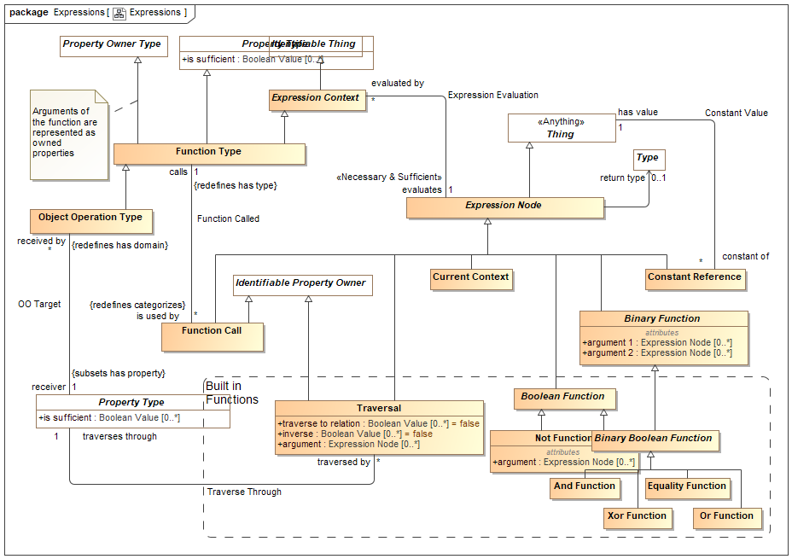

1. Expressions

Expressions define computations

## Class And Function

Direct Supertypes

Binary Boolean Function

## Class Binary Boolean Function

A function returning true or false and having two arguments

Direct Supertypes

Binary Function, Boolean Function

## Class Binary Function

Direct Supertypes

Expression Node

Attributes

argument 1 : Expression Node [0..*]



argument 2 : Expression Node [0..*]



## Class Boolean Function

A function returning true or false

Direct Supertypes

Expression Node

## Class Constant Reference

A calculation that returns a thing identified by <has value>.

[FIBO] Constant

[FUML] LiteralSpecification where subtype of literal is determined by the type of <has value>.

-LiteralInteger->type is Integer or a subtype

-LiteralReal-> type is not integer or a subtype

-LiteralBoolean->type is Boolean

-LiteralString->type is Text

Direct Supertypes

Expression Node

## Association Constant Value

Relationship defining a link to a constant value within an expression.

Association Ends

has value : Thing [1] *Redefines*: ownes property type: Owned Property Type



A constant value referenced in an expression.

constant of : Constant Reference [*] *Redefines*: ownes property type: Owned Property Type



Referencing constant expression node.

## Class Current Context

A proxy for the context in which the expression is evaluated. A.K.A. "This" or "Self".

Direct Supertypes

Expression Node

## Class Equality Function

Returns TRUE if all <has equal> things have the same value or represent the same thing or set of things regardless of how they are represented.

Equality will return TRUE or FALSE.

[ISO11404: EqualityIn every value space there is a notion of equality, for which the following rules hold:

⎯ for any two instances (a, b) of values from the value space, either a is equal to b, denoted a = b , or a is not equal to b, denoted a ≠ b ;

⎯ there is no pair of instances (a, b) of values from the value space such that both a = b and a ≠ b ;

⎯ for every value a from the value space, a = a ;

⎯ for any two instances (a, b) of values from the value space, a = b if and only if b = a ;

⎯ for any three instances (a, b, c) of values from the value space, if a = b and b = c , then a = c . On every datatype, the operation Equal is defined in terms of the equality property of the value space, by:

⎯ for any values a, b drawn from the value space, Equal(a,b) is true if a = b , and false otherwise.

Direct Supertypes

Binary Boolean Function

## Class Expression Context

An abstract element defining the static or dynamic evaluation context and resulting type of an expression.

An expression context that is referenced by another expression context inherits the referencing context by default.

Direct Supertypes

Identifiable Thing

## Association Expression Evaluation

Relationship defining the expression that will be evaluated by an evaluation.

Association Ends

evaluates : Expression Node [1] *Redefines*: ownes property type: Owned Property Type



The expression node "head" an evaluation evaluates.

evaluated by : Expression Context [*] *Redefines*: ownes property type: Owned Property Type



Evaluations of an expression node.

## Class Expression Node

An abstract class representing the computation of a value which is then bound to the context from which it is called. Each expression node has a type of the most general type it can return.

An expression node may reference other elements. Where the other elements are also expression nodes they will be considered part of the referencing expression and evaluated in the context of that expression.

The set of related expression nodes forms a "tree" for evaluation.

All references to an expression node other than as a "Constant Reference" shall return the result of evaluating the expression node.

An evaluation may be used in place of anything that requires the <resulting type> of the evaluation.

[FIBO] Expression

[UML] Expression

Direct Supertypes

Thing

## Class Function Call

An element of an expression that performs some operation based on a function type and produces a result. I.e. plus(a,1).

Arguments are bound to the function call via bindings.

Direct Supertypes

Expression Node, Identifiable Property Owner

## Association Function Called

Relationship defining the function (a type) called by a function call.

Direct Supertypes

Extent of Type

Association Ends

calls : Function Type [1] *Redefines*: ownes property type: Owned Property Type



Function called

is used by : Function Call [*] *Redefines*: ownes property type: Owned Property Type



Function calls using a function declaration.

## Class Function Type

A declaration of a function which performs a calculation on arguments (properties) to produce a result (function result). I.e. the definition of plus(a:Number, b:Number).

Functions are intended to be side-effect free and context free (they only depend on their arguments and don't change anything) but assertions to specify that certain functions are pure may be required,

Note: FUNCTION ARGUMENTS ARE PROPERTIES of the function.

[FUML] Operation where ownedParameter corresponds with <has property> and type corresponds with <resulting type>.

Direct Supertypes

Expression Context, Property Owner Type, Property Type

## Class Not Function

A function returning the complement of its argument.

Direct Supertypes

Boolean Function

Attributes

argument : Expression Node [0..*]



## Class Object Operation Type

An operation bound to a specific "receiver" in the "Object Oriented" sense.

[FUML] Operation

Direct Supertypes

Function Type

## Association OO Target

Relationship defining the "target" type of an object oriented function.

Association Ends

receiver : Property Type [1] *Redefines*: ownes property type: Owned Property Type



The property that is the receiver of an object operation.

[UML] class (of Operation)

received by : Object Operation Type [*] *Redefines*: ownes property type: Owned Property Type



The Object Operation for which a receiver is defined.

## Class Or Function

Direct Supertypes

Binary Boolean Function

## Class Traversal

Traversal from the current <evaluates in> context to another across a relation or other structure.

A traversal is a structure such that the structure's bindings may hold other properties of a traversal constant as independent variables where <traverses through> is the dependent variable. The traversal shall be considered to have the type of the relation it is traversing. Traversing binary relations does not require any bindings.

[OWL] ObjectPropertyChain

Direct Supertypes

Expression Node, Identifiable Property Owner

Attributes

traverse to relation : Boolean Value [0..*] = false



Where traverse to relation is false, the traversal will return the bound element(s) of the <traverses through> property from the current context via any intermediate relationships.

Where traverse to relation is true, the traversal shall return the structure/situation/relationship owning the property binding.

By default, traverse to relation is false.

inverse : Boolean Value [0..*] = false



Indicates that the traversal is defined based on properties that reference the current context. This results in traversing "backwards" across a property to an inverse property or the relation.

argument : Expression Node [0..*]



## Association Traverse Through

Relationship defining the property of the current context which will be traversed.

Association Ends

traverses through : Property Type [1] *Redefines*: ownes property type: Owned Property Type



Property or properties through which a traversal traverses as the dependent variable(s).

traversed by : Traversal [*] *Redefines*: ownes property type: Owned Property Type



Traversals through a property.

## Class Xor Function

Direct Supertypes

Binary Boolean Function

# Concept Library::Meta Concepts::Facets

The facet package defines facets, roles and phases. Types that "mix in" to other types in a specific context or timeframe.

## Diagram: Facets

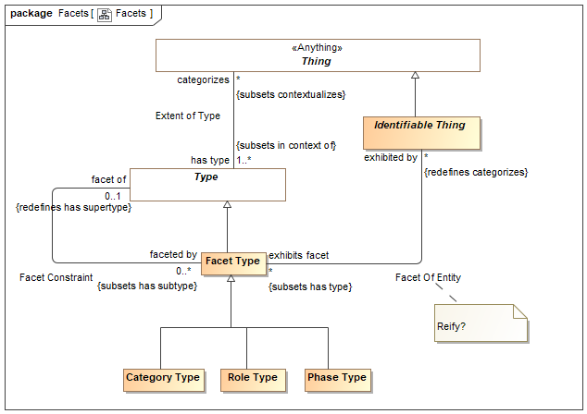

1. Facets

## Class Category Type

A category is a classification or division of people, events or things regarded as having particular shared characteristics. Categorization is typically contextual, potentially transient and may or may not be formally defined.

As with all facets, categories are non-rigid. Something classified by a category must also be classified by an entity type.

Direct Supertypes

Facet Type

## Association Facet Constraint

A Facet Constraint specifies a possible a "mix in" or "non rigid" classification of an entity beyond any fundamental entity type. The must common kinds of facets are roles and phases. Note that the UML profile also specifies subtypes of <<Facet Of>> that are syntactic sugar for facet classification.

The type of individual a facet can apply to may be specified using a facet classification. Note that Facets . A facet classification may be contextual, such as within a relation, situation and/or time frame. Instances may have any number of types and classifications may change over time.

A <<Sufficient>> property is typically used to specify the mediating concept the facet is with respect to.

There are various implementation strategies for facets including multiple classification and dependent objects. SMIF does not commit to any particular implementation strategy.

Direct Supertypes

Generalization

Association Ends

facet of : Type [0..1] *Redefines*: ownes property type: Owned Property Type



faceted by : Facet Type [0..*] *Redefines*: ownes property type: Owned Property Type



## Association Facet Of Entity

Facet of Entity is a first-class relationship defining a facet of an entity. As a relationship the application of the facet to the entity may be time and context specific. The entity will have the type of the identified facet. Properties and relationships specific to the entity exhibiting a facet, if required, may utilize a subtype of Entity Of Facet.

For example, a Person may play the "Parent" role for multiple children and there may be properties and relationships relative to this generic parent role. If it is required to specify properties and relationships specific to the person being a parent of a specific child, a subtype of Facet Of Entity is used.

Direct Supertypes

Extent of Type

Association Ends

exhibits facet : Facet Type [*] *Redefines*: ownes property type: Owned Property Type



The facet that an entity assumes when it is the facet of an entity.

[FIBO] (for roles) playsRole

exhibited by : Identifiable Thing [*] *Redefines*: ownes property type: Owned Property Type



Type of the entity exhibiting the facet.

## Class Facet Type

A facet is a "mix in" type that defines an aspect of something but does not define the identity or "fundamental" (A.K.A. "Rigid") type of that thing, but some potentially transient role, phase or other way to classify it. Something must have at least one type that is not a facet to define that things identity.

Facets do not define independent identity of the referent but technology implementations may create independent objects to represent a facet.

An instance of a facet must also have a type that is not a facet to provide the identity of the instance.

The type(s) a facet may categorize may be constrained by a Facet Generalization Constraint. E.g. Policeman is a role of a person.

[Guarino1994] Non-Substantial sortal

[Guizzard] Non-Rigid Universal: A universal G is non-rigid iff for a w ∈ W There is an x such that x ∈ extw(G), and there is a w∈ W such that x ∉extw(G)

[SOWA1999] Prehension (Relative

Direct Supertypes

Type

## Class Phase Type

A phase (or state) is a static characteristic of something that exists for limited time(s). Something takes on or looses a phase as a result of some event. E,g, Teenager, living, closed invoice.

A Phase is a situation in that there is a situation coincident with each phase.

[Guizzardi] (Phased-Sortal): Let PS be a universal and let S be a

substance sortal specialized (restricted by) PS. Now, let extw(~PS) = extw(S) \ extw(PS)

be the complement of the extension of PS in world w. In this formula, the

symbol \ represents the set theoretical operation of set difference. The

universal PS is a phased-sortal iff for all worlds w ∈ W, there is a w ∈ W such

that extw(PS) ∩ extw(~PS) ≠ ∅

Direct Supertypes

Facet Type

## Class Role Type

A role is a facet type that defines a specific purpose or behavior of a class of things. E.g. teacher, policeman, or employer.

[FIBO] Role. Note that partyInRole or thingInRole are implied by classification of a thing.

Direct Supertypes

Facet Type

# Concept Library::Meta Concepts::Identifiers

Terms and identifiers provide for signs for (ways to identify) anything.

## Diagram: Identifier Summary

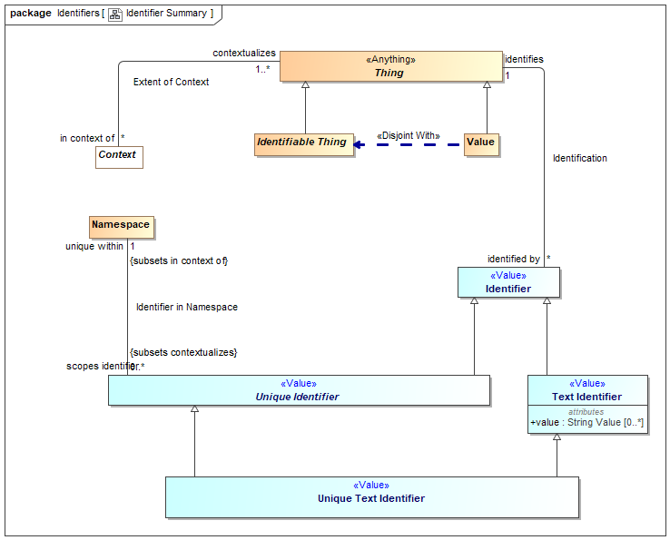

1. Identifier Summary

## Diagram: Identifiers

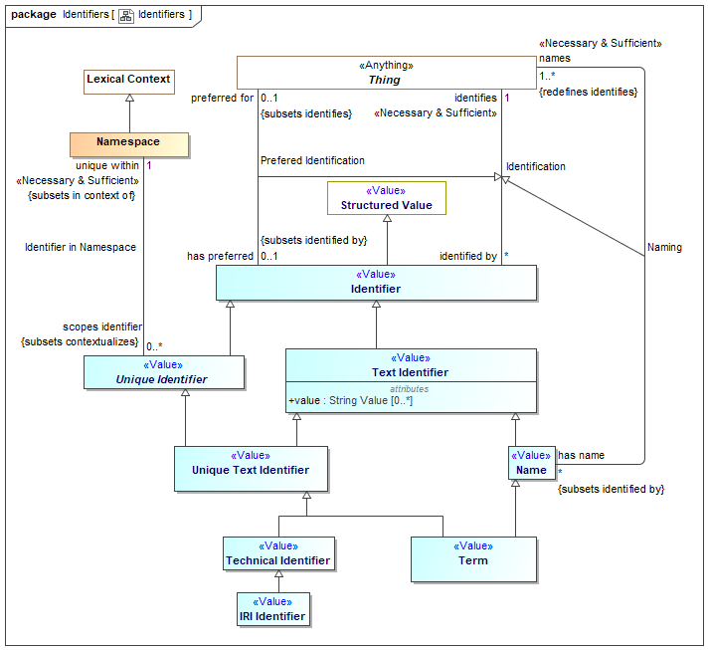

1. Identifiers

An identifier that can be represented as text. The text is in the "value" property.

[IDEAS] Sign: An Individual that signifies a Thing.

## Association Identification

Relationship defining an identifier for an entity.

[IDEAS] namedBy: A couple that asserts that a Name describes a Thing.

[ISO 1087] Designation

Association Ends

identifies : Thing [1] *Redefines*: ownes property type: Owned Property Type



The entity an identifier identifies.

[FIBO] identifies: is the relationship between something and that which provides a unique reference for it

[ISO 1087] designator: representation of a concept (3.2.1) by a sign which

denotes it

identified by : Identifier [*] *Redefines*: ownes property type: Owned Property Type



An identifier for an <Entity>.

[FIBO] hasDenotation

## Class Identifier <<Value>>

An identifier is any value that is used to distinguish an entity from other entities. Note that any identifier may be contextualized by one or more context, including language context. Identifiers are a “sign” for an identity where identity is an abstraction of individuality that is the basis for identifiers.

[IDEAS] Name: A Representation that identifies a Thing.

[FIBO] Identifier

[CL] Term: expression which denotes an individual, consisting of either a name or, recursively, a function term applied to a sequence of arguments, which are themselves terms

Direct Supertypes

Structured Value

## Association Identifier in Namespace

Relationship defining the namespace within which a unique identifier is defined and unique.

[ISO 1087] monosemy: relation between designations (3.4.1) and concepts (3.2.1) in a given language in which one designation only relates to one concept

Direct Supertypes

Extent of Context

Association Ends

unique within : Namespace [1] *Redefines*: ownes property type: Owned Property Type



The namespace in which an identifier is defined and has a unique value.

[FUML] memberNamespace

scopes identifier : Unique Identifier [0..*] *Redefines*: ownes property type: Owned Property Type



An Identifier defined within the scope of a namespace.

[FUML] member

## Class IRI Identifier <<Value>>

A IRI/URI Identifier for an entity, as defined in [RFC3987].

[FIBO] anyURI

Direct Supertypes

Technical Identifier

## Class Name <<Value>>

A word or set of words by which a person, animal, place, or thing is known, addressed, or referred to. Names are not necessarily unique.

[IDEAS] Name: A Representation that identifies a Thing.

[CL] Discourse Name

Direct Supertypes

Text Identifier

## Class Namespace

A namespace is a context that provides a way to make identifiers unique and identify exactly one entity. For example, the Virginia driver's license division provides unique driver's license numbers.

Similar to [IDEAS] UniqueNamingScheme: A NamingScheme where different Names will not contain tokens of the same Representation Type.

Note: SMIF identifiers are not instances of their namespace.

[FIBO] IdentificationScheme: system for allocating identifiers to objects

[ISO 1087] terminology 1: set of designations (3.4.1) belonging to one special language (3.1.3)

[FUML] Namespace

[CL] Vocabulary

Direct Supertypes

Lexical Context

## Association Naming

Relationship defining a human meaningfully name for an entity.

Direct Supertypes

Identification

Association Ends

names : Thing [1..*] *Redefines*: ownes property type: Owned Property Type



An entity named by a name.

has name : Name [*] *Redefines*: ownes property type: Owned Property Type



A human meaningful name for an entity.

[FIBO] hasName: that by which some thing is known; may apply to anything

[OWL] rdfs:label

## Association Prefered Identification

Relationship defining the preferred identifier for an entity.

[ISO 1087] preferred term: term (3.4.3) rated according to the scale of the term acceptability rating (3.4.14) as the primary term for a given concept (3.2.1)

Direct Supertypes

Identification

Association Ends

has preferred : Identifier [0..1] *Redefines*: ownes property type: Owned Property Type



Default identifier to use for an entity.

Where multiple identifiers are preferred in differing context any method for selecting the most preferred identifier is implementation specific and not specified by this standard.

[FUML] NamedElement.name: Note: An Identifier that is <preferred for> an entity is equivalent to the name of a named element.

preferred for : Thing [0..1] *Redefines*: ownes property type: Owned Property Type



The entity an identifier is preferred for.

## Class Technical Identifier <<Value>>

A technical identifier is defined within a technical system, information structure or system of systems for references and identity within that system or information element. Such identifiers may have no meaning outside of that system.

Typical technical identifiers include inter document "refs", record numbers, etc. The system should be referenced as the namespace.

Direct Supertypes

Unique Text Identifier

## Class Term <<Value>>

A word, phrase or name used by stakeholders to uniquely identify entities.

[ISO 1087] term: verbal designation of a general concept in a specific subject field.

Direct Supertypes

Name, Unique Text Identifier

## Class Text Identifier <<Value>>

A code or other simple value that can be represented as text, identifying something that may or may not be unique. Simple identifiers may be codes, names, numbers or compound values.

[NIEM] IdentificationType (IdentificationID=value)

Direct Supertypes

Identifier

Attributes

value : String Value [0..*]



Text value of an identifier

## Class Unique Identifier <<Value>>

A unique identifier is an entity used to uniquely identify something. The identified thing is referenced by what the identifier <identifies>.

Identifiers are defined and <unique within> a lexical scope as its namespace.

Multiple identifiers may use the same word or text value (or other forms of values) in differing <unique within> namespaces such that the same word may have different meanings in different context.

An entity may have any number of identifiers.

Direct Supertypes

Identifier

## Class Unique Text Identifier <<Value>>

An <Identifier> that is represented using text. e.g. a "word", "phrase" or "name".

Direct Supertypes

Text Identifier, Unique Identifier

# Concept Library::Meta Concepts::Lexical Scope

Lexical scope defines the structure of models and the ownership of model elements.

## Diagram: Lexical Scope

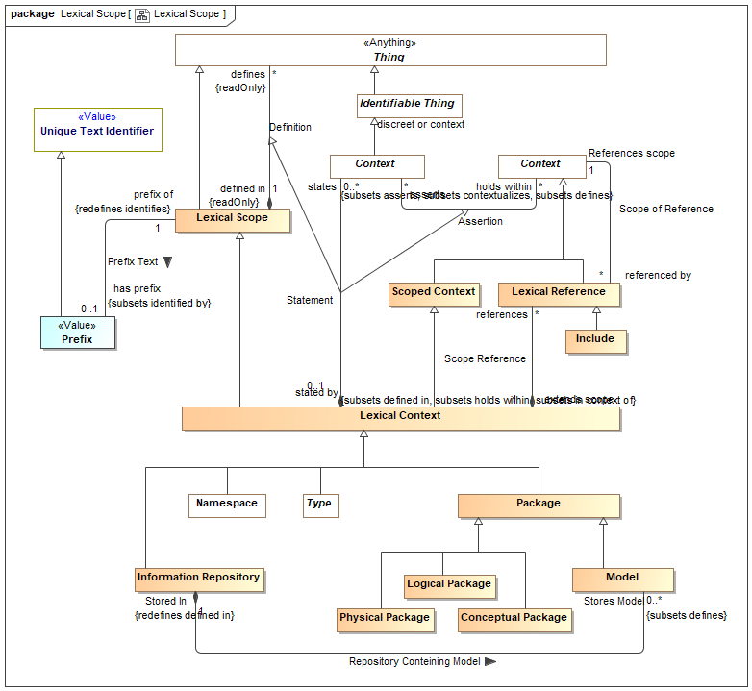

1. Lexical Scope

## Class Conceptual Package

A model of a real or possible world as conceived by the model authors.

Direct Supertypes

Package

## Association Definition

Relationship defining the set of elements defined within a lexical scope.

[OWL] RDF Graph

Association Ends

defines : Thing [*] *Redefines*: ownes property type: Owned Property Type



A model element defined within a lexical scope.

Definition within a scope does not assert everything within a scope but the lexical scope may be independently asserted, thus asserting what it defines.

[FUML] ownedElement, ownedMember

defined in : Lexical Scope [1] *Redefines*: ownes property type: Owned Property Type



Lexical scope defining model elements.

[UML]owner

## Class Include

An "Include" is an external scope that is visible and asserted by the owning lexical scope.

[FUML] PackageImport

[CL] Importation: An importation contains a name. The intention is that the name identifies a piece of Common Logic content represented externally to the text, and the importation re-asserts that content in the text.

Direct Supertypes

Lexical Reference

## Class Information Repository

An information repository is a resource that can store (directly or indirectly) information content, including models.

Typical information repositories are directories and file servers.

Direct Supertypes

Lexical Context

## Class Lexical Context

Lexical context represents a lexical scope that is also a context - asserting the contained elements

Direct Supertypes

Lexical Scope, Scoped Context

## Class Lexical Reference

A Lexical Reference is an external scope that is visible to but not necessarily asserted by the owning lexical scope.

Direct Supertypes

Context

## Class Lexical Scope

Lexical scope represents model content (the lexical structure of the model) that then models an area of concern. A lexical scope may define model elements representing anything.

[CL] Text: A text is a set, list, or bag of phrases. A piece of text shall optionally be identified by a name.

[OWL] Potential scope of a RDF graph defined by <defines>

Direct Supertypes

Thing

## Class Logical Package

A model of information about systems independent of technical representation.

Direct Supertypes

Package

## Class Model

A root package. A model has no owner and may be directly referenced as an independent information resource. A model is defined in it's self.

Direct Supertypes

Package

## Class Package

A model element that provides a definitional scope for other model elements. A package may be represented as a "graph".

[ISO 1087] concept system: system of concepts set of concepts (3.2.1) structured according to the

relations among them

[FUML] Package. FUML ownedMember corresponds with SMIF <defines>. FUML "nestedPackage" corresponds with "defines" where the element defined is a package.

[CL] Module: A module consists of a name, an optional set of names called the exclusion set, and a text called the body text.

Direct Supertypes

Lexical Context

## Class Physical Package

A physical, technology specific, data schema representing information about a real or possible world.

Direct Supertypes

Package

## Class Prefix <<Value>>

A technical abbreviation for a package.

Direct Supertypes

Unique Text Identifier

## Association Prefix Text

Relationship defining the prefix for a package.

Direct Supertypes

Identification

Association Ends

has prefix : Prefix [0..1] *Redefines*: ownes property type: Owned Property Type



An abbreviation that can be used to identify a package.

prefix of : Lexical Scope [1] *Redefines*: ownes property type: Owned Property Type



An abbreviation for a lexical context, including packages and models.

## Association Repository Conteining Model

Association Ends

Stores Model : Model [0..*] *Redefines*: ownes property type: Owned Property Type



Stored In : Information Repository [1] *Redefines*: ownes property type: Owned Property Type



## Association Scope of Reference

Relationship defining internal or external context that are referenced by a lexical scope using a lexical reference.

Association Ends

References scope : Context [1] *Redefines*: ownes property type: Owned Property Type



A referenced context, potentially in another model, that provides visibility to the elements in that context.

[FUML] importedPackage

[OWL] directlyImports (implies "Include")

referenced by : Lexical Reference [*] *Redefines*: ownes property type: Owned Property Type



References to a context.

## Association Scope Reference

Relationship defining references for a scope.

Association Ends

references : Lexical Reference [*] *Redefines*: ownes property type: Owned Property Type



A reference providing visibility of a lexical scope to an internal or external context.

extends scope : Lexical Context [1] *Redefines*: ownes property type: Owned Property Type



A lexical scope that is extended by a lexical reference.

[FUML] importingNamespace

## Association Statement

Relationship defining the set of elements defined within and asserted by a lexical scope.

Direct Supertypes

Assertion, Definition

Association Ends

states : Context [0..*] *Redefines*: ownes property type: Owned Property Type



<states> combines <defines> with <has assertion> to both define and assert an element within a lexical scope. <states> provides a more "structural" organization of concepts that are both defined and asserted in the same structure.

<states> is a convenience for the common case where assertion and lexical containment are combined.

stated by : Lexical Context [0..1] *Redefines*: ownes property type: Owned Property Type



<stated by> is a lexical scope that both defines and asserts a model element.

# Concept Library::Meta Concepts::Mapping

Mapping rules define how data represents concepts or how different data representations are related.

## Diagram: Facades

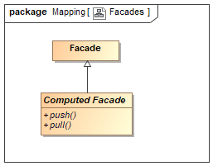

1. Facades

## Diagram: Mapping Rules

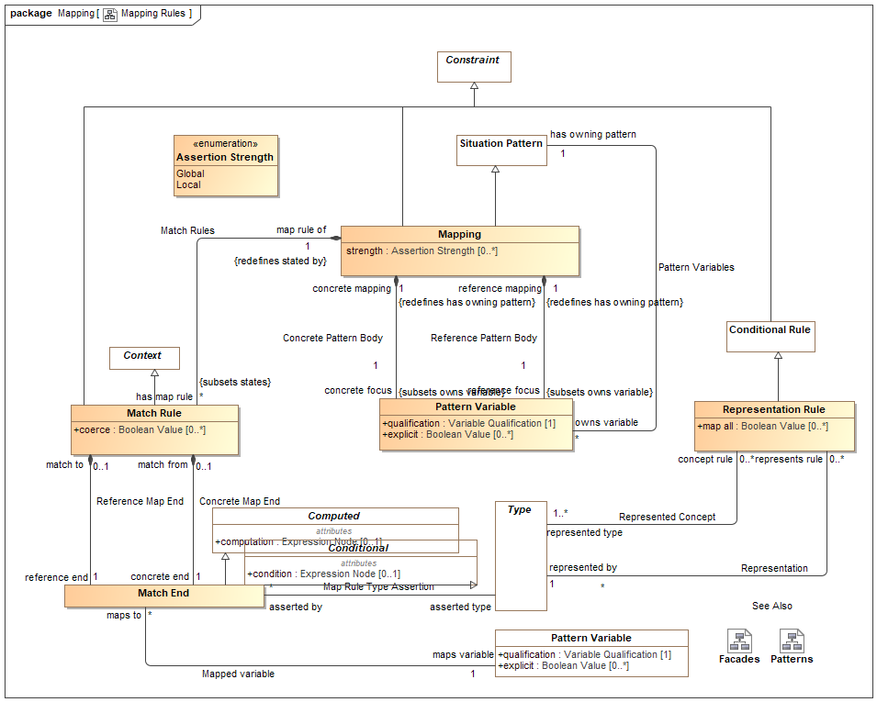

1. Mapping Rules

## Class Computed Facade

A facade that is computed by calling external methods.

Direct Supertypes

Facade

Operations

public push ()



An operation called to evoke the behavior associated with a new facade element being created or modified. Push asserts the more concrete type based on a reference type.

public pull ()



An operation called to evoke the behavior associated with a facade representing existing elements. Pull asserts the reference type based on a more concrete type.

## Association Concrete Map End

Relationship to the more concrete end of a match rule.

Association Ends

concrete end : Match End [1] *Redefines*: ownes property type: Owned Property Type



One end of a mapping, to be used for more concrete end.

match from : Match Rule [0..1] *Redefines*: ownes property type: Owned Property Type



Mapping rule owning a "concrete" end.

## Association Concrete Pattern Body

Relationship between a mapping and a pattern of the more concrete concepts to be mapped.

Association Ends

concrete focus : Pattern Variable [1] *Redefines*: ownes property type: Owned Property Type



The variable or variables that form the basis for the portion of the pattern for the more concrete (physical) model. The concrete portion of the pattern is derived from the transitive closure of all variables reachable from the pattern variable via characteristics, associations or relationships.

When a pattern matching the set of concrete variables is created or altered the mapping "fires" and the reference pattern is asserted.

The qualification of the referenced variable is constrained to be ""select".

concrete mapping : Mapping [1] *Redefines*: ownes property type: Owned Property Type



Mapping for which a more concrete pattern is defined.

## Class Facade

An intermediary data type used to hold common mappings. Facades may be computed and/or have mapping rules.

## Association Map Rule Type Assertion

Relationship defining more concrete types that shall be asserted for an end of a match rule.

Association Ends

asserted type : Type [*] *Redefines*: ownes property type: Owned Property Type



Type that will be asserted for the end that is more concrete than the defined type of a property or relationship. e.g. a unit type.

asserted by : Match End [*] *Redefines*: ownes property type: Owned Property Type



Map rule and that asserts a type

## Association Mapped variable

Relationship defining the property that is the source or target of a mapping

Association Ends

maps variable : Pattern Variable [1] *Redefines*: ownes property type: Owned Property Type



Variable that defines a set of elements to map to the other side of the mapping rule. The set of elements shall be those bound to the property on evaluation of the mapping.

maps to : Match End [*] *Redefines*: ownes property type: Owned Property Type



Map rule end for a property

## Class Mapping

A mapping is a rule based on a pattern that defines how different representations of the same things correspond. There are two "sub patterns", defined by the concrete and reference variables and other variables reachable from them via characteristics, associations and relationships. These sub-patterns are matched (made to correspond) using "Match Rules"

Patterns define a set of related elements to be mapped based on two distinguished variables, the "concrete body" and the "reference body".

Types in a "concrete" body may be defined to be a representation (data about) a concept in a "reference" pattern.

Match rules define how elements in each of the sub-patterns are mapped, bidirectionally.

A mapping utilizing more specific types subsumes maps for more general types.

Note that the roles of "concrete" and "reference" may or may not reflect different levels of abstraction and in some cases the choice may be arbitrary.

Direct Supertypes

Constraint, Situation Pattern

Attributes

strength : Assertion Strength [0..*]



Strength defines what will cause a rule to be considered for being asserted (firing).

## Class Match End

One end of a mapping from one thing to another that may be qualified with a condition.

The set of elements to be mapped is the union of the sets of all mapped types and mapped variables that conform to the condition.

Match rules are constrained to apply to only conforming types or types that represent the mapped ends (as specified by a representation rule).

Representation rules applied to a supertype apply to a subtype unless a more specific representation rule is specified for the corresponding types.

Direct Supertypes

Computed, Conditional

## Class Match Rule

A rule that the 2 ends represent the same things or information about a thing.

Redundant mappings are ignored and identity is preserved across all mappings.

Direct Supertypes

Constraint, Context

Attributes

coerce : Boolean Value [0..*]



Where <coerce> has a value of TRUE a map rule will be evaluated even if the <reference end> is not type compatible with the <concrete end> type.

Where <coerce> is FALSE or unstated a map rule will be evaluated only if the <reference end> is type compatible with the <concrete end> type.

Type compatible shall be defined as one of: Being the same type, <concrete end> being a subtype of <reference end> (as defined by a type generalization rule), <concrete end> being a representation of <reference end> (as defined by a representation rule).

Representation rules applied to a supertype apply to a subtype.

## Association Match Rules

Relationship defining the match rules for a mapping.

Direct Supertypes

Statement

Association Ends

has map rule : Match Rule [*] *Redefines*: ownes property type: Owned Property Type



Map rule that is asserted by a mapping.

map rule of : Mapping [1] *Redefines*: ownes property type: Owned Property Type



Mapping containing a map rule.

## Association Reference Map End

Relationship to the reference end of a match rule.

Association Ends

reference end : Match End [1] *Redefines*: ownes property type: Owned Property Type



One end of a match rule, to be used for more abstract end.

match to : Match Rule [0..1] *Redefines*: ownes property type: Owned Property Type



Mapping rule owning a reference" end.

## Association Reference Pattern Body

Relationship between a mapping and a pattern of the more abstract concepts to be mapped.

Association Ends

reference focus : Pattern Variable [1] *Redefines*: ownes property type: Owned Property Type



The variable or variables that form the basis for the portion of the pattern for the more abstract/reference (conceptual) model. The reference portion of the pattern is derived from the transitive closure of all variables reachable from the pattern variable via characteristics, associations or relationships.

When a pattern matching the set of reference variables is created or altered the mapping "fires" and the concrete pattern is asserted.

The qualification of the referenced variable is constrained to be ""select".

reference mapping : Mapping [1] *Redefines*: ownes property type: Owned Property Type



Mapping for which a more abstract pattern is defined.

## Association Representation

More concrete type that represents information about the represented concept of a representation rule.

Association Ends

represented by : Type [1] *Redefines*: ownes property type: Owned Property Type



The representation of a concept in a more specific form

represents rule : Representation Rule [0..*] *Redefines*: ownes property type: Owned Property Type



Rule defining a representation of a type.

## Class Representation Rule

A representation rule states that the <represented type> has a representation defined by the <represented by> type.

Representation rules are used to filter Map Rules such that only represented concepts may be mapped.

A representation is usually complimented with one or more mapping rules.

Direct Supertypes

Conditional Rule

Attributes

map all : Boolean Value [0..*]



Specifies a direct mapping between instances of the types in both directions.

<map all> is equivalent to a mapping with a rule mapping properties of each type but is lower precedence than other mappings - if types have a more specific map it will apply first.

## Association Represented Concept

More abstract type that is <represented by> a more concrete type of a representation rule.

Association Ends

represented type : Type [1..*] *Redefines*: ownes property type: Owned Property Type



A more general or abstract concept that is being represented.

concept rule : Representation Rule [0..*] *Redefines*: ownes property type: Owned Property Type



Rule defining a concept that is represented by another, more concrete, concept.

### Enumeration Assertion Strength

Rule strength defines what will cause a rule to be considered for being asserted (firing).

package Concept Library::Meta Concepts::Mapping

public enum Assertion Strength

{Global, Local}

Literals

Global



The rule will be in effect globally.

Local



The rule will only be in effect if required to fulfill another rule.

Known other enumerations

Enumeration Assertion Strength

# Concept Library::Meta Concepts::Metadata

Metadata defines data about model elements (their source, definition or trust), which can be differentiated from model elements about the subject domain.

## Diagram: Metadata

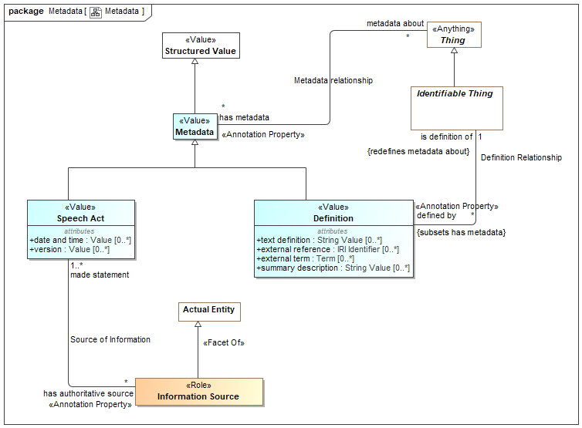

1. Metadata

## Class Definition <<Value>>

An informal or natural language definition of a something and potentially a reference to external definitions.

A Definition may be in the context of a natural language to scope the language it is expressed in.

[ISO 1087] definition: representation of a concept (3.2.1) by a descriptive statement which serves to differentiate it from related concepts

[FUML] Comment (where body corresponds with "text definition").

Direct Supertypes

Metadata

Attributes

text definition : String Value [0..*]



Text describing a something in natural language. The language may be indicated by a context of the definition.

[OWL] rdfs:comment

external reference : IRI Identifier [0..*]



A reference to an external information resource that further defines something.

[FIBO] ReferenceDOcument

external term : Term [0..*]



Specific term in an external resource that further defines something.

summary description : String Value [0..*]



A short description of something.

## Association Definition Relationship

Relationship between a thing and its definitions.

Direct Supertypes

Metadata relationship

Association Ends

is definition of : Identifiable Thing [1] *Redefines*: ownes property type: Owned Property Type



Some thing described by a definition.

[FIBO] defines

[FUML]annotatedElement

defined by : Definition [*] *Redefines*: ownes property type: Owned Property Type



An informal description of something.

[FIBO] hasDefinition

[UML] comment

[FUML] ownedComment

## Class Information Source <<Role>>

Metadata defining the origin or provenance of a set of statements in a model or data.

Note that the source could be a human, an organization, a mapping or other automated processes.

Direct Supertypes

Actual Entity

## Class Metadata <<Value>>

Information about the source, provenance or origin of information. Metadata may be a managed entity, providing for provenance.

[NIEM] MetadataType

Direct Supertypes

Structured Value

## Association Metadata relationship

Relationship between something and metadata about that thing; data about data.

[OWL] AnnotationAssertion

Association Ends

metadata about : Thing [*] *Redefines*: ownes property type: Owned Property Type



The subject of metadata, the entity described by the metadata.

[OWL] annotationSubject of Annotation Assertion

has metadata : Metadata [*] *Redefines*: ownes property type: Owned Property Type



Metadata associated with (data about the information concerning) the subject entity.

[OWL] AnnotationProperty, annotationValue of Annotation Assertion

## Association Source of Information

Relation defining an entity making a statement represented within a model. E.g. the person or organization that made a statement.

[ISO 1087] source identifier: information in a terminological entry (3.8.2) which indicates the source documenting the terminological data (3.8.1)

Association Ends

made statement : Speech Act [1..*] *Redefines*: ownes property type: Owned Property Type



Metadata representing statements made by an authoritative source.

Sources may be people, organizations, documents, information systems, etc.

has authoritative source : Information Source [*] *Redefines*: ownes property type: Owned Property Type



Metadata representing the authority behind a statement - who or what made a statement captured in a model.

## Class Speech Act <<Value>>

Statements provide metadata as to the source of information - who or what said it.

This source of the information may be captured using "InformationSource" metadata about the metadata.

[ISO11404] provision that conveys information

Direct Supertypes

Metadata

Attributes

date and time : Value [0..*]



Metadata representing the date and time the statement was made or modified.

version : Value [0..*]



Metadata representing an identifier for a version of information.

# Concept Library::Meta Concepts::Patterns

Patterns are templates for structures or compositions of things that may then be expressed as instances of the pattern.

## Diagram: Patterns

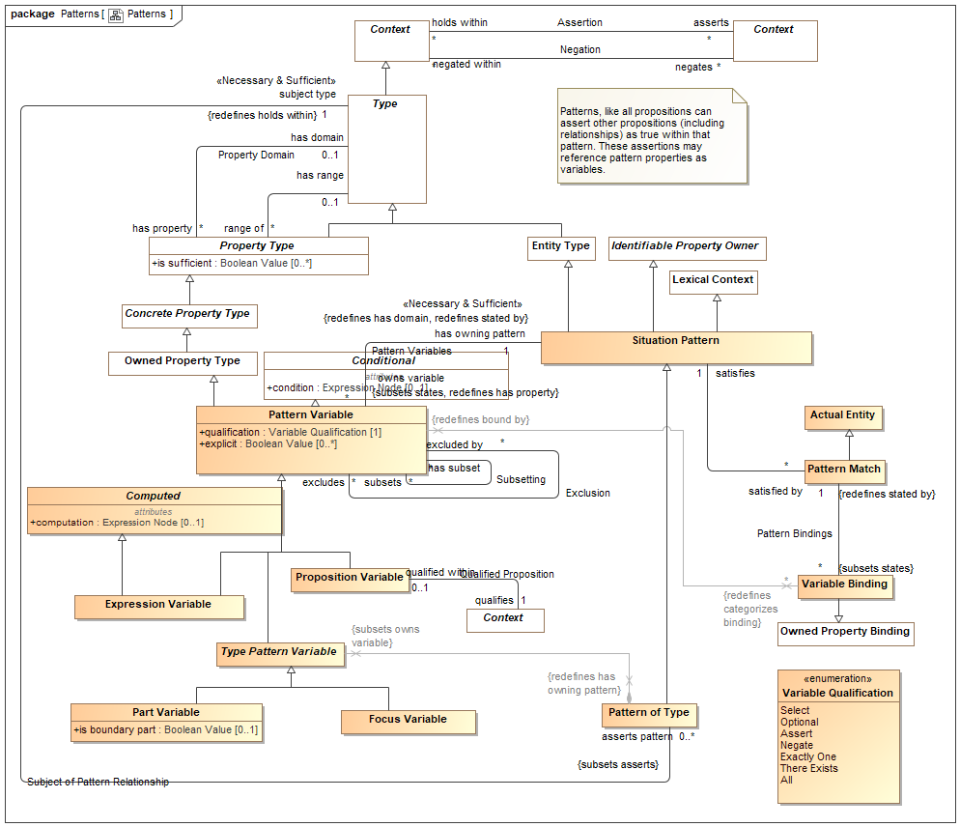

1. Patterns

## Class Computed

Attributes

computation : Expression Node [0..1]



<computation> provides an expression that computes a value for the variable based on the expression applied to the current context..

## Association Exclusion

Association Ends

excluded by : Pattern Variable [*] *Redefines*: ownes property type: Owned Property Type



excludes : Pattern Variable [*] *Redefines*: ownes property type: Owned Property Type



## Class Expression Variable

An expression variable defines the value of the variable as computed by <computation>. Note that expression variables are not always able to be asserted or reversed and may therefore not provide for bi-directional mapping patterns. Any ability to assert or reverse a computation is implementation specific.

Direct Supertypes

Computed, Pattern Variable

## Class Focus Variable

A property variable of a pattern representing the extent of the subject type within the context of the owning pattern.

The value of qualification shall be "Select".

The <has type> of the variable is asserted be the same as the subject type of the pattern.

Direct Supertypes

Type Pattern Variable

## Class Part Variable

A pattern property variable representing a part of the subject type. Additional relations and rules may be made about the part. A type with parts is by its nature a composition.

Direct Supertypes

Type Pattern Variable

Attributes

is boundary part : Boolean Value [0..1]



True if the property is on the boundary of the pattern and connectible (may have relationships) external to the pattern. e.g. "Port"

## Association Pattern Bindings

Association Ends

: Variable Binding [*] *Redefines*: ownes property type: Owned Property Type



: Pattern Match [1] *Redefines*: ownes property type: Owned Property Type



## Class Pattern Match

A pattern match provides the corespondents between a pattern and the situations it matches using variable bindings.

A pattern match implies and proves that the pattern <categorizes> the situation.

The matched pattern <states> any consequences of the matching, such as the pattern <categorizes> the pattern instance.

Direct Supertypes

Actual Entity

## Association Pattern Matches

Association Ends

satisfies : Situation Pattern [1] *Redefines*: ownes property type: Owned Property Type



Pattern that is satisfied by a "Pattern Match" based on a set of "Variable Bindings".

satisfied by : Pattern Match [*] *Redefines*: ownes property type: Owned Property Type



Pattern match that satisfies a pattern.

## Class Pattern of Type

A pattern of type defines a set of properties and relationships that must hold true for all instances of a type. Where the pattern includes parts, the subject type is a composition.

Patterns augment the semantics of th subject type in the context of the pattern.

Direct Supertypes

Situation Pattern

## Class Pattern Variable

A pattern variable is a property of a pattern that provides a contextual property within that pattern for rules and relationships to be bound to.

A pattern variable is a placeholder for all or a subset of the instances of the variables type.

Properties of an association or relationship may be bound to a pattern variable where the type of the pattern variable is compatible with the type of the relationship's property type.

[UML] Similarity with TemplateParameter

[CL] Functional Term

[Devlin] Parameter

Direct Supertypes

Conditional, Owned Property Type

Attributes

qualification : Variable Qualification [1]



<qualification> defines the behavior of an element with respect to a pattern - how the variable impacts the selection, evaluation or assertion of the pattern.

explicit : Boolean Value [0..*]



If true, Element must be explicitly asserted as the indicted type, not derived or inferred from a supertype or super property.

## Association Pattern Variables

Relationship defining variable properties within a pattern.

Direct Supertypes

Statement

Association Ends

owns variable : Pattern Variable [*] *Redefines*: ownes property type: Owned Property Type



A variable property defined within the context of a pattern that is used as part of the patterns definition.

[UML] ownedAttribute

has owning pattern : Situation Pattern [1] *Redefines*: ownes property type: Owned Property Type



Pattern owning a pattern variable.

## Class Proposition Variable

A proposition variable utilizes some proposition (e.g. relationships) as a part of the definition of a pattern, it extends a basic proposition in that it adds properties to determine the effect the assertion has on pattern instances.

A Proposition Variable is a lexical scope context that <asserts> or <negates> other propositions qualified by <has strength> and <explicit>. As a lexical scope it may "own" the asserted propositions.

Proposition Variable is often used with associations and relationships to define the way pattern properties are related to other pattern properties or actual entities.

For a pattern associations, [UML] Connector. (type = has type). Each ConnectorEnd corresponds with a Structured Property Binding.

Direct Supertypes

Pattern Variable

## Association Qualified Proposition

Association defining exactly one proposition (such as an association) qualified by a qualified proposition variable.

Association Ends

qualifies : Context [1] *Redefines*: ownes property type: Owned Property Type



qualified within : Proposition Variable [0..1] *Redefines*: ownes property type: Owned Property Type



## Class Situation Pattern

A pattern represents a set of assertions true about individuals or sets of individuals qualified by pattern properties. All propositions asserted or negated by a pattern (as a context) are considered "templates" where identity is not required to match.

The structure of the pattern is defined by the properties and asserted (sub) situations (including relationships) that are asserted by the pattern.

In many cases the relationships and rules defined for a pattern will reference pattern properties. These relationships will hold for instances of the pattern where things are bound to the pattern properties.

[DTV] general situation kind: situation kind that is not an individual situation kind. A situation kind is a general situation kind if it can be exemplified by more than one Event in some possible world, even when it cannot have more than one Event in the possible world chosen to be the universe of discourse.

[UML] StructuredClassifier. Also Similarity with TemplateSignature

[OWL] May be used to represent Class Expressions

[Devlin] Situation-type (SIT)

Direct Supertypes

Entity Type, Identifiable Property Owner, Lexical Context, Situation

## Association Subject of Pattern Relationship

Relationship defining the subject pattern of a type specific pattern.

Direct Supertypes

Assertion

Association Ends

asserts pattern : Pattern of Type [0..*] *Redefines*: ownes property type: Owned Property Type



A pattern asserted for all instances of a type. Where the pattern includes parts, the type defines a composition.

subject type : Type [1] *Redefines*: ownes property type: Owned Property Type



The type which is the context of a pattern of type. The pattern is "about" the subject type.

## Association Subsetting

In a pattern or mapping rule, defines a variable that represents a subset of another property (or if multiple, their union). The subset may be constrained by a more specific type, expressions or required cardinalities.

Subset: Set A is a subset of set B if all of the elements (if any) of set A are contained in set B

Association Ends

subsets : Pattern Variable [*] *Redefines*: ownes property type: Owned Property Type



Variable that a subset variable subsets. The subset variable shall be populated by a subset of the <subsets> variable based on the type and constraints of the subset variable.

has subset : Pattern Variable [*] *Redefines*: ownes property type: Owned Property Type



Subsets of the variable.

## Class Type Pattern Variable

Type Pattern variable is an abstract supertype that provides for a restriction that parts and focus properties must be owned by a pattern of a type.

Direct Supertypes

Pattern Variable

## Class Variable Binding

A variable binding defines a value for a particular variable of a particular owning pattern as part of a pattern match.

Direct Supertypes

Owned Property Binding

### Enumeration Variable Qualification

Variable qualification values define the behavior of an element with respect to a pattern - how it impacts the selection, evaluation or assertion of the pattern.

package Concept Library::Meta Concepts::Patterns

public enum Variable Qualification

{Select, Optional, Assert, Negate, Exactly One, There Exists, All}

Literals

Select



Select is used in query and mapping patterns, all elements of the classified type that match the pattern are selected as instances of the pattern.

Select may be considered a qualified "All". Select does not assert the existence of something, it determines the existence of a pattern match such that other assertions may be made.

Where a pattern is asserted, "Select" variables shall be asserted.

Relationships between properties with <quantifier>=Select must hold between the selected properties for the pattern to be asserted.

Optional



Optional is used in query and mapping patterns, the property shall be populated as a consequence of the pattern matching.

Where a pattern is asserted, "Optional" variables shall not be asserted.

Optional is the default if no qualification is stated.

Assert



The property does not impact the selection of the pattern, it is an asserted consequence of the pattern.

Negate



The property does not impact the selection of the pattern, it is negated consequence of the pattern - it may not exist.

Exactly One



The existential quantifier limited to exactly one of a potentially larger set of the properties type.

There Exists



The existential quantifier - at least one of the properties type.

All



The universal quantifier - the quantified property is a stand-in for all elements of the existent of the quantified type



1. Patterns

# Concept Library::Meta Concepts::Properties

Properties define the most granular connections between entities or values. Properties may be used as the ends of relationships, to represent individual characteristics or as elements of a data structure.

## Diagram: Characteristics

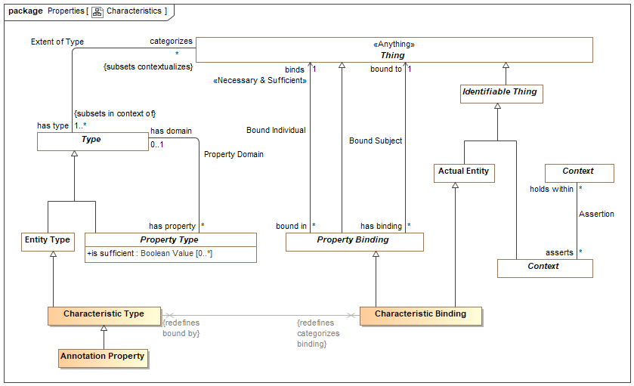

1. Characteristics

## Diagram: Properties

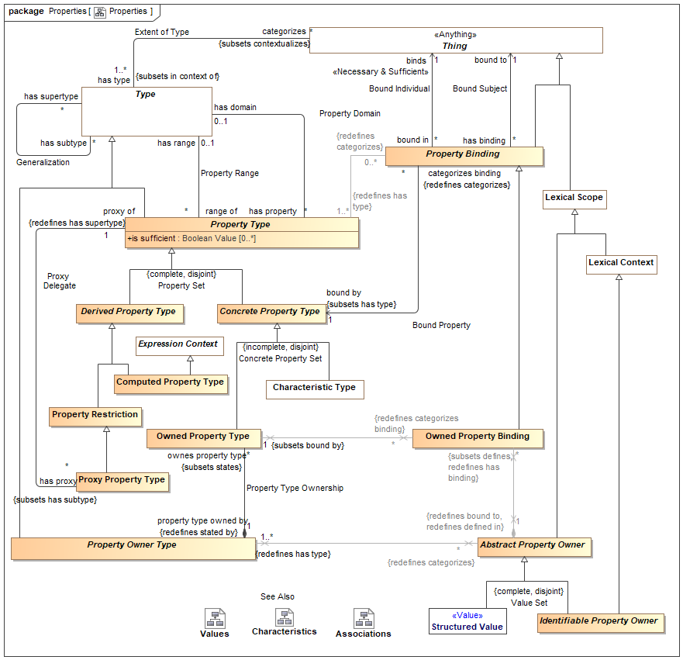

1. Properties

## Diagram: Property Foundation

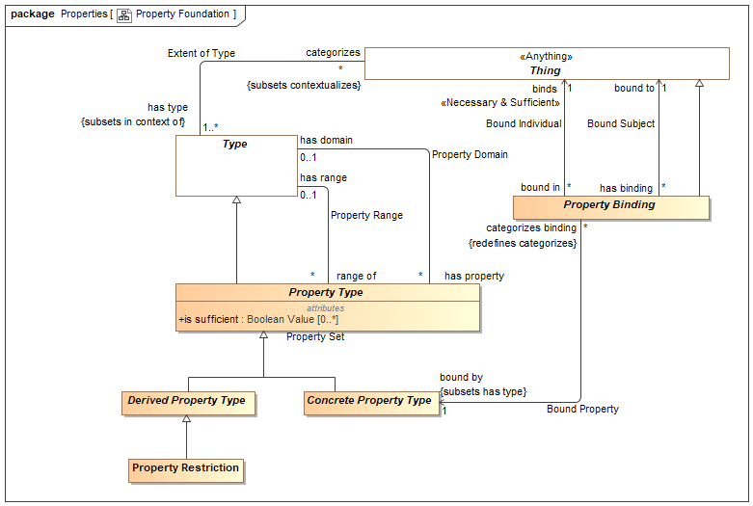

1. Property Foundation

## Class Abstract Property Owner

Direct Supertypes

Lexical Scope

## Class Annotation Property

An annotation property is a specialization of property where the referenced elements represent metadata about the related proposition, structure or information (or model element) rather than a fact or condition of the domain being represented.

For an annotation property, <is of type> describes instances of the structured type for which the property is defined.

Typical uses of annotations include provenance of information, when a record was created, etc.

[ISO11404] annotation: descriptive information unit attached to a datatype, or a component of a datatype, or a procedure (value), to characterize some aspect of the representations, variables, or operations associated with values of the datatype

Direct Supertypes

Characteristic Type

## Association Bound Individual

Relationship defining the thing bound to a subject based on a bound property - the "object" of the property binding.

Association Ends

binds : Thing [1] *Redefines*: ownes property type: Owned Property Type



The thing bound to a property in a specific situation. E.g. if the weight of truck-XYZ is 4500 LBS, the bound individual would be "4500 LBS".

[FUML] value

[OWL] rdf:object

bound in : Property Binding [*] *Redefines*: ownes property type: Owned Property Type



Bindings in which a thing participates.

## Association Bound Property

Relationship defining the property type that defines the semantics of a property binding. E.g. if the weight of truck-XYZ is 4500 LBS, the bound property could be "has weight".

Direct Supertypes

Extent of Type

Association Ends

categorizes binding : Property Binding [*] *Redefines*: ownes property type: Owned Property Type



Bindings referencing a property.

bound by : Concrete Property Type [1] *Redefines*: ownes property type: Owned Property Type



The property a binding binds a thing to.

[FUML] definingFeature

[OWL] rdf:predicate

## Association Bound Subject

Relationship defining the subject of a bound property. Where the subject is a relationship, the relationship becomes transparent and the applicable subject(s) are the other ends of the relationship. E.g. if the weight of truck-XYZ is 4500 LBS, the bound subject would be Truck-XYZ". Also known as "Inherence" (UFO).

Association Ends

has binding : Property Binding [*] *Redefines*: ownes property type: Owned Property Type



Bindings asserted for properties, the property values inhering in the thing.

bound to : Thing [1] *Redefines*: ownes property type: Owned Property Type



The subject of a property binding.

[FUML] owningInstance (note that in SMIF the owner and subject may not be the same). Where the are the same, the semantics are the same as FUML.

[OWL] rdf:subject

[UFO] Inheres in

## Class Characteristic Binding

A characteristic of a specific thing, e.g. the color of Pump-1234 in the <bound to> entity. A characteristic is a "first class" element and may participate in relationships and have annotations.

[IDEAS] measureOfIndividual: A typeInstance that asserts an Individual is an instance of a Measure - i.e. the Individual "has" a property corresponding to the Measure.

[ISO 1087] characteristic: abstraction of a property of an object (3.1.1) or of a

set of objects

[Guizzardi] Intrinsic Trope (UFO)

[DOLCE] Quality

Direct Supertypes

Actual Entity, Property Binding

## Class Characteristic Type

A kind of characteristic a type of thing may have, e.g. paint may have a color. Characteristic type is the type of characteristic bindings which are "first class" elements and may participate in relationships and have other characteristics.

[IDEAS] Property: An IndividualType whose members all exhibit a common trait or feature. Often the Individuals are states having a property (the state of being 18 degrees centigrade), where this property can be a CategoricalProperty (qv.) or a DispositionalProperty (qv.).

[ISO 1087] type of characteristics: category of characteristics (3.2.4) which serves as the criterion of subdivision when establishing concept systems. NOTE The type of characteristics colour embraces characteristics (3.2.4) being red, blue, green, etc. The type of characteristics material embraces characteristics made of wood, metal, etc.

[FIBO] Simple Property: Simple Properties are assertions about things in a class, which may be framed in terms of some simple type of information.

[Guizzardi] Intrinsic Trope Type

[DOLCE] Quality Type

[OWL] rdf:Statement

[UML] Property

Direct Supertypes

Concrete Property Type, Entity Type

## Class Computed Property Type

A property derived by an expression.

Direct Supertypes

Derived Property Type, Expression Context

## Class Concrete Property Type

A concrete property type is a property type which has instances defined by property bindings.

Direct Supertypes

Property Type

## Class Derived Property Type

A derived property type is a property type that is derived in some way from one or other properties in the same context.

Direct Supertypes

Property Type

## Class Identifiable Property Owner

Property Owner is an abstract element for anything that may own a set of property bindings. This element is abstract and not intended to directly represent domain concepts. Subtypes of property owner provide semantic interpretation.

Direct Supertypes

Abstract Property Owner, Lexical Context

## Class Owned Property Binding

An owned property binding defines a value for a particular property of a particular owning property type (or structure).

Similar to an OWL triple, an owned property binding does not have independent identity.

Constraint: Each owned property binding must be <bound by> an owned property type that is owned by the <has type> owned type of the <bound to> property owner.

Owned property type is abstract and not intended to directly represent semantic elements.

Direct Supertypes

Property Binding

## Class Owned Property Type

An owned property type is a property definition defined as a composite part of an association type - most often used in data structures and relationships. Association property types are the types of association property bindings. Also known as "association end".

[FIBO] Relationship Property

[FUML] memberEnd (of association) Property

Direct Supertypes

Concrete Property Type

Associations

: Binary Association Type [1] *Subsets*: property type owned by:Property Owner Type



## Class Property Binding

A property value binding binds a particular thing (the value) to a situation based on a defined property.

Where <binds> is an expression evaluation, the property value shall evaluate to the evaluation of the expression.

Where <binds> is a property, the property value shall be the property values bound to that property in <bound to> situation.

The bound to thing must conform with the <is of type> type of the property. If the bound individual conforms to the "requires type" of the property, the <is of type> of the bound thing will be asserted.

The type of the <bound to> structure must (directly or indirectly) have the type the <bound by> properties <property of> type.

[Guizzardi] Trope (UFO)

[FUML] Slot (Noting that in SMIF the binding may or may not be owned by the subject, depending on the subtype of property).

[CL] Binding:

[OWL] Union(ObjectPropertyAssertion, DataPropertyAssertion, AnnotationAssertion), RDF Triple

=Note: RDF Triples do not have identity where as some subtypes of SMIF:Property Type do have identity and are therefor statements.

Direct Supertypes

Thing

Associations

<<Restriction>> : Property Type [1..*] *Redefines*: has type:Type



## Association Property Domain

Relationship defining the set of properties defined for a type.

Where the <property of> type is a relationship type, the "subject" of the property is the other ends (properties) of the relationship.

Where the <property of> type is not a relationship, the subject of the property is the <property of> type.

Association Ends

has property : Property Type [*] *Redefines*: has type: Type



A property of a structured type such that there may be bindings of a thing to instances of the structured type with reference to the property which defines the semantics of the bound thing withing the context of the structure.

[FUML] feature

[UML] memberEnd. attribute (of classifier).

has domain : Type [0..1] *Redefines*: has type: Type



Type for which a property is relevant. The domain of the property.

<property of> excludes "Owned Property Type" and ("Association Type" that is not "Relationship Type")

[FUML] featuringClassifier

[OWL] Domain

## Class Property Owner Type

A type of Property Owner (See Property Owner for details) which defines a set of "Owned Property Types" which are the types of owned property bindings.

Property owner is abstract and not intended to directly represent semantic elements.

Direct Supertypes

Type

## Association Property Range

Property range is a relationship defining the possible ranges of a property. Property range may be restricted to hold within a relationship or a domain type.

Association Ends

has range : Type [0..1] *Redefines*: has type: Type



The range of a property reflects the type of possible values of that property type.

range of : Property Type [*] *Redefines*: has type: Type



Properties having a type.

## Class Property Restriction

A property restriction is a derived property that utilizes the subset (hasSupertype) redefined properties to make additional assertions about a property in the context of its domain, which is part of its context. The property domain and other constraints apply when the domain is satisfied.

Property restrictions may also be used do define multiple domains and ranges, per OWL.

Direct Supertypes

Derived Property Type

## Class Property Type

A property type defines the way in which instances of a type participate in (or, are involved in) instances of another type (including relationships). Sometimes called a variable, argument or role.

Owned properties are the basis for the ends of associations and relationships.

In a conceptual model the terms associated with a property kind are typically "verb phrases" defining how instances of the involved type participate in the situation or relationship.

In a value (static data structure) the property is a "slot" of a record and may have a term which is a noun or verb phrase.

So that constraints of a type flow to relationships involving that type: All propositions that hold within a type referenced by <is of type> hold within the structured type referenced by <property of>. I.e. the structured type is in the context of the types of its properties.

In a function, a property is a function argument.

[Guizzardi] Trope Type

[FUML] Parameter where owner is operation. Otherwise Property.

[UML] Property. All typed elements in SMIF are Property Types.

[CL] Operator: distinguished syntactic role played by a specified component within a functional term

[OWL] rdf:Property, ObjectUnionOf(owl:ObjectProperty, oe;DatatypeProperty).

Direct Supertypes

Type

Attributes

is sufficient : Boolean Value [0..*]



One of the set of sufficient conditions that will infer the type designated in <has domain>.

Asserts that when a property binding is <bound> to a thing, that thing will be asserted to be of the defined domain type and all other sufficient contritions are met. Sufficient conditions may be specified in properties an sufficient generalizations.

If this property is not set, assertion is based on the contextual default, such as the rules of the underlying logic. In description logics such as OWL, the default is TRUE for concrete properties and FALSE for derived properties.

If asserts domain is false it is an error to create a property binding that does not already have the domain type, the domain is a constraint.

Associations

<<Restriction>> : Property Binding [0..*] *Redefines*: categorizes:Thing



## Association Property Type Ownership

Direct Supertypes

Statement

Association Ends

ownes property type : Owned Property Type [*] *Redefines*: categorizes: Thing



property type owned by : Property Owner Type [1] *Redefines*: categorizes: Thing



## Association Proxy Delegate

A relationship defining the proxies for an owned property type, the restrictions that are contextually added to a concrete property based on the domain of the property restriction.

Association Ends

proxy of : Property Type [1] *Redefines*: categorizes: Thing



The property type that is proxied.

has proxy : Proxy Property Type [*] *Redefines*: categorizes: Thing



A type of proxy for a type of property.

## Class Proxy Property Type

A proxy property is a derived property and a property restriction that utilizes the <proxy of> property to provide another way to reference, name or constrain that property, in general from another domain. The proxies property must be <stated by> a common context such that the traversal through that property is unambiguous.

By convention, proxy properties are verb phrases where as non-proxy owned properties are noun phrases (role names).

Direct Supertypes

Property Restriction

## Association Redefinition

Defines the generalization as a redefinition, subsuming the more general type in the definitional context.

Where <redefines> is true the more specific type subsumes the more general type in the definition context. In this case the more general and more specific sets are equivalent. A type may be redefined multiple times, as long as it is unambiguous which definition applies for a particular instance.

Where <redefines> is false or not defined the more specific type represents a subset of the more general property.

Redefinition is most often used with properties (as defined in UML) but may also be applied to other types.

Direct Supertypes

Generalization

Association Ends

redefines : Property Type [*] *Redefines*: categorizes: Thing



redefined by : Property Type [*] *Redefines*: categorizes: Thing



# Concept Library::Meta Concepts::Relationships

Relationships are primitive but identifiable conditions that relate other entities through properties of the relationships. Relationships have their semantics described by a relationship type. The ends of relationships are defined by "structured property type", a relationship may have any number of "ends".

Relationships are first-class "actual" and "temporal" things that exist in their own right. These are known as "external relations" in much of the theoretical literature.

## Diagram: Relationships

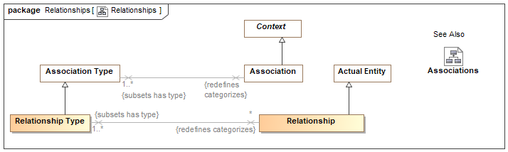

1. Relationships

Relations are atomic actual situations that bind 2 or more properties as a fact.

## Class Relationship

A relationship is a material atomic situation involving related things that are not part of the relationship. A relationship may be asserted within a context as true or false within that context. Each relationship type has a number of bindings of which do not change for the life of the relationship..

A relationship may be true or false within its context (including a timeframe) but is atomic in its truth value.

Relationships may participate in (be bound to) other relationships and as such bindings involving a relationship may change over time. That is, relationships are "first class" objects.

[IDEAS] tuple: A relationship between two or more things.

Note: SMIF allows one end of a relationship.

[OWL] An OWL class that is a subclass of SMIF: Relationship

[Devlin] Relation

Direct Supertypes

Actual Entity, Situation

## Class Relationship Type

A relationship type defines a type of condition, the relationship, involving related things. A relationship may be asserted within a context as true or false within that context. Each relationship type has a number of <has property> "structured property type" properties which describe the role of the related things with respect to the relationship, values of which uniquely do not change for the life of the relationship.

A relationship may be true or false within its context (including a timeframe) but is atomic in its truth value.

Relationships may participate in (be bound to) other relationships and as such bindings involving a relationship may change over time.

The terms for properties of a relationship in a conceptual model are typically verb phrases, connecting the relationship with the related types.

[FIBO] A kind of Mediating Thing

[IDEAS] TupleType: The Powertype of tuple.

[FUML] Association where memberEnd corresponds with <has property>. Note that SMIF relationships are "first class" and may also be considered to correspond to an association class where there are any properties or other relationships referencing the subject relationship.

[UML] AssociationClass (note that "end ownership" is meaningless in SMIF).

[Guizzardi2015] Relator: endurants of a special kind, with the power of connecting (mediating) other endurants. Note: Guissardi "mediation" corresponds with relationship properties.

Direct Supertypes

Association Type, Entity Type

# Concept Library::Meta Concepts::Top level

The top level objects provide the foundation for all objects in a SMIF model

## Diagram: Context

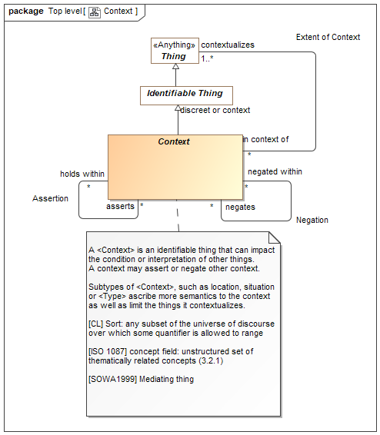

1. Context

## Diagram: Proposition

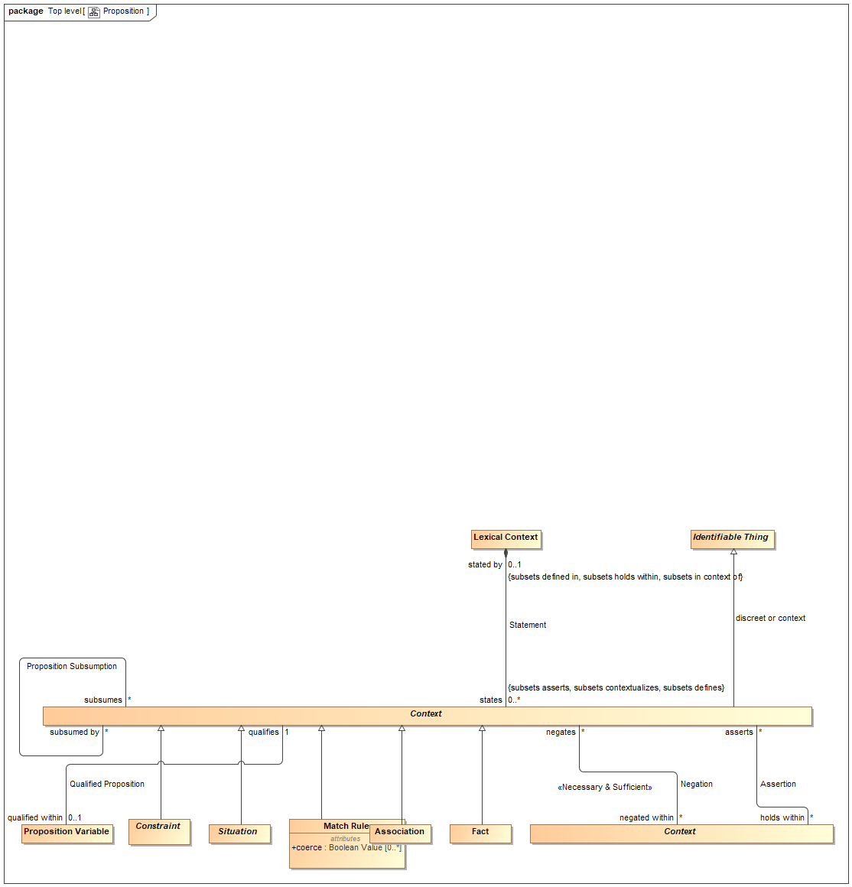

1. Proposition

## Diagram: Top Level

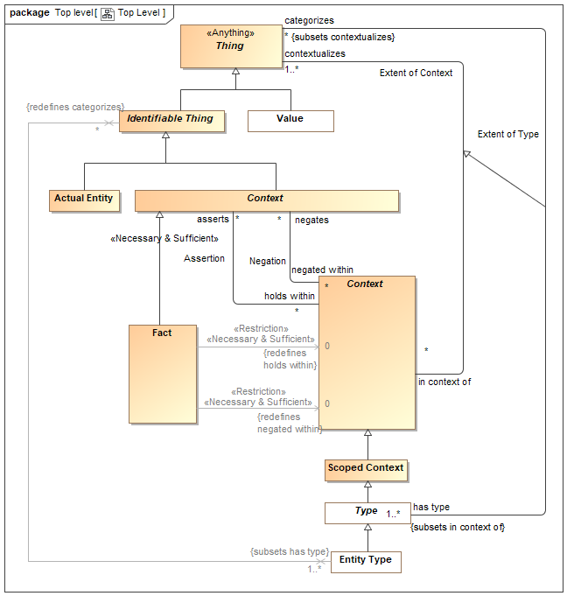

1. Top Level

Diagram showing summary of top level classes and significant subtypes.

## Class Actual Entity

An actual entity is an identifiable, individual person, specific object, process enactment, agreement, etc. Actual Entities do not have to be physical, e.i. may denote social constructs. Actual entities are disjoint from types.

A more specific class of actual entity (e.g., Person) is intended to refine the classification of the individual thing.

Individuality (or selfhood) is the state or quality of being an individual; particularly of being separate from other individuals and possessing identity. Actual entities typically have a lifetime and some individuals may change over that lifetime. Individuals may have parts that together help define the individual but may change over time.

"Actual" does not imply current existence.

[ISO 1087] individual concept: concept (3.2.1) which corresponds to only one object

[UML] Loose correspondence with "InstanceSpecification". SMIF instances are direct instances of their types, there is no "indirection" through value specification as their is in UML.

[Guizzardi] (individual concept)

[CL] Individual: one element of the universe of discourse

[DOLCE] Particular: particulars are entities which have no instances

[SOWA1999] Independent. Can be considered "Actuality" when including social constructs in [SOWA1999] Physical.

[OWL] Individual

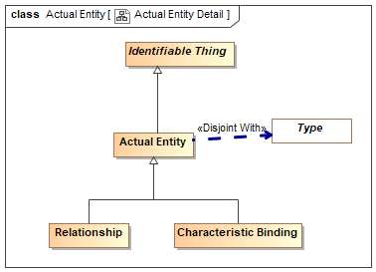

1. Actual Entity Detail

Direct Supertypes

Identifiable Thing

## Association Assertion

An assertion relationship between a context and the propositions asserted within that context. The <asserts> proposition is asserted (defined as "true") for all things contextualized by the <holds within> context. Assertion of truth is not absolute, it is relative to the context. For example, something could be asserted within a context where that entire context is asserted to be false.

Assertion is transitive.

[CL] Implication

[OWL] Assertion; Any [OWL] Assertion included in a graph (All assertions in an OWL graph are asserted by the graph)

Association Ends

asserts : Context [*] *Redefines*: categorizes: Thing



Proposition that is asserted (must be true) for anything contextualized by a context.

As types are a context, types may assert a proposition for their instances.

holds within : Context [*] *Redefines*: categorizes: Thing



Context in which a proposition is asserted (required to be true). Anything contextualized by the context is subject to the proposition.

## Class Context

A <Context> is an identifiable thing that can impact the condition or interpretation of other things.

A context may assert or negate other context.

Subtypes of <Context>, such as location, situation or <Type> ascribe more semantics to the context as well as limit the things it contextualizes.

[CL] Sort: any subset of the universe of discourse over which some quantifier is allowed to range

[ISO 1087] concept field: unstructured set of thematically related concepts (3.2.1)

[SOWA1999] Mediating thing

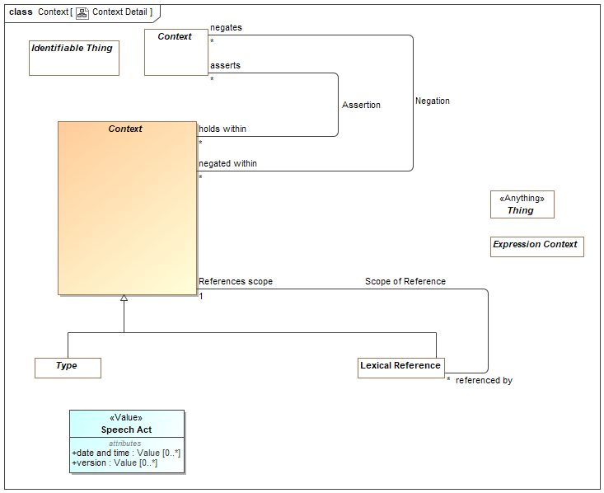

1. Context Detail

Direct Supertypes

Identifiable Thing

## Association Extent of Context

Extent of context is the association between context and the set of things contextualized by that context, defining the extent of the context, a set. The thing the context <contextualizes> are subject to the propositions true <in context of>.

[Devlin] <in context of> corresponds to a resource situation where both <in context of> and <contextualizes> are situations.

Association Ends

contextualizes : Thing [1..*] *Redefines*: categorizes: Thing



The set of things contextualized by a <Context>, a.k.a. "in" the <Context> and therefor subject to the propositions of the <Context>.

in context of : Context [*] *Redefines*: categorizes: Thing



Context that applies to a thing.

[Devlin] Resource situation. {where <in context of> is a Situation}

## Class Fact

A fact is a proposition that is not qualified by a context - asserted or negated in any context. Facts are not expected to represent "truth", but a commitment accepted by an interpreter of a model.

Propositions that are not facts are, directly or indirectly, qualified by some fact.

Facts that do not assert or negate other propositions are considered "atomic".

Example: Jill believes Johnny fell in a well.

"Johnny fell in a well" is a proposition (probably a relationship).

What Jill believes is a statement of fact and also a relationship that subtypes "Assertion".

Direct Supertypes

Context

Associations

: Context [0] *Redefines*: holds within:Context



: Context [0] *Redefines*: negated within:Context



## Class Identifiable Thing

An identifiable thing is any thing that can be distinguished from another, it is disjoint from values. Identifiable thing includes individuals, types, axioms, situations, speech acts, information structures, etc.

Identifiable things always have some kind of identity and may have identifiers. Note that identity is an abstraction that may have representation in models as any number of identifiers, also known as a "sign".

[OWL] Entity type (Implied in section [OWL] 5.8) as an instance of rdfs:Class

Direct Supertypes

Thing

## Association Negation

An assertion relationship between a context and the propositions negated (FALSE) within that context. The <negates> proposition is asserted as FALSE for all things contextualized by the <negated within> context. Assertion or negation of truth is not absolute, it is relative to the context.

[CL] Negation+Implication

Association Ends

negates : Context [*] *Redefines*: negated within: Context



Proposition that is negatively asserted (must be FALSE) for anything contextualized by a context.

As types are a context, types may assert or negate a proposition for their instances.

negated within : Context [*] *Redefines*: negated within: Context



Context in which a proposition is negated (required to be FALSE). Anything contextualized by the context is subject to the proposition.

## Class Scoped Context

A <Scoped Context> is a context that <asserts> or <negates> propositions that hold for all things the context <contextualizes>, thus providing the link between an assertion and the set of things asserted. Likewise a context <negates> propositions that are false within the context.

Context that are not scoped apply too all things.

Direct Supertypes

Context

## Class Thing <<Anything>>

Any thing or value that does or may exist in any possible world. Thing is the supertype of all types and may therefore participate in unbounded relations.

Instances of Thing are referred to as "a thing" in this model.

[IDEAS] Thing

[OWL] Thing

[ISO 1087] object: anything perceivable or conceivable

[FIBO] Thing

[Guizzardi] Thing

[FUML] Element

[SOWA1999] "T"

[OWL] rdfs:Resource

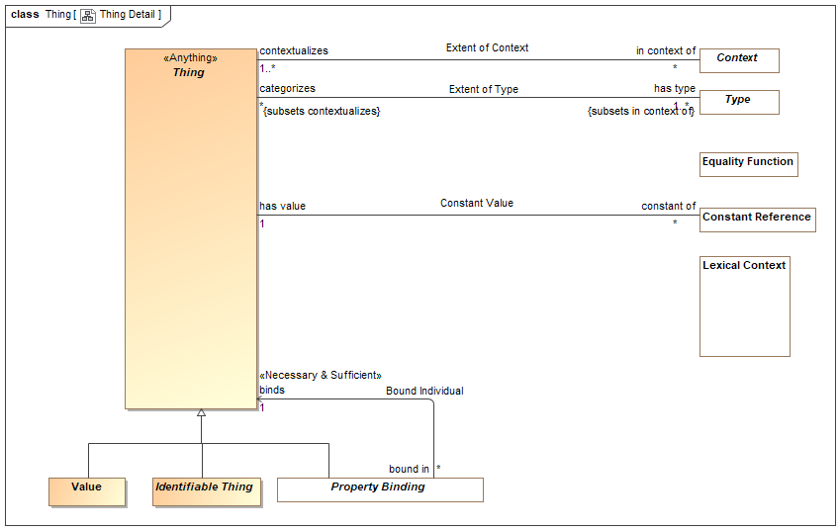

1. Thing Detail

# Concept Library::Meta Concepts::Types

Types provide for ways to categorize anything based on what it is, the roles it plays or the phases it may be in.

Something may be categorized by any number of types (multiple classification assumption).

## Diagram: Type-instance

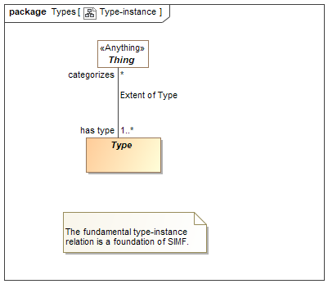

1. Type-instance

## Diagram: Types

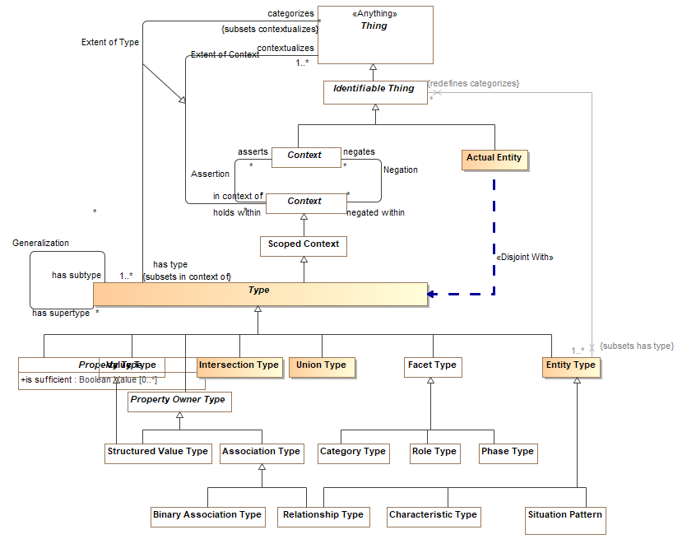

1. Types

## Diagram: Types as Context

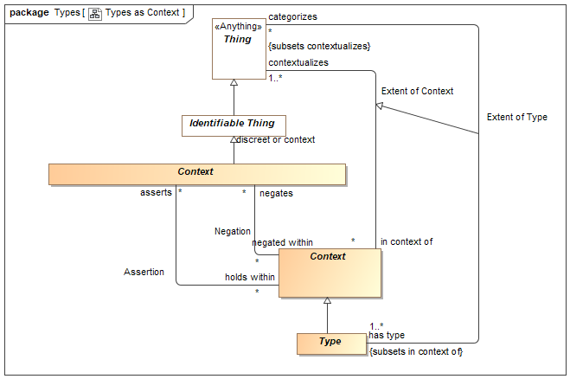

1. Types as Context

## Class Entity Type

A type of an identifiable entity. All concrete entity instances must have at least one entity type. Entity type may be mixed with other types to fully define an entity.

[FUML] Classifier

[BFO] Universal

[Guarino1994] Substantial or Pseudo-Sortal (Substantial being concrete)

[Guizzardi] A Rigid Universal.

(Rigid Universal): A universal G is rigid (or modally constant) iff for any w,w ∈ W 3. extw(G) = extw(G) Putting definitions 4.1 and 4.3 together, we have that for any rigid universal G the following is true 4. ext(G) = extw(G), for all w ∈ W A rigid universal is one that applies to its instances necessarily, i.e., in every possible world. Every substance sortal G is a rigid universal.

[OWL] rdfs:Class (as Entity Type does not include values). However, non=primitive values are typically represented as rdfs:Class

Direct Supertypes

Type

## Association Extent of Type

The relation between a type and the things that type categorizes, the instances which defines the extent of the type, a set.

[IDEAS] typeInstance: A couple that asserts that a Thing is a member of a Type.

[Guizzardi] (Extension functions): Let W be a non-empty set of

possible worlds and let w ∈ W be a specific world. The extension function extw(G) maps a universal G to the set of its instances in world w. The extension function ext(G) provides a mapping to the set of instances of the

universal G that exist in all possible worlds, such that ext(G) = U w∈W w ext (G)

[OWL] ClassAssertion

Direct Supertypes

Extent of Context

Association Ends

categorizes : Thing [*] *Redefines*: negated within: Context



The set of things described by a type, the "extent" of the type.

The thing a type <categorizes> is subject to the <has assertion> propositions of the type.

[FIBO] classifies

has type : Type [1..*] *Redefines*: negated within: Context



A type that holds for something.

Things may have multiple types and these types may change over time.

The <categorized> thing satisfies the constraints of the <has type> type.

[FIBO] isClassifiedBy

[OWL] rdf:type

## Association Generalization

A Type Generalization is a taxonomic relationship between a more general <has supertype> type and a more specific <has subtype> type. Each instance of the specific type is also an instance of the general type.

The extent (<categorizes> property) of the specific type is the same as or a subset of the extent of the more general type. Therefore, any statement that is true for all members of a supertype must also be true for all members of any subtype.

Note that "multiple inheritance" is supported.

[IDEAS] superSubtype: A couple relating two Types which asserts that one type is a subset of the other.

[ISO 1087] generic relation: genus-species relation relation between two concepts (3.2.1) where the intension (3.2.9) of one of the concepts includes that of the other concept and at least one additional delimiting characteristic (3.2.7)

[FIBO] Inheritance

[UML] Generalization

[Guizzardi] (Specialization relation): Let F and G be two universals such that F is a specialization of G. Then, for all w ∈ W we have that extw(F) ⊆ extw(G)

[OWL] Union(SubClassOf, SubPropertyOf)

Association Ends

has supertype : Type [*] *Redefines*: negated within: Context



The extent (categorizes) of the subtype is a subset of the extent of the supertype. All constraints of a supertype must also be true for any subtype

has subtype : Type [*] *Redefines*: negated within: Context



The more general type of a generalization. The extent of the subtype is a subset of the extent of the supertype.

## Class Intersection Type

An intersection is a type that has an extent which is the complete intersection of the extents of all supertypes. Intersection is a stronger statement than a subtype as a subtype may not be a complete intersection.

[MathWorld] The intersection of two sets A and B is the set of elements common to A and B. This is written A intersection B, and is pronounced "A intersection B" or "A cap B."

Direct Supertypes

Type

## Association Sufficient Generalization

One of the set of sufficient conditions that will infer the type designated in <justifies subtype>.

Asserts that if an instance is of the <sufficient supertype> and all other sufficient conditions are met, the instance may be inferred to be the <justifies subtype>.

Association Ends

sufficient supertype : Type [*] *Redefines*: negated within: Context



justifies subtype : Type [*] *Redefines*: negated within: Context



## Class Type

A <Type> is a categorization of any thing based on specific criteria. The specific criteria may or may not be formalized in a model.

A <Type> <categorizes> a set of <Thing>s which comprises the "extent" of the type.

A <Type> is a <Context> where the things it <categorizes> are <in the context> of the <Type>.

Types may participate in a taxonomy based on generalizations.

[ISO 1087] general concept: concept (3.2.1) which corresponds to two or more objects (3.1.1) which form a group by reason of common properties

[FIBO] Classifier: a standardized classification or delineation for something, per some scheme for such delineation, within a specified context

[FUML] Type

[CL] Type:: logical framework in which expressions in the logic are classified into syntactic or lexical categories (types) and restricted to apply only to arguments of a fixed type

[Guarino1994] Universal

[OWL] Union(rdfs:Class, rdfs:Datatype)

Similar to:

[IDEAS] Type: A set (or class) of Things.

Direct Supertypes

Context, Lexical Context, Scoped Context

Associations

sufficient supertype : Context [0] *Redefines*: negated within:Context



*through association:* Sufficient Generalization

justifies subtype : Context [0] *Redefines*: negated within:Context



*through association:* Sufficient Generalization

## Class Union Type

A Union is a type that has an extent which is the complete union of the extents of all types that specialize the Union.

[FIBO] Logical Unions

[MathWorld] Given two sets A and B, the union is the set that contains elements or objects that belong to either A or to B or to both. We write A È B

[OWL] ObjectUnionOf( ObjectUnionOf, DataUnionOf)

Direct Supertypes

Type

# Concept Library::Meta Concepts::Values

The values package defines the concepts of values and quantities expressed in units.

Values may be differentiated from entities in that values have no independent lifetime or "identity" other than the value its self. E.g. the number 5 "just is" and can't be changed. Properties and relations referencing values can, of course, change but the values are constant.

The failure to properly express units in data models often results in errors, inefficiencies and risk. Translation and federations between models, schema and data sources that is not cognizant of the units used would be even more error prone and risky. For example, what does “Speed limit 50” mean? For these reasons the SMIF language provides specific support for specifying quantity kinds and unit types in conceptual, logical and physical models. The SMIF mapping rules may then perform the appropriate unit conversions.

The foundation of information specification in SMIF at all levels is the type system. Types specified for all properties and relations involving values must match the types of the related values. The concepts of units and values as defined in "VIM" [JCGM 200-2008] is used as the basis for defining the types used in SMIF to guarantee type safety of quantities across different representations. Since many existing models and schema do not include well defined units some effort may be required to find and then specify the implicit units based on documentation, SME interviews or inspection of data or source code. It is recommended that the units used by external models and schema be determined prior to attempting federation and integration of information based on those models or schema.

**VIM [JCGM 200-2008] concepts of quantities and units**

VIM defines

* quantity: property of a phenomenon, body, or substance, where the property has a magnitude that can be expressed as a number and a reference [ed. to a unit]
* kind of quantity (kind): aspect common to mutually comparable quantities
* measurement unit (unit): real scalar quantity, defined and adopted by convention, with which any other quantity of the same kind can be compared to express the ratio of the two quantities as a number

**SMIF concepts of quantities and units**

SMIF uses the VIM concepts to define "quantity values" and types to capture the quantity kind and unit. Types are defined for each Unit. The goals for this type based approach are:

* That it is clearly grounded in semantics as defined in VIM
* That a type may be used to specify the range of a property or relation involving unit based values.
* That a quantity value (e.g. 5 grams) be representable as a simple number with a type.
* That there is a clear type hierarchy starting with a representationally independent type in a conceptual model (e.g. mass) that can be further specialized to a specific unit in a logical model (e.g. grams) and further specialized to be represented by a physical data type (e.g. “double”).
* That external models and schema may have unit specifications asserted without changing the schema.
* That a quantity of an entity be able to be referenced without a specific quantity value being known (e.g. John’s weight).
* That systems of units such as [ISO-80000] or [OMG QUDV] (A part of SysML) be able to be directly referenced as the definition of a unit.

SMIF defines three types to realize the above goals: Quantity Kind, Unit Type, Base Unit Type. SMIF also defines Quantity Values, which are instances of unit types.

In VIM a quantity has a magnitude that is expressed as a number and a reference. The SMIF quantity value is the numeric value of such a quantity where the reference is specified by the “unit reference” property of the quantity value’s type. The quantity value’s type is a “Unit Type”. The Unit type has attributes for converting a unit to a base unit, a symbol and a unit reference. Based on VIM the unit reference may be “a measurement unit, a measurement procedure, a reference material, or a combination of such” and is specified with a description that contains reference information. In summary, the reference of a SMIF quantity value is determined indirectly through its unit type. A quantity value has exactly one unit type and exactly one Quantity Kind. A quantity value expressed in any unit of the same quantity kind may be converted to any other unit of the same quantity kind.

This type-based sapproach allows specification of a property at the conceptual (quantity kind) logical (unit type) or physical (unit type with a numeric type) levels. Such specifications use the same type-based approach used for other aspects of the models. Given this information a SMIF implementation may correctly and reliably convert between compatible types regardless of representation. Please see the specification of the value types, attributes and relationships for more detail.

**Example:**

* A specification for a road segment has a property “Speed limit”.
* The type of this property in a reference conceptual model is “Speed:Quantity Kind”.
* A unit “Kilometer per Hour:Unit Type” is defined as a subtype of “Speed:Quantity Kind” with a “unit reference” of “[ISO-80000.4] Kilometer per Hour”. Note that quantity kinds and unit types would normally be defined in reference models that correspond to a “system of units”.
* Miles per hour is also defined as a subtype of Speed.
* A physical schema defines “Speed-KPH: Integer”.
* A SMIF mapping rule maps “Speed limit” to “Speed-KPH” and asserts a type of “Kilometer per Hour” on the “Speed-KPH” end.
* A data file defines a road “Route One” with a speed limit of 100:KPH-Int.
* When converted to a U.S. application this speed limit of route one can be viewed as 62:MPH-Int.

## Diagram: Values

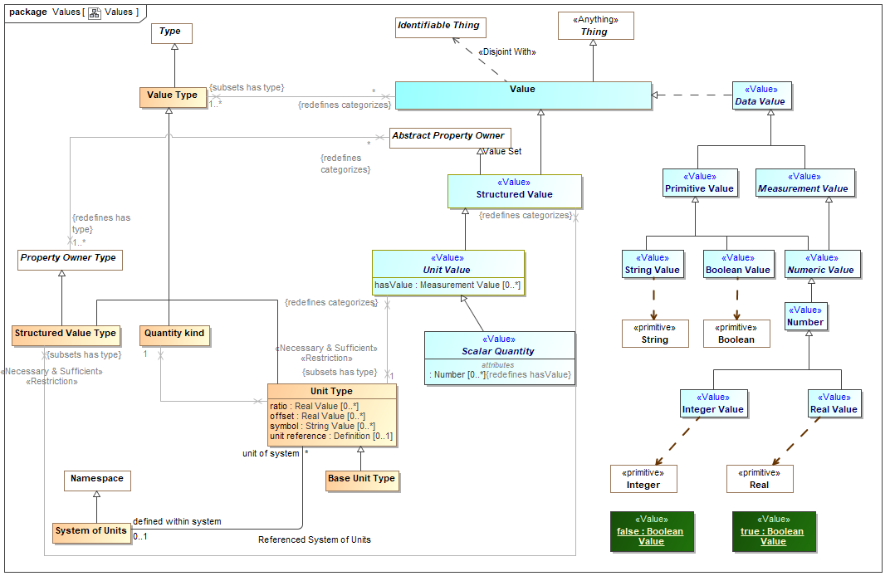

1. Values

## Diagram: Values Only

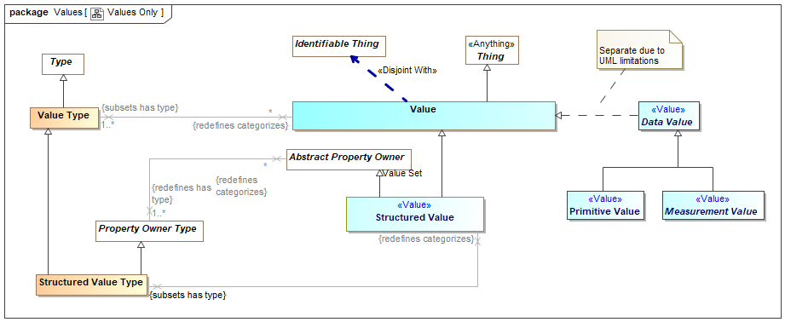

1. Values Only

## Class Base Unit Type

One unit type of a quantity kind may be marked as the base unit within a system of units. The base unit provides the basis for conversions between units of the same quantity kind. The base unit always has a ratio of one and an offset of zero.

Type of a [JCGM 200:2008] measurement unit that is adopted by convention for a base quantity

[FIBO] (type of) Base Unit: a measurement unit that is defined by a system of units to be the reference measurement unit for a base quantity

There ma be at most one base unit for a quantity kind within a system of units.

Direct Supertypes

Unit Type

## Class Quantity kind

[JCGM 200:2008] A Quantity Kind is an aspect common to mutually comparable quantities represented by one or more units. Units with a common quantity kind may be algorithmically converted to any other unit of that quantity kind. e.g. temperature.

Quantity kinds are a supertype of unit types which are then a type of all quantity values, Quantity values are mutually comparable with all other quantity values categorized by the same quantity kind.

[FIBO] QuantityKind: a categorization type for “quantity” that characterizes quantities as being mutually comparable

[DOLCE] Quality Space

Direct Supertypes

Value Type

## Association Referenced System of Units

Relationship between a system of units and the set of unit types defined within that system.

Association Ends

defined within system : System of Units [0..1] *Redefines*: negated within: Context



The system of units in which a unit is defined and is the basis for ratio and offset.

By default the system of units is "si": http://www.iso.org/iso/iso_catalogue/catalogue_ics/catalogue_detail_ics.htm?csnumber=30669

unit of system : Unit Type [*] *Redefines*: negated within: Context



Unit type defined within a system of units

## Class Scalar Quantity <<Value>>

Direct Supertypes

Unit Value

Attributes

: Number [0..*]



The value of a quantity that, when multiplied by the unit defined in a subtype of quantity kind, specifies a measurement value such as 3 Meters.

## Class Structured Value <<Value>>

A value that may have sub-elements (owned properties) defined as "structure property type".

Direct Supertypes

Abstract Property Owner, Value

## Class Structured Value Type

A structured value type is a type of value that has parts represented as properties - also used for "data types" and forms.

Direct Supertypes

Property Owner Type, Value Type

## Class System of Units

[JCGM 200:2008] A set of base units and derived units, together with their multiples and submultiples, defined in accordance with given rules, for a given system of quantities.

[FIBO] SystemOfUnits: a set of measurement units associated with a system of quantities, together with a set of rules that assign one measurement unit to be the base unit for each base quantity in the system of quantities and a set of rules for the derivation of other units from the base units

Direct Supertypes

Namespace

## Class Unit Type

A Unit type is a type of a quantity value referencing a specific unit. A Unit Type a required type of a property representing a quantity.

Each quantity value has a reference as defined by the "unit reference" property of the quantity value's type.

[JCGM 200:2008] A Unit is a real scalar quantity, defined and adopted by convention, with which any other quantity of the same quantity kind can be compared to express the ratio of the two quantities as a number. e.g. Degrees Centigrade, Miles.

Each unit type represents refinement of a quantity kind using generalization and is thus substitutable for that quantity kind. Typically quantity kinds are used in conceptual models and unit types in physical or logical models.

Unit types may only subtype quantity kinds or other units.

Note that unit types are not units, but the type of quantity values expressed with respect to a common unit as defined in [JCGM 200:2008].

[IDEAS] MeasureCategory: A MeasureType whose members are recognized types of MeasureInstance.

Direct Supertypes

Value Type

Attributes

ratio : Real Value [0..*]



The multiplier by which to multiple the referenced unit to convert to the base unit within a system of units.

offset : Real Value [0..*]



The difference between zero in the referenced unit and zero in the base unit after the ratio is applied within a system of units.

symbol : String Value [0..*]



The accepted symbol for the unit referenced by the unit type

unit reference : Definition [0..1]



The unit reference is the reference to a unit shared by all quantities values that are instances of a unit type.

[JCGM 200:2008] A reference can be a measurement unit, a measurement procedure, a reference material, or a combination of such. For magnitude of a quantity.

Typical references include ISO 8000 and OMG QUDV.

## Class Unit Value <<Value>>

A unit value is a numeric magnitude with a unit type that may be used as the value of a quantity property as defined by [JCGM 200:2008]. The reference of the quantity is defined by the "unit reference" property of the Unit Type.

e.g. 5cm is an instance of the unit type "Centimeter"

Each unit value has exactly one UNit Type as a type.

In a physical model a quantity value must have a type that specifies its unit (e.g. "Gram"). The magnitude shall be expressed using "hasValue"

[JCGM 200:2008] A quantity is a property of a phenomenon, body, or substance, where the property has a magnitude that can be expressed as a number and a reference.

Note: A quantity as defined here is a scalar. However, a vector or a tensor, the components of which are quantities, is also considered to be a quantity.

[IDEAS] ScaleMapping: A CoupleType whose members are all the couples linking MeasurePoints to RealNumbers. The CoupleType (i.e. the set of couples) represents the scale.

[FIBO] QuantityValue: number and measurement unit together giving magnitude of a quan-tity

[Guizzardi] (quale): A point in a n-dimensional quality domain

Direct Supertypes

Structured Value

Attributes

hasValue : Measurement Value [0..*]



The value of a quantity that, when multiplied by the unit defined in a subtype of quantity kind, specifies a measurement value such as 3 Meters.

[OWL] rdf:value restricted to abstract quantity

## Class Value

A Value is an atomic. immutable piece of information without a specific lifetime or identity independent of the value. Values include numbers, strings and other atomic "primitive" data. Values also include structured values, which are immutable.

In UML values may be defined by the name of an instance specification with a value type.

[IDEAS] Representation: A SignType where all the individual Signs are intended to signify the same Thing.

[ISO11404] The identification of members of a datatype family, subtypes of a datatype, and the resulting datatypes of datatype generators may require the syntactic designation of specific values of a datatype.

[OWL] data values

Direct Supertypes

Thing

## Class Value Type

A type categorizing values where a value is an atomic piece of information without a specific lifetime or identity independent of that value. Values include numbers, strings and other atomic "primitive" data.

[IDEAS] RepresentationType: A Type that is the Powertype of Representation.

[FUML] DataType

[ISO11404] datatype: set of distinct values, characterized by properties of those values, and by operations on those values

[OWL] rdfs:Datatype (Note that some values are represented as OWL classes)

Direct Supertypes

Type

# Concept Library::Objectives

Objectives captures how the intents of *stakeholder's* relate to the real-world *consequences* of *situations* that have or may happen. A *consequence* results in a *benefit* or *harm* to these *objectives* - generally related to a specific entity of value to the stakeholder.

As any situation may have multiple consequences, both benefits and harms, the net desirability of any situation to a stakeholder is calculated in the *Stakeholder Desirability Relation* by combining all of the related consequences.

## Diagram: Objectives

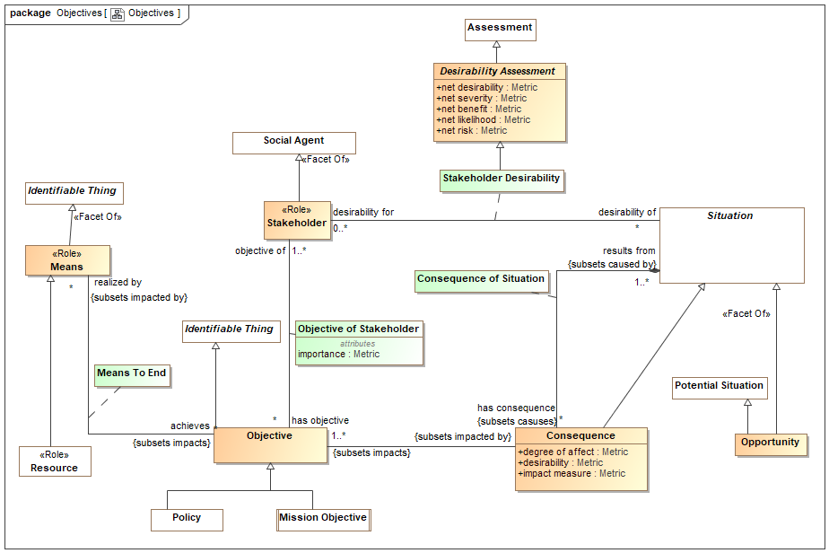

1. Objectives

## Class Benefit

A benefit is a consequence of a situation having positive desirability.

Direct Supertypes

Consequence

## Class Consequence

A consequence or impact of the outcome of a situation affecting objectives of a stakeholder.

NOTE 1 An event can lead to a range of consequences.

NOTE 2 A consequence can be certain or uncertain and can have positive or negative effects on objectives.

NOTE 3 Consequences can be expressed qualitatively or quantitatively.

NOTE 4 Initial consequences can escalate through knock-on effects.

[ISO 73-2009]

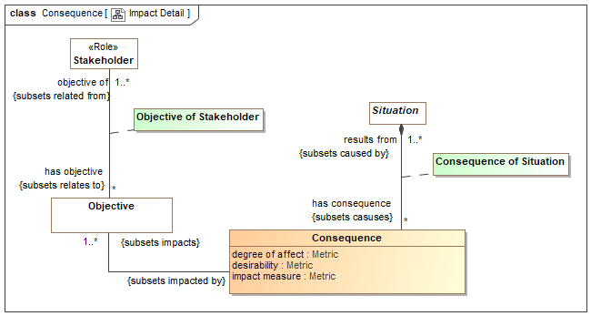

1. Impact Detail

Direct Supertypes

Situation

Attributes

degree of affect : Metric



A metric for how much the consequence affects an objective - a measure of harm or benefit.

desirability : Metric



A metric describing the desirability of an impact. May be positive or negative where positive is desirable and negative is undesirable.

impact measure : Metric



A metric for impact where Impact = desirability * likelihood

## Association Class Consequence of Situation

Impact of a situation - its affect on the objectives of stakeholders.

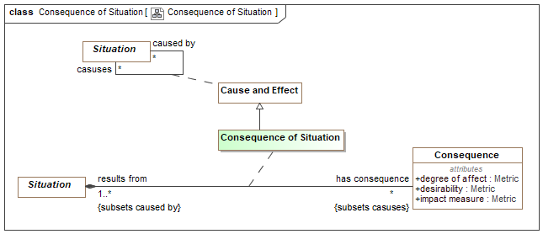

1. Consequence of Situation

Direct Supertypes

Cause and Effect

Association Ends

has consequence : Consequence [*] *Redefines*: negated within: Context



A consequence of a situation that impacts the objectives of a stakeholder.

results from : Situation [1..*] *Redefines*: negated within: Context



Situation causing an impact..

## Class Desirability Assessment

Desirability measure of a situation. The context of the desirability can be the specific stakeholder desirability relation or a classification of a situation in a context, such as an undesirable situation.

Desirability may be computed by aggregating the impact of a situation on stakeholders but the specific calculation is not specified in the standard.

A positive desirability is an opportunity; a negative desirability is a danger.

When the stakeholder desirability of a situation to a stakeholder has net harm, that harm may be identified as a risk. S

Direct Supertypes

Assessment

Attributes

net desirability : Metric



A metric representing the aggregation of the impact of all consequences of a situation for a stakeholder. (net benefit - net risk)

net severity : Metric



The aggregation of the impact of all detriments (negative consequences) of a situation for a stakeholder.

net benefit : Metric



A metric representing the aggregation of the impact of all benefits (positive consequences) of a situation for a stakeholder.

net likelihood : Metric



The net sum of the likelihood of a situation or risk.

net risk : Metric



A metric representing the aggregation of risk metrics computed as likelihood*impact.

## Class Means <<Role>>

[BMM] A means represents any device, capability, regime, technique, restriction, agency, instrument, or method that may be called upon, activated, or enforced to achieve Ends.

Direct Supertypes

Identifiable Thing

## Association Class Means To End

The relation between a means and an objective such that the means supports the objective.

[BMM] means is impacted by influencer

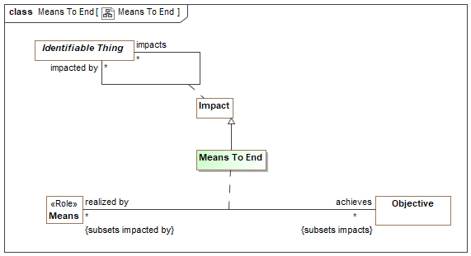

1. Means To End

Direct Supertypes

Impact

Association Ends

achieves : Objective [*] *Redefines*: negated within: Context



Objectives supported by a means.

realized by : Means [*] *Redefines*: negated within: Context



Means that serves to meet an objective.

## Class Objective

An aim or goal that a stakeholder intends to attain or accomplish; purpose; goal; target.

[BMM] End: something that is to be accomplished.

[BMM] Objective: An Objective is a statement of an attainable, time-targeted, and measurable target that the enterprise seeks to meet in order to achieve its Goals.

[FIBO] Objective

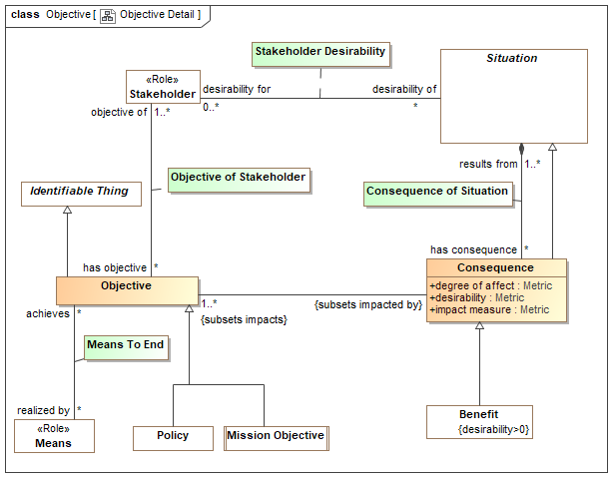

1. Objective Detail

Direct Supertypes

Identifiable Thing

## Association Class Objective of Stakeholder

Relationship between a stakeholder and their objectives.

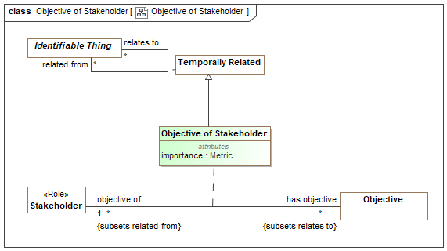

1. Objective of Stakeholder

Direct Supertypes

Temporally Related

Association Ends

has objective : Objective [*] *Redefines*: negated within: Context



An objective that a stakeholder intends to retain or achieve.

objective of : Stakeholder [1..*] *Redefines*: negated within: Context



A stakeholder having an objective they intend to attain or retain.

Attributes

importance : Metric



A metric of importance of an objective to a stakeholder.

## Class Opportunity

An opportunity is any potential future situation having beneficial consequences.

[BMM] Opportunity: This category of Assessment indicates that some Influencer can have a favorable impact on the organization’s employment of Means or achievement of Ends. For example, the bankruptcy of Pizza Company’s major competitor in Region-Y is assessed to be an Opportunity in its Goal “To increase market share.”

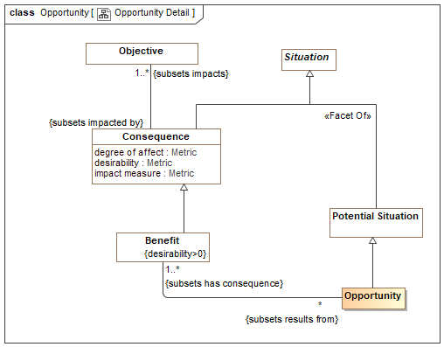

1. Opportunity Detail

Direct Supertypes

Potential Situation, Situation

## Class Stakeholder <<Role>>

A stakeholder is a responsible performer having objectives and promoting the means for achieving those objectives.

Direct Supertypes

Social Agent

## Association Class Stakeholder Desirability

A relationship representing the net desirability of a situation for a stakeholder.

Note: Stakeholder desirability is expected to be computed based on aggregating the impact of a situation for a stakeholder. However, the algorithm for this aggregation is not specified in the standard.

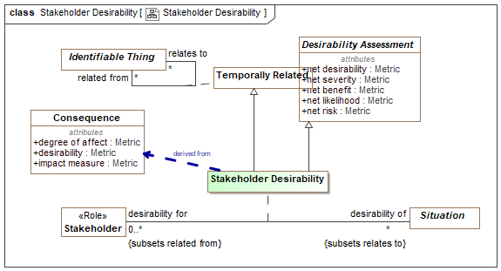

1. Stakeholder Desirability

Direct Supertypes

Desirability Assessment, Temporally Related

Association Ends

desirability of : Situation [*] *Redefines*: negated within: Context



The situation evaluated in terms of its desirability for a stakeholder.

desirability for : Stakeholder [0..*] *Redefines*: negated within: Context



A stakeholder for which desirability of a situation is evaluated.

# Concept Library::Observations

Observations are acts where an observer notes some entity (including situations and individuals') that are observed in a situation.

## Diagram: Measurement

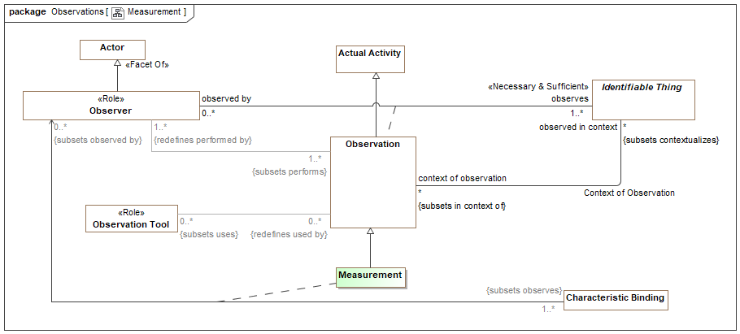

1. Measurement

## Diagram: Observations

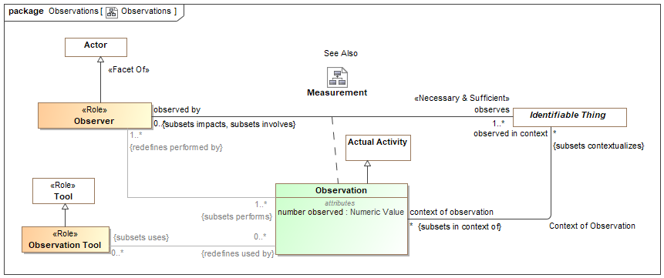

1. Observations

## Association Context of Observation

Context of an observations - e.g. the physical place, situation or timeframe in which the observation was made.

Direct Supertypes

Extent of Context

Association Ends

observed in context : Identifiable Thing [*] *Redefines*: negated within: Context



The context of an observation, what environment, location, timeframe or system is being observed. e.g. A man with a gun observed in an airport. The man is <observed in context> of the airport.

context of observation : Observation [*] *Redefines*: negated within: Context



Observations made in the context of the subject entity. E.G. Sightings within an airport.

## Association Class Measurement

A measurement is an observation made by <observed by> that <observes> the value of a characteristic for a particular entity, which is the Characteristic Binding the observer <observes>. The characteristic binding binds a particular value, e.g. 2 meters, with a particular characteristic, e.g. height, of a particular individual, e.g. John Smith.

As a characteristic binding is a temporal entity it has a time and context which may be different from the time and context of the measurement. e.g. The nurse "Sue" took the patients (Joe) weight measurement (Characteristic Binding - Joe <has weight> 94 KG) on 2/5/2010 at 9:31AM which was recorded as the patents current weight for 90 days.

Direct Supertypes

Observation

Association Ends

: Characteristic Binding [1..*] *Redefines*: negated within: Context



: Observer [0..*] *Redefines*: negated within: Context



## Association Class Observation

An observation is an actual (not possible) activity of the <observed by> observer where <observes> has been noticed or perceived as being significant. The observation is <observed in context> such as a place or condition. The observation <uses> any number of observation tools.

Example: Sam, a driver and Observer, notices <observes> a Deer <observed in context> of the road on which he is driving.

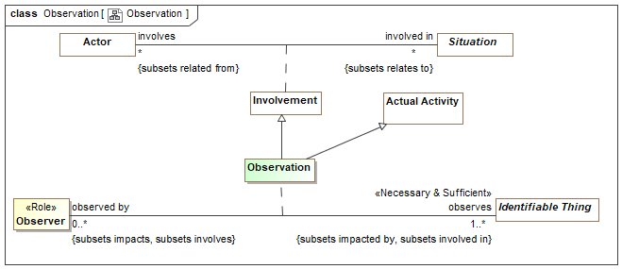

1. Observation

Direct Supertypes

Actual Activity, Impact, Involvement

Association Ends

observes : Identifiable Thing [1..*] *Redefines*: negated within: Context



Entity observed by an observer making an observation.

observed by : Observer [0..*] *Redefines*: negated within: Context



Observations of an entity by an observer.

Attributes

number observed : Numeric Value



The number of individual observations aggregated into a single observation. The <observes> entity will likely be a type.

E.G. Sue saw 5 birds.

## Class Observation Tool <<Role>>

A tools that assists in observations. e.g. a wireless microphone is used to observe a conversation.

Direct Supertypes

Tool

## Class Observer <<Role>>

Role of an actor that can or has observed something

Direct Supertypes

Actor

# Concept Library::Occurrences

Events are things that occur in time, impacting the things involved in those events. Events include actual events as well as patterns of events that describe a process.

## Diagram: Occurrences

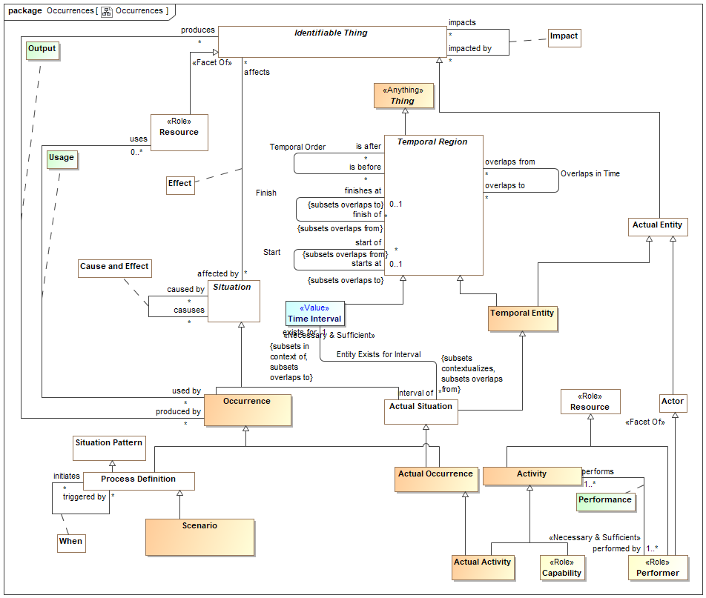

1. Occurrences

## Class Activity

A process performed by one or more actors intended to meet a need.

[UAF] Work, not specific to a single organization, weapon system or individual that transforms inputs (Resources) into outputs (Resources) or changes their state.

Direct Supertypes

Process, Resource

## Class Actor

An entity capable of behavior - performing an activity or process.

[IDEAS] Agent: Something capable of action.

[FIBO] AutonomousAgent: An agent is an autonomous individual that can adapt to and interact with its environment.

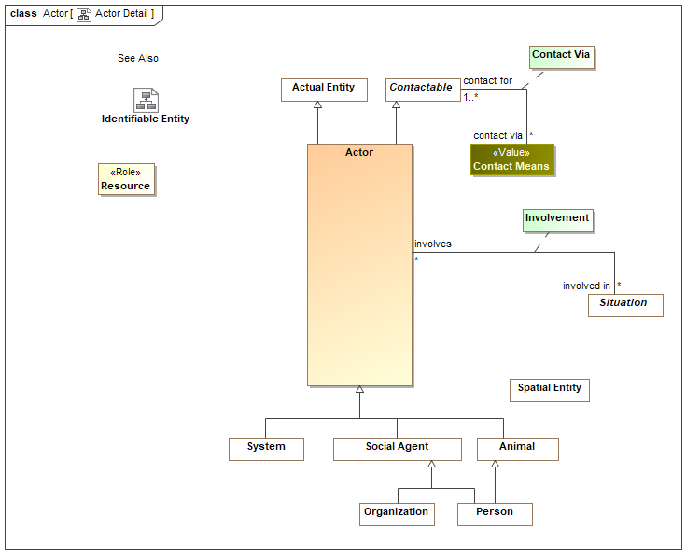

1. Actor Detail

Direct Supertypes

Actual Entity, Contactable

## Class Actual Activity

A specific, actual, activity that has or may happen.

Direct Supertypes

Activity, Actual Occurrence

## Class Actual Occurrence

A specific individual occurrence that has happened, is happening or may happen.

[FIBO] Occurrence: An Occurrence is a happening of an OccurrenceKind. Each Occur-rence has a DateTimeStamp, which identifies when the Occurrence happened, and a Location (possibly virtual), that identifies where the Occurrence happened.

Direct Supertypes

Actual Situation, Occurrence

## Class Occurrence

An Occurrence is a situation that "happens" (a.k.a. occurs). A dynamic situation (past, present or future) composed of a set of things changing over a period of time. e.g., a rock falling.

Occurrences are not limited in their timeframe. Occurrences can have long or short timeframes, from an instant to infinity and beyond.

[DOLCE] Perdurant

[BFO]Occurrent

[NIEM] ActivityType

Direct Supertypes

Situation

## Association Class Output

Outputs from a process or actual event - the things or situations it creates.

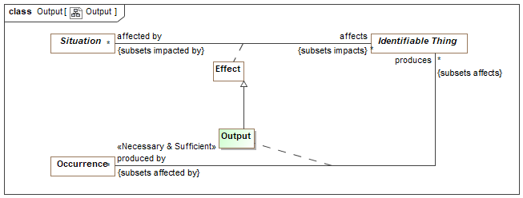

1. Output

Direct Supertypes

Effect

Association Ends

produces : Identifiable Thing [*] *Redefines*: negated within: Context



Resources produced by a process or actual event

produced by : Occurrence [*] *Redefines*: negated within: Context



Occurrences which produce an entity.

## Association Class Performance

Performance is the act of an actor as the driving force in the execution of an activity. Related to "Capability" as the ability to perform.

[DOLCE] Subtype of Participation

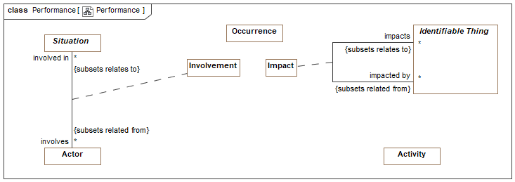

1. Performance

Direct Supertypes

Impact, Involvement, Occurrence

Association Ends

performs : Activity [1..*] *Redefines*: negated within: Context



An activity performed (executed or enacted) by an actor.

performed by : Performer [1..*] *Redefines*: negated within: Context



The actor which is the performer of an activity.

## Association Class Usage

Inputs to a process or actual event - what it uses

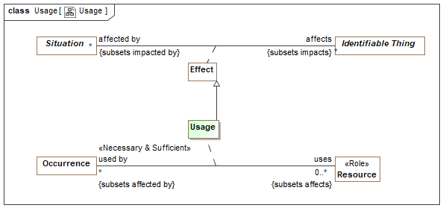

1. Usage

Direct Supertypes

Effect

Association Ends

uses : Resource [0..*] *Redefines*: negated within: Context



A resources used by a process or actual event.

used by : Occurrence [*] *Redefines*: negated within: Context



A process or actual occurrence that is used by a resource for the resource to fulfill its function.

# Concept Library::Organizations

An Organization is group of persons and/or other actors and resources organized for some end or work.

Subtypes of organizations include governments and corporations.

## Diagram: Organization

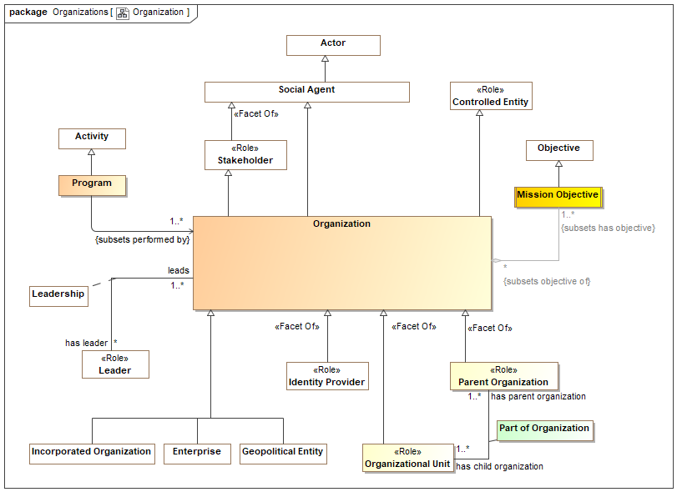

1. Organization

## Association Class Membership

Relationship representing the participation of an actor in an organization. Subtypes of membership may provide more explicit membership kinds.

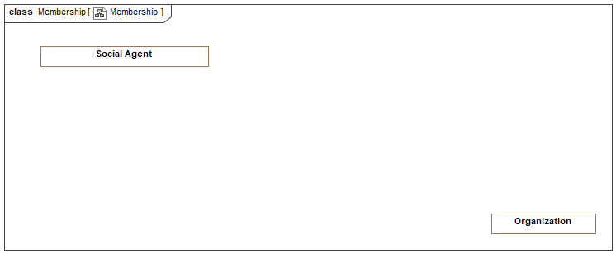

1. Membership

Direct Supertypes

Associated Actor

Association Ends

has member : Member [*] *Redefines*: negated within: Context



An assertion of membership in an organization.

[FIBO] hasMember

member of : Organization [*] *Redefines*: negated within: Context



Organization a performer belongs to.

[FIBO] memberOf

## Class Mission Objective

A core objective of an enterprise.

[BMM] A Mission indicates the ongoing operational activity of the enterprise. The Mission describes what the business is or will be doing on a day-to-day basis.

Direct Supertypes

Objective

## Class Organization

An Organization  is a group of persons and/or other actors and resources organized for some end or work

[FIBO] Organization: a social unit of people, systematically structured and managed to meet a need or pursue collective goals on a continuing basis.

[NIEM] OrganizationType

[DOLCE] Society

Direct Supertypes

Controlled Entity, Social Agent, Stakeholder

## Class Organizational Unit <<Role>>

Organizational unit is a role that encompasses subdivisions, departments, subsidiaries and other organizational parts of an organization.

[BMM] organization unit: An administrative or functional unit within an organization structure.

Direct Supertypes

Controlled Entity, Organization

## Class Parent Organization <<Role>>

Organization with component parts such as divisions and departments.

Direct Supertypes

Composite, Controlling Actor, Organization

## Association Class Part of Organization

Relationship between an organization and its organizational units - the sub-organizations such as departments and subsidiaries.

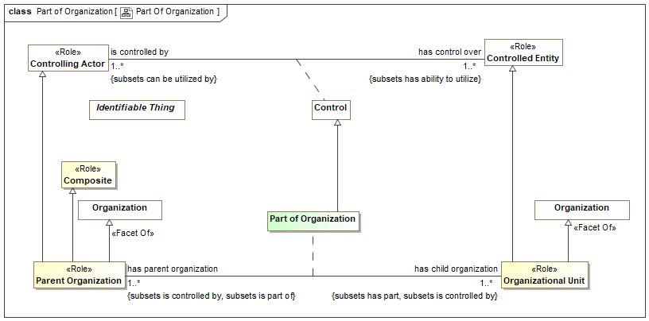

1. Part Of Organization

Direct Supertypes

Control, Parthood

Association Ends

has parent organization : Parent Organization [1..*] *Redefines*: negated within: Context



The parent (controlling organization) of another organization.

has child organization : Organizational Unit [1..*] *Redefines*: negated within: Context



An organization constituted as a component of another organization.

## Class Program

A set of projects, activities, or services of an organization that are intended to meet a need.

[NIEM] ProgramType

Direct Supertypes

Activity

# Concept Library::Organizations::Corporations

## Diagram: Corporations

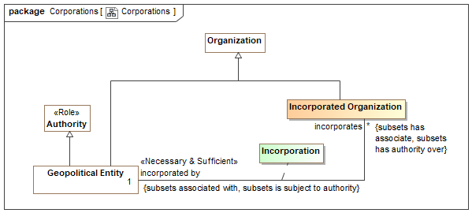

1. Corporations

## Class Incorporated Organization

An organization recognized by and incorporated by a recognized government.

[FIBO] FormalOrganization: an organization that is recognized in some legal jurisdiction, with associated rights and responsibilities

Direct Supertypes

Organization

## Association Class Incorporation

Act by which individuals' are voluntarily united into a new entity through the creation of an artificial, intangible, and legal person called a corporation.

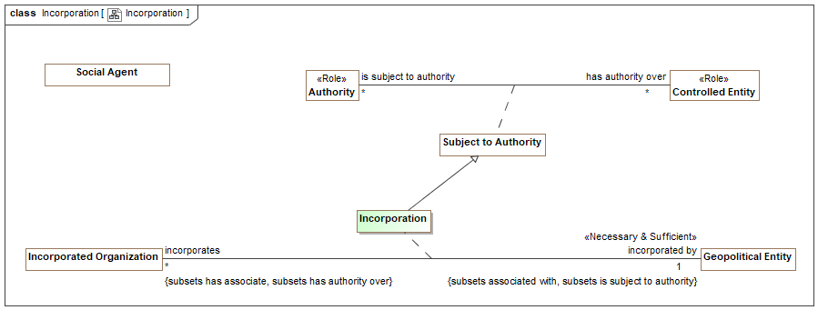

1. Incorporation

Direct Supertypes

Associated Actor, Subject to Authority

Association Ends

incorporated by : Geopolitical Entity [1] *Redefines*: negated within: Context



Geopolitical entity incorporating an organization.

incorporates : Incorporated Organization [*] *Redefines*: negated within: Context



An organization incorporated by a government.

# Concept Library::Organizations::Geopolitical Organizations

## Diagram: Geopolitical Entities

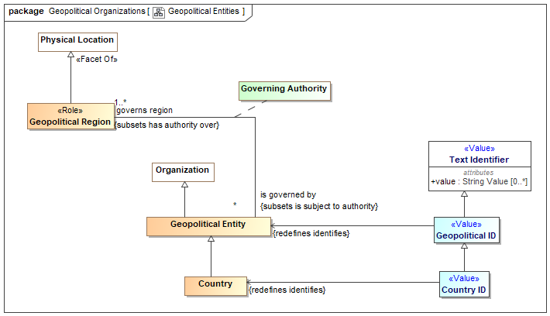

1. Geopolitical Entities

## Class Country

A nation with its own government, occupying a particular territory (not necessarily contiguous).

[FIBO] Country: A self-governing geopolitical unit that is recognized as a country by the United Nations (more specific concept as being recognized by the U.N.)

Direct Supertypes

Geopolitical Entity

## Class Country ID <<Value>>

A code, ID, or name for a country.

[ISO 1087] country identifier: information in a terminological entry (3.8.2) which indicates the name of a geographical region where the designation (3.4.1) is used

Direct Supertypes

Geopolitical ID

## Class Geopolitical Entity

An organization which is the governing body of a nation, state, tribe or community.

[FIBO] GeopoliticalEntity (In FIBO this is a subclass of Physical Location. In Threat/risk Geopolitical Region is a role of a physical location. FIBO combines Geopolitical Entity with Geopolitical Region).

Direct Supertypes

Authority, Organization

## Class Geopolitical ID <<Value>>

A code, ID or administered name for a geopolitical entity with governmental authority e.g., city, state, county, tribe.

Direct Supertypes

Text Identifier

## Class Geopolitical Region <<Role>>

A physical location governed by a geopolitical entity.

[FIBO] GeopoliticalEntity (In FIBO this is a subclass of Physical Location. In Threat/risk Geopolitical Region is a role of a physical location. FIBO combines Geopolitical Entity with Geopolitical Region.

[NIEM] LocaleType

Direct Supertypes

Physical Location

## Association Class Governing Authority

Relationship representing authority over a region.

Direct Supertypes

Associated Actor, Subject to Authority

Association Ends

governs region : Geopolitical Region [1..*] *Redefines*: negated within: Context



Region governed by a geopolitical entity.

is governed by : Geopolitical Entity [*] *Redefines*: negated within: Context



A governing authority for a region.

# Concept Library::Parthood

## Diagram: Parthood

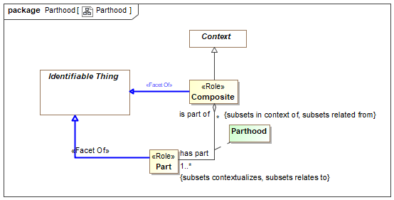

1. Parthood

## Class Composite <<Role>>

Direct Supertypes

Context, Identifiable Thing

## Class Part <<Role>>

Direct Supertypes

Identifiable Thing

## Association Class Parthood

Relationship defining one thing as a part of another. More specific concepts of parthood and mereology (the study of parts and their relations) may subtype Parthood.

[IDEAS] wholePart: The whole-part pattern establishes a relationship between individual elements, asserting that one Object element is composed of the other element.

[IDEAS] A couple that asserts one (part) Individual is part of another (whole) Individual.

[ISO 1087] partitive relation: part-whole relation relation between two concepts (3.2.1) where one of the concepts constitutes the whole and the other concept a part of that whole

[DOLCE] Parthood

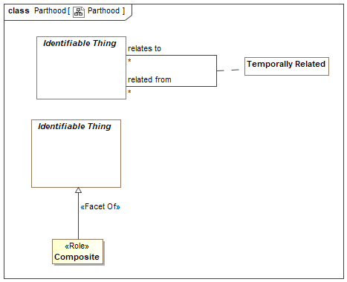

1. Parthood

Direct Supertypes

Temporally Related

Association Ends

has part : Part [1..*] *Redefines*: negated within: Context



Entity that is a part of the subject entity (the whole) such that the part is essential to the whole.

This is a general concept of part and does not assume exclusivity of partness or total part inclusion.

[FIBO] hasPart

[ISO 1087] partitive concept: concept (3.2.1) in a partitive relation (3.2.22) viewed as one of the parts making up the whole

is part of : Composite [*] *Redefines*: negated within: Context



Composite entity (whole) of which this entity is a part.

[FIBO] isPartOf

[ISO 1087] comprehensive concept: concept (3.2.1) in a partitive relation (3.2.22) viewed as the whole

# Concept Library::Permissions

Concepts relating to the permission an actor has to perform some process.

## Diagram: Permission

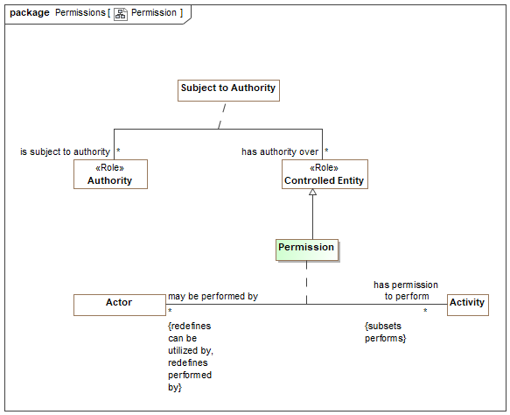

1. Permission

## Association Class Permission

Permission is a relationship representing authorization granted by an authority to an actor to perform a kind of activity. THe activity may be either an "Actual Activity" or a kind of activity - a Modus Operandi.

Direct Supertypes

Ability, Controlled Entity

Association Ends

has permission to perform : Activity [*] *Redefines*: negated within: Context



Activity the actor has permission to perform.

may be performed by : Actor [*] *Redefines*: negated within: Context



Actors that have permission to perform the subject activity.

Attributes

revokes permission : Boolean



Inverts or removes the permission asserted by the permission relationship.

# Concept Library::Persons

This person module defines foundation concepts of people such as their location and name. More specific person attributes may augment this specification.

## Diagram: Person

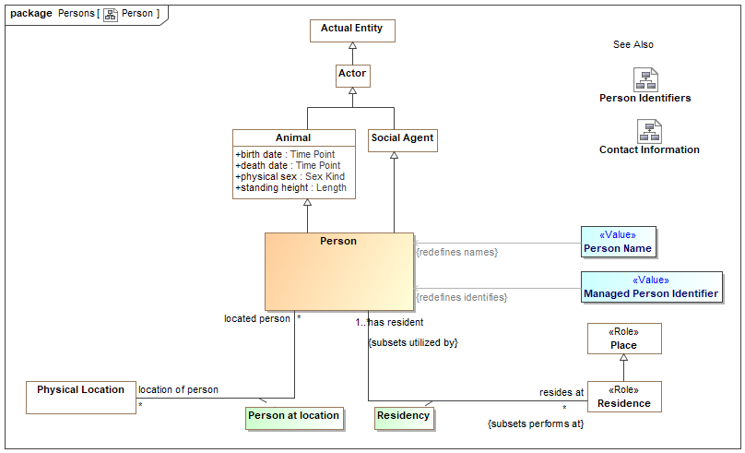

1. Person

## Diagram: Person Identifiers

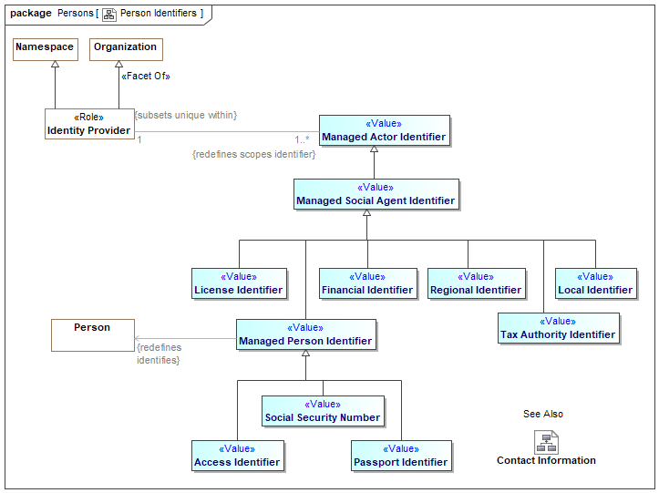

1. Person Identifiers

## Diagram: Person Name Representations

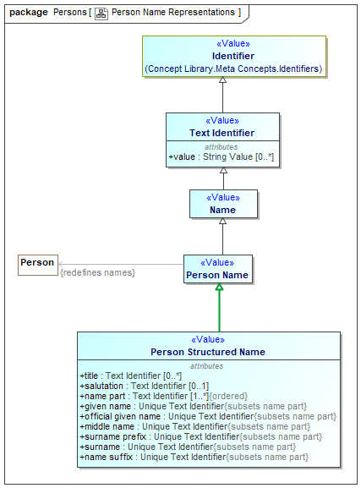

1. Person Name Representations

## Class Access Identifier <<Value>>

An term, data value or other sign that identifies a person for access to a resource.

Direct Supertypes

Managed Person Identifier

## Class Financial Identifier <<Value>>

An identifier for purposes of making financial transactions, such as a credit card number or bank account.

Direct Supertypes

Managed Social Agent Identifier

## Class Managed Person Identifier <<Value>>

An identifier for a person managed by some identity provider who asserts the validity of the identifier, frequently but not always a government organization.

Direct Supertypes

Managed Social Agent Identifier

## Class Passport Identifier <<Value>>

[NIEM] PersonPassportIdentification (property): An identification of a passport issued to a person.

Direct Supertypes

Managed Person Identifier

## Class Person

An individual human being.

[FIBO] Person

[NIEM] PersonType

[DOLCE] (Subtype of) Agentive Physical Object

Direct Supertypes

Animal, Social Agent

## Association Class Person at location

A relationship representing the location of a person at a particular time.

[NIEM] PersonLocationAssociationType

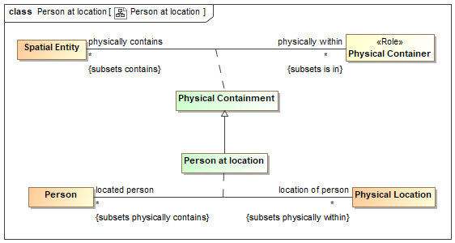

1. Person at location

Direct Supertypes

Physical Containment

Association Ends

location of person : Physical Location [*] *Redefines*: negated within: Context



Location of the subject person.

[FIBO] isSituatedAt (mode general concept)

located person : Person [*] *Redefines*: negated within: Context



A person who is at a location.

## Class Person Name <<Value>>

Text identifying a person by a recognized name.

[FIBO] hasFullLegalName (More specific concept)

[NIEM] PersonNameType

Direct Supertypes

Name

## Class Person Structured Name <<Value>>

A full name of a person in a structured form.

Note: Conversion between structured and textual names is provided by the implementation and is not defined in this specification.

Direct Supertypes

Person Name

Attributes

title : Text Identifier [0..*]



[NIEM] PersonNamePrefixText: A title or honorific used by a person.

salutation : Text Identifier [0..1]



[NIEM] PersonNameSalutationText: A formal sign or expression of greeting that is appropriate for a person.

name part : Text Identifier [1..*]



Parts of a person's name, e.g., surname, given name.

[FIBO] hasFamilyName

given name : Unique Text Identifier



[NIEM] PersonGivenName: A first name of a person.

[FIBO] hasGivenName

official given name : Unique Text Identifier



[NIEM] PersonOfficialGivenName: A name, out of possibly multiple given names, that a person selects to use as his or her official given name.

middle name : Unique Text Identifier



[NIEM] PersonMiddleName: A middle name of a person.

surname prefix : Unique Text Identifier



[NIEM] PursonSurNamePrefix: A prefix that precedes this person's family name such as Van, Von.

surname : Unique Text Identifier



[NIEM] PersonSurName: A last name or family name of a person.

[FIBO] hasSurname

name suffix : Unique Text Identifier



[NIEM] PersonNameSuffixText: A term appended after the family name that qualifies the name.

## Association Class Residency

A residence of a person - where they live.

[NIEM] PersonResidenceAssociationType

[FIBO] Residence: Note that residence is not the same as domicile, as a person or organization can have many transient residences but only one legal domicile. The domicile of a formal organization is the address (location) where the establishment is maintained or where the governing power of the organization is exercised.

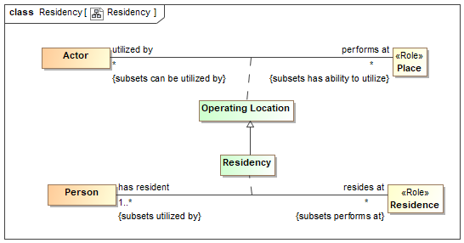

1. Residency

Direct Supertypes

Operating Location

Association Ends

resides at : Residence [*] *Redefines*: negated within: Context



A residence of a person, where they live.

[FIBO] isDomiciledIn: identifies the permanent home or principal establishment of an individual or organization

has resident : Person [1..*] *Redefines*: negated within: Context



A person living in a residence.

## Class Social Security Number <<Value>>

[NIEM] PersonSSNIdentification (property): A unique identification reference to a living person; assigned by the United States Social Security Administration.

Direct Supertypes

Managed Person Identifier

# Concept Library::Physical Entities

This package defines a hierarchy of physical entities and items. Items are inanimate material object as distinct from a living sentient being.

## Diagram: Physical Entities

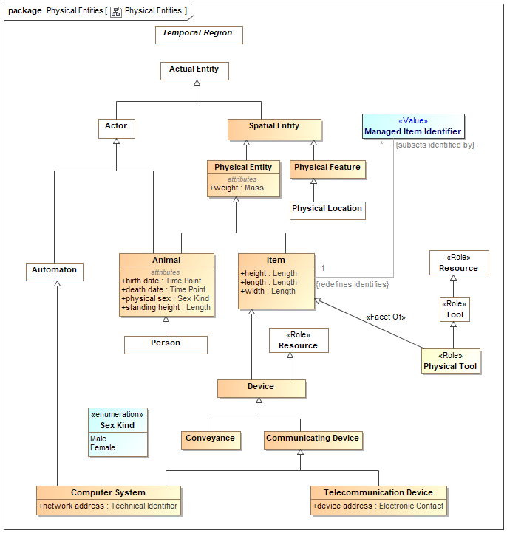

1. Physical Entities

## Class Animal

Any member of the kingdom Animalia, comprising multicellular organisms that have a well-defined shape and usually limited growth, can move voluntarily, actively acquire food and digest it internally, and have sensory and nervous systems that allow them to respond rapidly to stimuli. A super type of "Person".

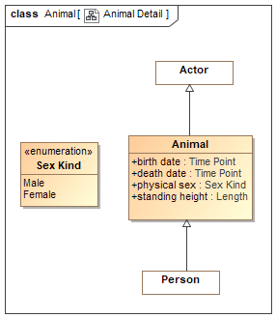

1. Animal Detail

Direct Supertypes

Actor, Physical Entity

Attributes

birth date : Time Point



The date an animal (including a person) was born, became an independent entity.

[FIBO] hasDateOfBirth

death date : Time Point



The date an animal (including a person) died, ceased to be living.

physical sex : Sex Kind



Sex of a living thing as indicated by essential physical characteristics, primarily genitalia.

[FIBO] hasGender

standing height : Length



The measurement from base to top or (of a standing person) from head to foot. "Current" is relative to the time frame of the defining context.

## Class Conveyance

A device or system providing a means of physical transport from place to place.

[NIEM] ConveyanceType

Direct Supertypes

Device

## Class Device

A thing made for a particular purpose; an invention or contrivance, especially a mechanical or electrical one.

[NIEM] DeviceType

Direct Supertypes

Item, Resource

## Class Item

An inanimate material object as distinct from a living sentient being.

[NIEM] ItemType

[DOLCE] Non-agentive Physical Object

Direct Supertypes

Physical Entity

Attributes

height : Length



[NIEM]ItemHeightMeasure: A measurement of the height of an item.

A measurement in the vertical plane. For a person, from head to toe.

length : Length



[NIEM] ItemLengthMeasure: A measurement of the length of an item.

A longitudinal measurement - from end to end. Usually greater than width.

width : Length



[NIEM] ItemWidthMeasure: A measurement of the width of an item.

A horizontal measurement - from side to side.

## Class Managed Item Identifier <<Value>>

[NIEM] An identification inscribed on or attached to a part, collection of parts, or complete unit by the manufacturer. Syn. ItemSerialIdentification.

[FIBO] ProductIdentifier: an identifier for a product

Direct Supertypes

Unique Identifier

## Class Physical Entity

A thing that exists in space and time including people, places, and things.

[DOLCE] Object

[IDEAS] Individual: A Thing that has spatio-temporal extent.

Note1 - this may be some that existed in the past, exists now, or may exist in some future possible world.

Note2 - the Individual may be scattered - i.e. it is the fusion of several disconnect parts.

Direct Supertypes

Spatial Entity

Attributes

weight : Mass



The current weight (as mass) of a physical thing.

## Class Physical Feature

Physical features are spacial entities which are generically constantly dependent on physical objects (their hosts). Typical examples of features are “parasitic entities” such as holes, boundaries, surfaces, or stains. Physical features do not have mass independent of their host.

[DOLCE] Feature

Direct Supertypes

Spatial Entity

## Class Physical Tool <<Role>>

An physical item intended to be used to perform some function.

Direct Supertypes

Item, Tool

## Class Spatial Entity

A thing that exists in space: The union of locations and physical entities.

[DOLCE] Physical Endurant

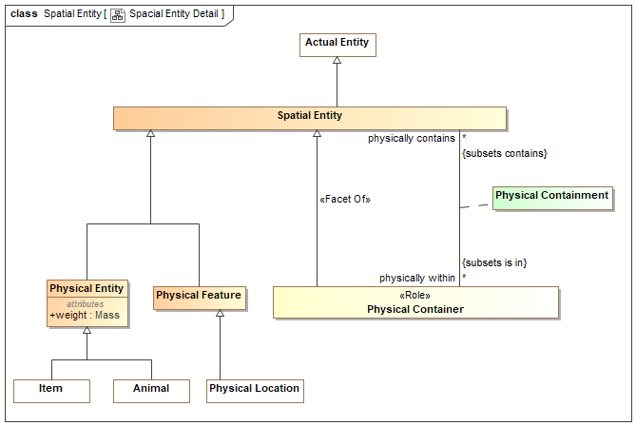

1. Spacial Entity Detail

Direct Supertypes

Actual Entity

## Class Telecommunication Device

A device for human to human communication over a distance by cable, telegraph, telephone, computer networks, or broadcasting.

[NIEM] TelecommunicationsDeviceType

Direct Supertypes

Communicating Device

Attributes

device address : Electronic Contact



An code or number used to communicate with or through a telecommunications device.

### Enumeration Sex Kind

Kinds of sex. Eg. male/female.

package Concept Library::Physical Entities

public enum Sex Kind

{Male, Female}

Literals

Male



A male person, plant, or animal. One able to fertilize a female with gametes.

Female



A female person, plant, or animal. Of or denoting the sex that can bear offspring or produce eggs, distinguished biologically by the production of gametes (ova) that can be fertilized by male gametes:



1. Physical Entities

# Concept Library::Places

This package defines concepts related to places. Places are buildings or localities used or intended for a purpose.

## Diagram: Place

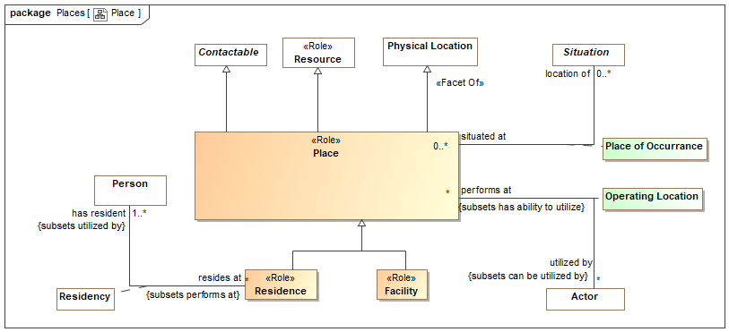

1. Place

## Class Facility <<Role>>

[NIEM] FacilityType: A building, place, or structure that provides a particular service.

Direct Supertypes

Place

## Association Class Operating Location

Place where an actor performs activities.

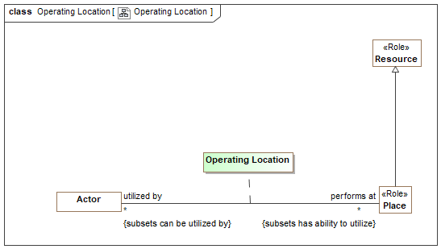

1. Operating Location

Direct Supertypes

Ability

Association Ends

performs at : Place [*] *Redefines*: negated within: Context



Places where an actor perform activities.

utilized by : Actor [*] *Redefines*: negated within: Context



Actors who utilizes a place to perform activities.

## Class Place <<Role>>

A building or locality used or intended for a specific purpose such as a house or factory.

[FIBO] Facility: something that is built, contrived, established, or installed to serve a particular purpose, or make some course of action or operation easi-er, or provide some capability or service

Direct Supertypes

Contactable, Physical Location, Resource

## Association Class Place of Occurrance

Relationship describing where something happens.

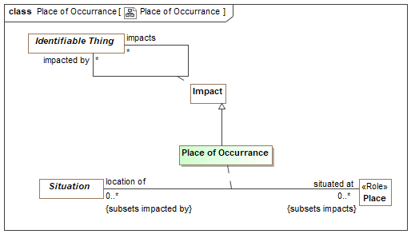

1. Place of Occurrance

Direct Supertypes

Impact

Association Ends

situated at : Place [0..*] *Redefines*: negated within: Context



Place where a situation or event is located or happens.

location of : Situation [0..*] *Redefines*: negated within: Context



Situations (Events, incidents, static arrangements, etc.) that happen at the subject place.

## Class Residence <<Role>>

A place where people live/reside.

Direct Supertypes

Place

# Concept Library::Policies

This package defines concepts related to policies. Policies deal with conditions asserted on one entity by another. This includes requirements and laws.

## Diagram: Policy

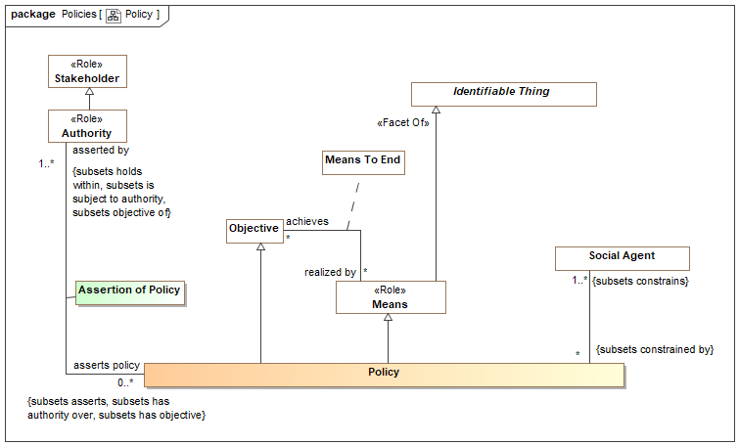

1. Policy

## Association Class Assertion of Policy

The assertion of a policy by an authority.

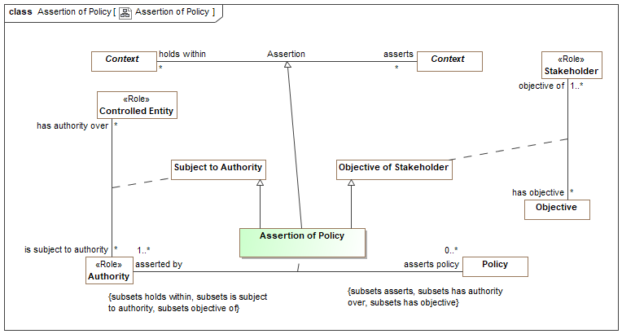

1. Assertion of Policy

Direct Supertypes

Assertion, Objective of Stakeholder, Subject to Authority

Association Ends

asserts policy : Policy [0..*] *Redefines*: negated within: Context



A policy asserted by an authority whom states with authority that it must be followed.

asserted by : Authority [1..*] *Redefines*: negated within: Context



The authority that asserts a policy, states with authority that it must be followed

## Class Policy

A policy is a thing that is compulsory; a necessary condition.

A statement that identifies a necessary attribute, capability, characteristic, or quality of a system for it to have value and utility to a customer, organization, internal user, or other stakeholder. The constrained parties are identified as the <constrains> responsible performer(s).

A policy is a means in that it fulfills a broader objective. A policy is an objective in that performers seek to comply with the objective. A policy is a state in that it is a situation that exists for a finite period of time.

Policies include requirements.

[BMM] Business policy: directive that is concerned with directly controlling, influencing, or regulating the actions of an enterprise and the people in it and that is not directly enforceable

Direct Supertypes

Controlled Entity, Means, Objective

# Concept Library::Predictions

Predictions are acts where an actor predicts that some possible situation will occur.

## Diagram: Prediction

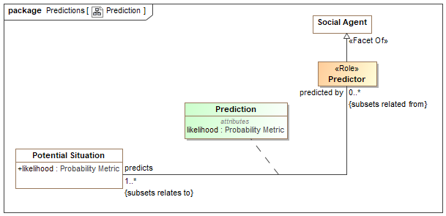

1. Prediction

## Association Class Prediction

A prediction is a forecast that potential situations will happen.

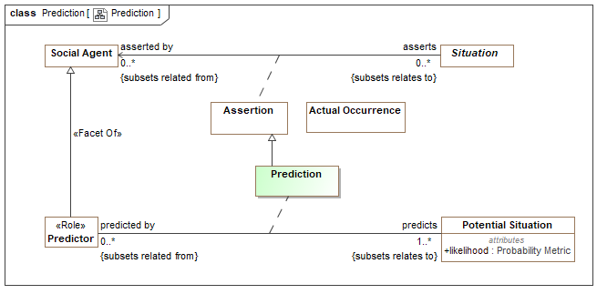

1. Prediction

Direct Supertypes

Assertion

Association Ends

predicts : Potential Situation [1..*] *Redefines*: negated within: Context



The situation that is postulated by a prediction.

predicted by : Predictor [0..*] *Redefines*: negated within: Context



Predictor is the role of the actor who made a prediction.

Attributes

likelihood : Probability Metric



Metric representing the possibility that the containing element represents reality.

## Class Predictor <<Role>>

The role of an actor making predictions.

Direct Supertypes

Social Agent

# Concept Library::Processes

A package representing concepts about processes. Processes are templates for (descriptions of) a related sets of Events (activities, events, etc.). Processes may be natural, organizational or carried out by an actor. Processes carried out by an actor are plans.

Processes may require resources - noting that resource can be a role of any entity.

Processes are essentially patterns of Events.

Scenarios are typically less formal processes and describe how a series of Events may play out.

## Diagram: Process

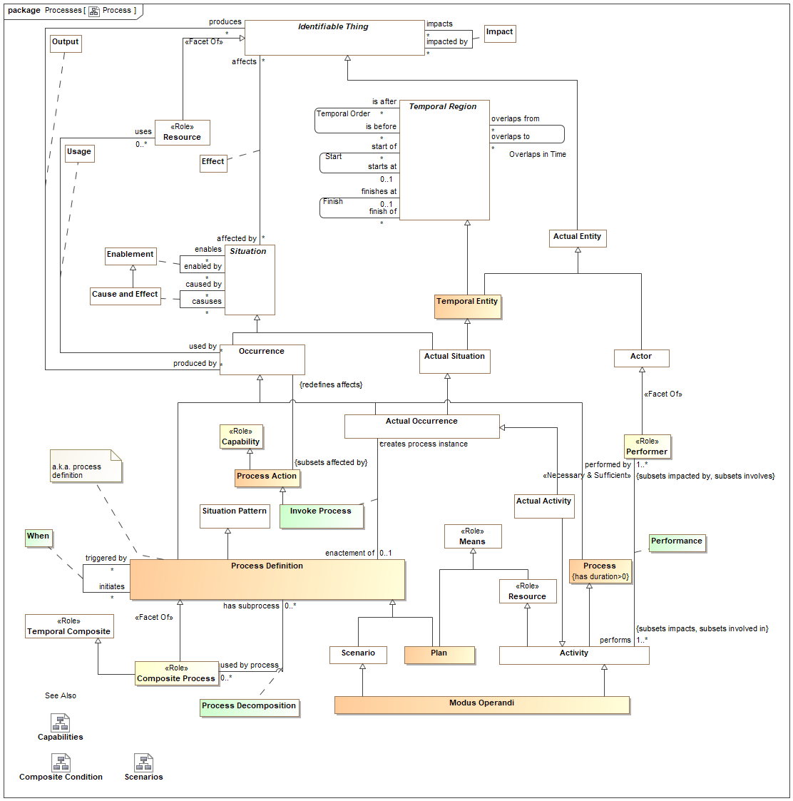

1. Process

## Class Atomic Occurrence

An occurrence with zero duration on a relevant time scale representing an atomic unit of change, sometimes called an event.

Direct Supertypes

Occurrence

## Class Composite Process <<Role>>

Direct Supertypes

Process Definition, Temporal Composite

## Association Class Invoke Process

The activity of initiating the performance of a process.

The process instance will be classified by the process.

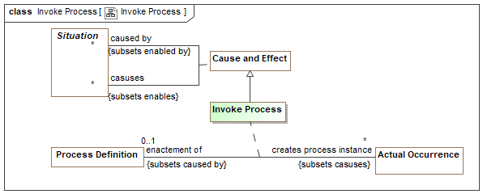

1. Invoke Process

Direct Supertypes

Cause and Effect, Create, Process Action

Association Ends

creates process instance : Actual Occurrence [*] *Redefines*: negated within: Context



An actual Event created as the instantiation of a process definition.

enactement of : Process Definition [0..1] *Redefines*: negated within: Context



Process enacted by an Invoke Process

## Class Modus Operandi

A particular way or method an actor typically does something, especially one that is characteristic or well-established. It may or may not have a formal definition of the process.

In threat terms, a particular tactic, technique or procedure for achieving a result.

Syn. TTP [STIX]

Direct Supertypes

Activity, Scenario

## Class Plan

A plan is a design for a process that supports a stakeholders objectives. As a process definition a plan is a pattern for a series of activities as well as the resources required to meet objectives.

Scenario's are observed where as plans are designed.

[BMM] Course of Action: A Course of Action is an approach or plan for configuring some aspect of the enterprise involving things, processes, locations, people, timing, or motivation undertaken to achieve Desired Results. In other words, a Course of Action channels efforts towards Desired Results. To help ensure success in this regard, Courses of Action are governed by Directives.

Direct Supertypes

Means, Process Definition

## Class Process

An process is an occurrence with a non-zero duration frequently having sub-processes (parts).

[BFO] Event: perdurant that is related to exactly two states (its pre-state and its post-state).

An event is related to the states before and after it has happened.

Direct Supertypes

Occurrence

## Class Process Action

An action impacting a potential or realized process.

Direct Supertypes

Capability

## Association Class Process Decomposition

Relationship describing the decomposition of a process.

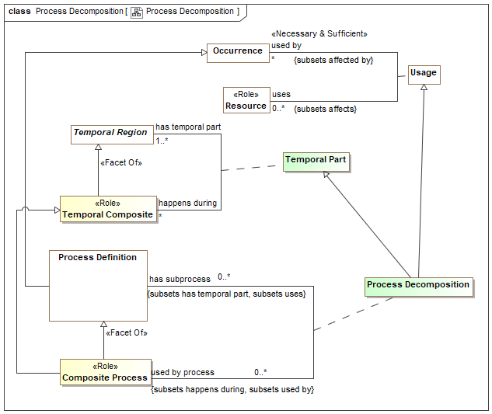

1. Process Decomposition

Direct Supertypes

Temporal Part, Usage

Association Ends

has subprocess : Process Definition [0..*] *Redefines*: negated within: Context



Process occurring within the scope of and in support a composite process.

used by process : Composite Process [0..*] *Redefines*: negated within: Context



Composite processes which utilize the subject property as a component part.

## Class Process Definition

A process pattern is a template and definition for a family of Events (i.e. actions, events) that results in an outcome. A process may be natural or caused by the activities of actors, in which case it is a plan.

A process may contain other entities, sub-processes and situations to define characteristics and sub-processes of the process. The sub-processes may or may not be known, sub-processes are defined using "Temporal Part".

[ISO 14971:2007] set of interrelated or interacting activities which transforms inputs into outputs

Direct Supertypes

Occurrence, Situation Pattern

## Association Class When

A "When" rule defines an atomic process where by a <trigger> conditionally causes the <initiates> process to be invoked when the <trigger> process is matched under conditions(s) of the context - a proactive cause and effect. This results in an invocation of the <initiates> process.

E.g. when <trigger> do <initiates>

Also known as a "Course of action" or "ECA Rule" .

[PRR] ProductionRule: A ProductionRule is a statement of programming logic that specifies the execution of one or more actions in the case that its conditions are satisfied.

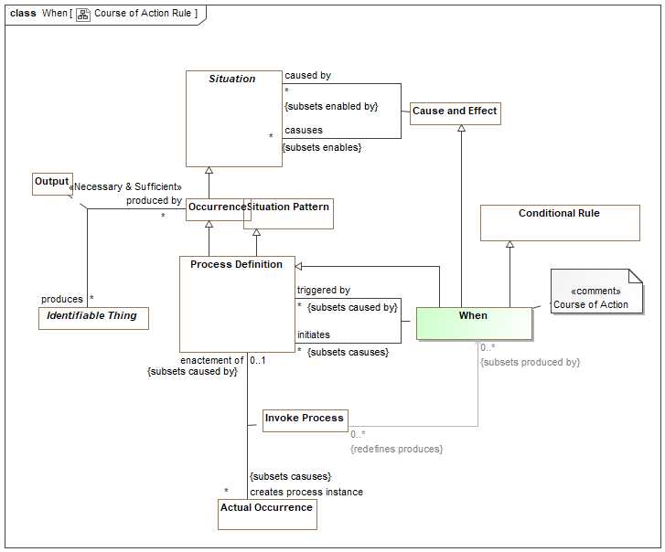

1. Course of Action Rule

Direct Supertypes

Cause and Effect, Conditional Rule, Process Definition

Association Ends

initiates : Process Definition [*] *Redefines*: negated within: Context



Processes that will occur if the <trigger> process occurs. Consequent.

triggered by : Process Definition [*] *Redefines*: negated within: Context



Processes that may cause the <initiates> process to occur. Antecedent.

# Concept Library::Processes::Capabilities

Actions that impact various kinds of entities in specific ways. Such actions can be the subject of or part of processes, permissions, capabilities, or objectives.

## Diagram: Capabilities

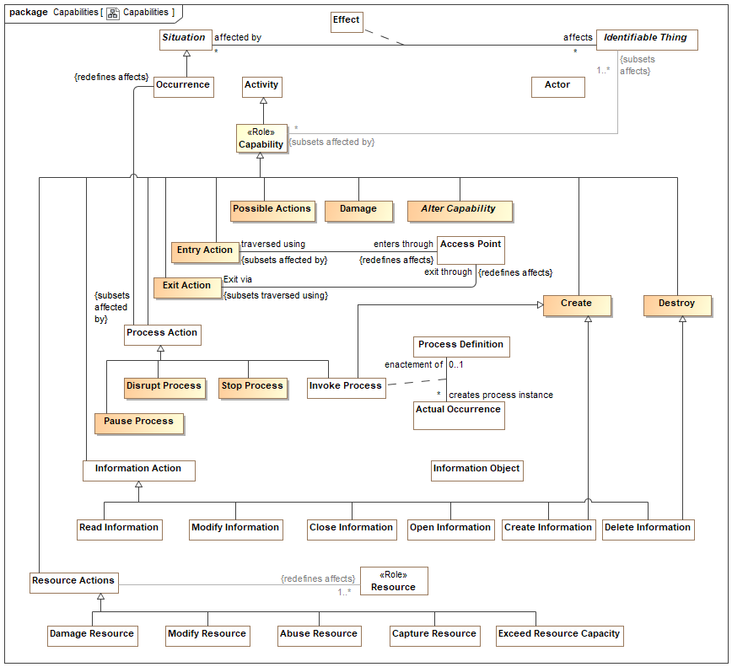

1. Capabilities

## Class Capability <<Role>>

A particular ability or capacity that an actor may possess or exchange to achieve a specific purpose or outcome.

Where a specific actor possesses the capability, the actor has an ability.

Adapted from: Ulrich Homann, “A Business-Oriented Foundation for Service Orientation”, 2006.

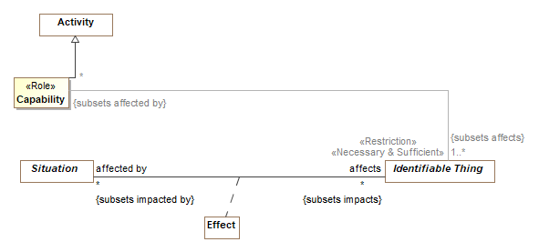

1. Event Effecting Entity

Direct Supertypes

Activity

## Class Create

The creation of something

Direct Supertypes

Capability

## Class Damage

An action that causes an entity to no longer completely fulfill its purpose.

Direct Supertypes

Capability

## Class Destroy

The destruction or deletion of something.

Direct Supertypes

Capability

## Class Disrupt Process

An action intended to cause a process to not achieve its desired affect.

Direct Supertypes

Damage, Process Action

## Class Entry Action

The action of entering through a boundary.

Direct Supertypes

Capability

## Class Exit Action

An action of exiting through a boundary.

Direct Supertypes

Capability

## Class Pause Process

An action that pauses a process instance such that it can be restarted.

Direct Supertypes

Process Action

## Class Possible Actions

All possible effects to an entity.

Direct Supertypes

Capability

## Class Stop Process

An action to terminate a process.

Direct Supertypes

Process Action

# Concept Library::Processes::Composite Conditions

Composite conditions provide for "and"/"or" evaluation of causality between situations.

## Diagram: Composite Condition

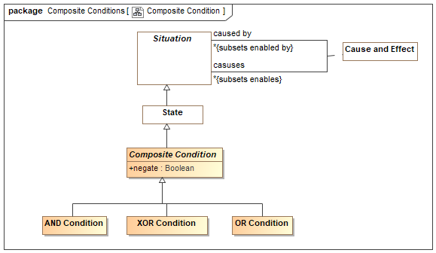

1. Composite Condition

## Class AND Condition

A situation that is true (happening) only when all "enabled by" are true - AND

Direct Supertypes

Composite Condition

## Class Composite Condition

A composite condition is a state that is inferred to be true or false based on the set of "affected by" (input) situations and the logic of the specific composite event subtype and the condition (if any).

The composite condition can then be used to trigger a set of "effects" (output) situations.

Combinations of Events, states. and composite conditions be combined with composite conditions to represent fault, flow or dependency graphs.

Note that cause & effect, negation and enablement are all subtypes of effect and can be combined using composite conditions.

Direct Supertypes

State

Attributes

negate : Boolean



Negates the logic of a complex event - NOT <condition>

## Class OR Condition

A composite condition that is true (occurring) when any "affected by" is true - OR

Direct Supertypes

Composite Condition

## Class XOR Condition

A state that is True only when exactly one of its "affected by" is true - XOR

Direct Supertypes

Composite Condition

# Concept Library::Processes::Scenarios

Scenarios describe sequences and/or dependent situation patterns that include fault trees, attack/defense trees and other scenarios impacting stakeholders.

The attack-defense tree model is based on [Schweitzer 2013]

The attack-defense tree formalism can informally be described as follows. For a security scenario, the main goal of the attacker is depicted by the root node of a tree, an attack goal. Two types of refinement relations help to detail the model. Disjunctive (or) and constructive (and). Both types of refinement are recursively applied. Defense goals lower the probability of an attackers success, attack goals increase the probability.

## Diagram: Scenarios

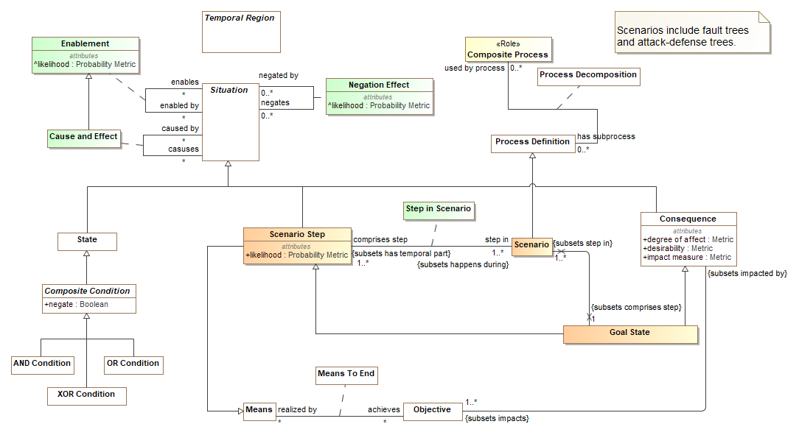

1. Scenarios

A performance goal that is an objective to disrupt some resource.

## Class Goal State

A goal state is a step in a scenario that directly impacts resources of a stakeholder, thereby impacting the goals of the same or a different stakeholder. Goal states may be positive (e.g. making more money) or negative (e.g. an attack target).

A goal state is usually but not necessarily the end state of a scenario.

Direct Supertypes

Consequence, Scenario Step

## Class Scenario

A scenario is a process pattern that provides template for a set of steps (may be but are not always activities) and resource that formally or informally depict how things may happen based on observations of similar occurrences. Scenarios are intended to be descriptive, not prescriptive.

Scenarios are described by at least one scenarios steps, one of which must provide a goal state.

Scenarios include attack/defense and fault trees.

Direct Supertypes

Process Definition

## Class Scenario Step

A scenario step is a node in one or more scenarios that ultimately result in consequences.

Direct Supertypes

Means, Situation

Attributes

likelihood : Probability Metric



Metric representing the probability that the scenario step will happen.

## Association Class Step in Scenario

Definition of a particular step as comprising a particular scenario.

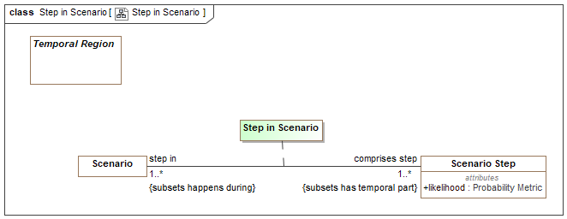

1. Step in Scenario

Direct Supertypes

Temporal Part

Association Ends

comprises step : Scenario Step [1..*] *Redefines*: negated within: Context



A step in a scenario that is or leads to a goal state.

step in : Scenario [1..*] *Redefines*: negated within: Context



Scenario in which is defined, in part, be a step.

# Concept Library::Quantities and Units

This package defines quantities and units. Quantities are the basis for units and measurements.

Qualities of things are represented with respect to what that thing means, not how it is represented. This introduces multiple "quantity kinds" which derive from Value and Quantity. Quantiles are stereotyped as "Quantity Kind".

The representation of a value or quantity will typically use the "primitive types" that are found in I.T. systems such as "Integer", "Real" and "String".

.

## Diagram: Quantities and units

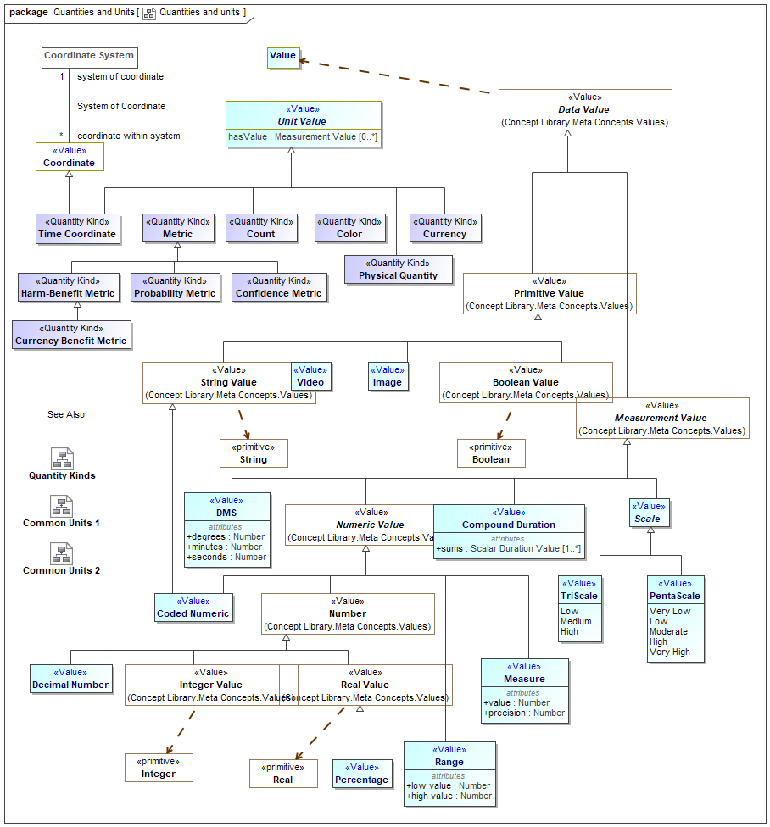

1. Quantities and units

## Class Confidence Metric <<Quantity Kind>>

Any metric of confidence that something is true or valid.

Direct Supertypes

Metric

## Class Count <<Quantity Kind>>

The number of something used as a property or metric, e.g., 5 fish.

Direct Supertypes

Unit Value

## Class Currency Benefit Metric <<Quantity Kind>>

A metric for benefit or harm expressed in terms of a currency, such as dollars or yen.

Direct Supertypes

Harm-Benefit Metric

## Class Harm-Benefit Metric <<Quantity Kind>>

A metric to quantify benefit or harm.

Direct Supertypes

Metric

## Class Metric <<Quantity Kind>>

A standard for measuring or evaluating something in a quantifiable way.

Typical representations of a metric may be a fraction from zero to 1 or a rating such as "high, medium, low". Not to be confused with the "Metric System".

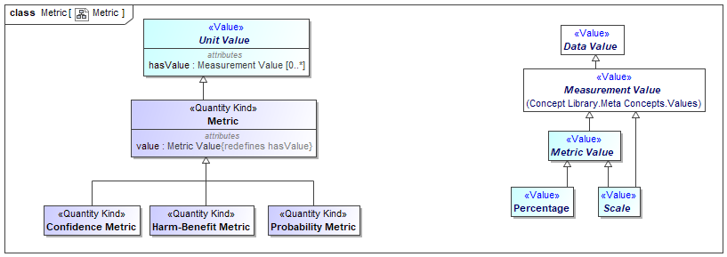

1. Metric

Direct Supertypes

Unit Value

Attributes

value : Metric Value



The value of a quantity that, when multiplied by the unit defined in a subtype of quantity kind, specifies a measurement value such as 3 Meters.

## Class Probability Metric <<Quantity Kind>>

A metric that represents the possibility that something uncertain will happen.

Direct Supertypes

Metric

## Class Time Coordinate <<Quantity Kind>>

An identifier for a particular point in time, recognizing that any such point is an interval at a finer level of granularity.

Specific time coordinate systems, such as ISO or Internet time, specialize Time Coordinate and relate it to a time scale.

[DTV] time point: concept that specializes the concept 'time interval' and that is a member of a time scale

[ISO11404] time: time is a family of datatypes whose values are points in time to various common resolutions: year, month, day, hour, minute, second, and fractions thereof.

Direct Supertypes

Coordinate, Unit Value

Attributes

value : Duration



### <<Value>>Enumeration PentaScale <<Value>>

An scale of 5 values the interpretation of which is context specific.

Direct Known Superclasses

Scale

package Concept Library::Quantities and Units

public enum PentaScale

{Very Low, Low, Moderate, High, Very High}

Literals

Very Low



Low



Moderate



High



Very High



1. Quantities and units

### <<Value>>Enumeration TriScale <<Value>>

A scale of 3 arbitrary levels.

Direct Known Superclasses

Scale

package Concept Library::Quantities and Units

public enum TriScale

{Low, Medium, High}

Literals

Low



Medium



High



1. Quantities and units

# Concept Library::Quantities and Units::Quantity Kinds

Quantity kinds are abstractions for the way we measure or quantify things, such as mass or length. Units provide specific ways to specify a quantity kind.

## Diagram: Quantity Kinds

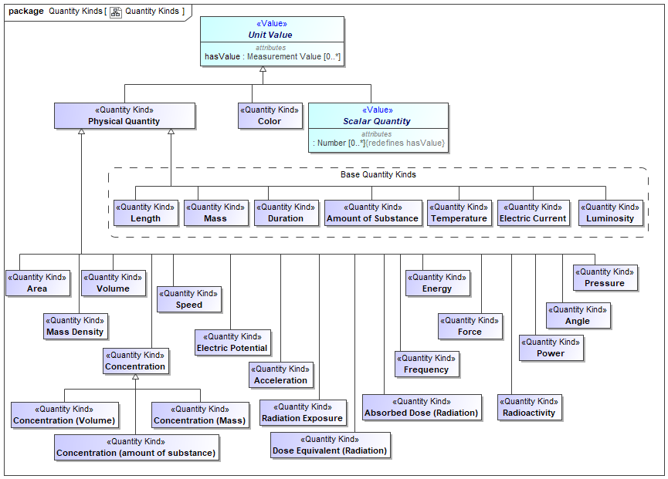

1. Quantity Kinds

## Class Absorbed Dose (Radiation) <<Quantity Kind>>

The energy of ionizing radiation absorbed per unit mass by a body, often measured in rads.

Direct Supertypes

Physical Quantity, Scalar Quantity

## Class Acceleration <<Quantity Kind>>

The rate of change of velocity per unit of time.

Direct Supertypes

Physical Quantity, Scalar Quantity

## Class Amount of Substance <<Quantity Kind>>

The abstract unit of the amount of a substance which is the supertype of all amount units and also acts as its "quantity kind".

Amount of substance is a standards-defined quantity that measures the size of an ensemble of elementary entities, such as atoms, molecules, electrons, and other particles. It is sometimes referred to as chemical amount. The International System of Units (SI) defines the amount of substance to be proportional to the number of elementary entities present. The SI unit for amount of substance is the mole. It has the unit symbol mol.

Direct Supertypes

Physical Quantity, Scalar Quantity

## Class Angle <<Quantity Kind>>

The space (usually measured in radians or degrees) between two intersecting lines or surfaces at or close to the point where they meet.

Direct Supertypes

Physical Quantity, Scalar Quantity

## Class Area <<Quantity Kind>>

[QUDT] Area is a quantity expressing the two-dimensional size of a defined part of a surface, typically a region bounded by a closed curve.

Direct Supertypes

Physical Quantity, Scalar Quantity

## Class Color <<Quantity Kind>>

Color is the visual perceptual property corresponding in humans to the categories called red, blue, yellow, and others. Color derives from the spectrum of light (distribution of light power versus wavelength) interacting in the eye with the spectral sensitivities of the light receptors. Color categories and physical specifications of color are also associated with objects or materials based on their physical properties such as light absorption, reflection, or emission spectra. By defining a color space, colors can be identified numerically by their coordinates.

Direct Supertypes

Unit Value

## Class Concentration <<Quantity Kind>>

The abstract concept of the amount, mass or volume of one substance in another without being specific as to how it is measured.

Direct Supertypes

Physical Quantity, Scalar Quantity

## Class Concentration (amount of substance) <<Quantity Kind>>

Concentration based on amount-of-substance.

Direct Supertypes

Concentration

## Class Concentration (Mass) <<Quantity Kind>>

Concentration based on mass per unit of volume.

Direct Supertypes

Concentration

## Class Concentration (Volume) <<Quantity Kind>>

Volume concentration is defined as the volume of a constituent divided by the volume of the mixture.

Direct Supertypes

Concentration

## Class Currency <<Quantity Kind>>

Any form of money.

[FIBO] Currency: medium of exchange value, defined by reference to the geographical location of the authorities responsible for it

Direct Supertypes

Unit Value

## Class Dose Equivalent (Radiation) <<Quantity Kind>>

A measure of the biological damage to living tissue as a result of radiation exposure. Also known as the "biological dose," the dose equivalent is calculated as the product of absorbed dose in tissue multiplied by a quality factor and then sometimes multiplied by other necessary modifying factors at the location of interest. The dose equivalent is expressed numerically in rems or sieverts (Sv) (see 10 CFR 20.1003). For additional information, see Doses in Our Daily Lives and Measuring Radiation. [NRC]

For practical purposes, 1 R (exposure) = 1 rad (absorbed dose) = 1 rem or 1000 mrem (dose equivalent).

Direct Supertypes

Physical Quantity, Scalar Quantity

## Class Duration <<Quantity Kind>>

The abstract quantity kind of time which is the supertype of all time duration units.

Time is a measure that allows events to be ordered from the past through the present into the future, and also the measure of durations of events and the intervals between them. Durations are quantities of time, not points or intervals of time.

[DTV] base quantity of the International System of Quantities, used for measuring time intervals.

[IDEAS] Time: A MeasureInstance whose members are individuals' that have a particular temporal dimension of the same length.

[FIBO] Duration: An amount of time.

[UML] Duration

[OWL] xsd:duration

Direct Supertypes

Physical Quantity

## Class Electric Current <<Quantity Kind>>

The abstract quantity kind of electric current which is the supertype of all current units.

[QUDT]Electric Current is the flow (movement) of electric charge. The amount of electric current through some surface, e.g., a section through a copper conductor, is defined as the amount of electric charge flowing through that surface over time. Current is a scalar-valued quantity.

The SI unit for measuring an electric current is the ampere, which is the flow of electric charge across a surface at the rate of one coulomb per second.

[IDEAS] ElectricCurrent: A MeasureInstance whose members are individuals' that all have the same electric current flowing through them

Direct Supertypes

Physical Quantity, Scalar Quantity

## Class Electric Potential <<Quantity Kind>>

[QUDT] Electric Potential is a scalar valued quantity associated with an electric field.

Direct Supertypes

Physical Quantity, Scalar Quantity

## Class Energy <<Quantity Kind>>

The measure of energy- the ability to perform work (such as moving a mass).

Direct Supertypes

Physical Quantity, Scalar Quantity

## Class Force <<Quantity Kind>>

(Physical) force is an influence that causes mass to accelerate. It may be experienced as a lift, a push, or a pull.

Force is defined by Newton's Second Law as F = m · a, where F is force, m is mass and a is acceleration. Net force is mathematically equal to the time rate of change of the momentum of the body on which it acts. Since momentum is a vector quantity (has both a magnitude and direction).

Direct Supertypes

Physical Quantity, Scalar Quantity

## Class Frequency <<Quantity Kind>>

Repetitions per unit of time. e.g., Hertz.

[IDEAS] Frequency: A MeasureInstance whose instances are individuals' that all oscillate at the same frequency

Direct Supertypes

Physical Quantity, Scalar Quantity

## Class Length <<Quantity Kind>>

The abstract unit of distance (or length) which is the supertype of all length units and also acts as its "quantity kind".

In the International System of Quantities, length is any quantity with dimension distance. In other contexts "length" is the measured dimension of an object.

[IDEAS] Length: A MeasureInstance whose instances are individuals' that all have the same length

Direct Supertypes

Physical Quantity, Scalar Quantity

## Class Luminosity <<Quantity Kind>>

Luminosity ( or luminous intensity ) is a measure of the wavelength-weighted power emitted by a light source in a particular direction per unit solid angle, based on the luminosity function, a standardized model of the sensitivity of the human eye. The SI unit of luminous intensity is the candela (cd), an SI base unit.

[IDEAS] LuminousIntensity: A MeasureInstance whose members are individuals' that all have the same luminous intensity

Direct Supertypes

Physical Quantity, Scalar Quantity

## Class Mass <<Quantity Kind>>

The abstract unit of Mass which is the supertype of all mass units and also acts as its "quantity kind".

The mass of a body is a measure of its inertial property or how much matter it contains. The weight of a body is a measure of the force exerted on it by gravity or the force needed to support it. Gravity on earth gives a body a downward acceleration of about 9.8 m/s2.The SI unit of mass is the kilogram (kg).

[IDEAS] Mass: A MeasureInstance whose members are individuals' that all have the same mass.

Direct Supertypes

Physical Quantity, Scalar Quantity

## Class Mass Density <<Quantity Kind>>

The density, or more precisely, the volumetric mass density, of a substance is its mass per unit volume. The symbol most often used for density is ρ (the lower case Greek letter rho). Mathematically, density is defined as mass divided by volume.

Direct Supertypes

Physical Quantity, Scalar Quantity

## Class Physical Quantity <<Quantity Kind>>

A measurable property of a physical object.

Direct Supertypes

Unit Value

## Class Power <<Quantity Kind>>

(Physical) power is the rate at which work is performed or energy is transmitted, or the amount of energy required or expended for a given unit of time. As a rate of change of work done or the energy of a subsystem, power is: P = W/t where P is power W is work t is time.

Direct Supertypes

Physical Quantity

## Class Pressure <<Quantity Kind>>

A quantity kind representing the continuous physical force exerted on or against an object by something in contact with it.

Direct Supertypes

Physical Quantity, Scalar Quantity

## Class Radiation Exposure <<Quantity Kind>>

A measure of exposure to radiation.

Direct Supertypes

Physical Quantity, Scalar Quantity

## Class Radioactivity <<Quantity Kind>>

Radioactivity is a quantity kind that refers to the amount of ionizing radiation released by a material. Whether it emits alpha or beta particles, gamma rays, x-rays, or neutrons, a quantity of radioactive material is expressed in terms of its radioactivity (or simply its activity), which represents how many atoms in the material decay in a given time period. The units of measure for radioactivity are the curie (Ci) and Becquerel (Bq).

Direct Supertypes

Physical Quantity, Scalar Quantity

## Class Speed <<Quantity Kind>>

A Quantity kind representing distance per unit of time.

Direct Supertypes

Physical Quantity, Scalar Quantity

## Class Temperature <<Quantity Kind>>

The abstract quantity kind of Thermodynamic temperature which is the supertype of all temperature units and also acts as its "quantity kind".

Thermodynamic temperature is the absolute measure of temperature and it is one of the principal parameters of thermodynamics.

Thermodynamic temperature is defined by the third law of thermodynamics in which the theoretically lowest temperature is the null or zero point.

[IDEAS] ThermodynamicTemperature:

Direct Supertypes

Physical Quantity, Scalar Quantity

## Class Volume <<Quantity Kind>>

A quantity kind for the amount of space that a substance or object occupies.

Direct Supertypes

Physical Quantity, Scalar Quantity

# Concept Library::Quantities and Units::Units

A package of common SI and U.S. Units. Note: All measures in concrete models should be bound to the expected units, even if units are implicit in the data structure.

This package is non-normative in the threat and risk specification. It is supplied to assist users in defining the units used in data structures.

## Diagram: Common Units 1

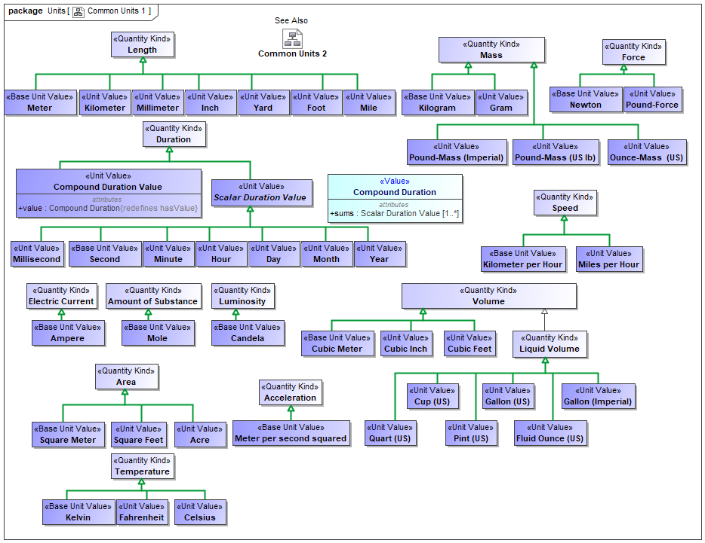

1. Common Units 1

An amount of time.

## Diagram: Common Units 2

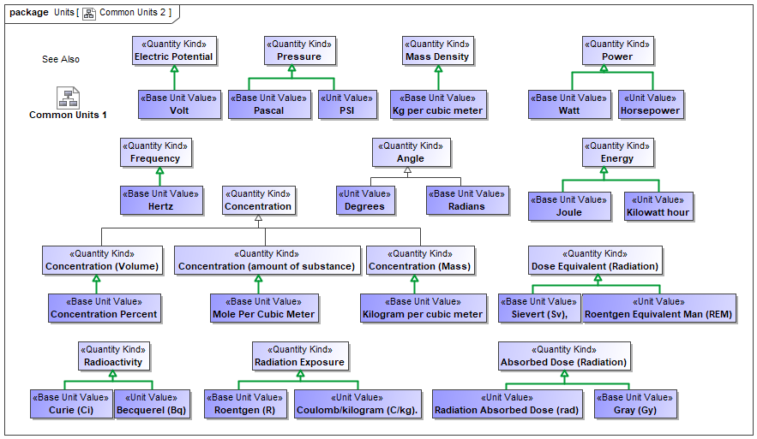

1. Common Units 2

## Class Acre <<Unit Value>>

1 acre = 43 560 square feet.

Direct Supertypes

Area

## Class Ampere <<Base Unit Value>>

[NIST-SI] The ampere is that constant current which, if maintained in two straight parallel conductors of infinite length, of negligible circular cross-section, and placed 1 meter apart in a vacuum, would produce between these conductors a force equal to 2 x 10-7 newton per meter of length.

[IDEAS] electricCurrentInAmperes: A measureNamedNumericallyBy that names an ElectricCurrent with its ValueInAmperes

Direct Supertypes

Electric Current

## Class Becquerel (Bq) <<Unit Value>>

The SI unit of radioactivity, corresponding to one disintegration per second.

Direct Supertypes

Radioactivity

## Class Candela <<Base Unit Value>>

The candela is the luminous intensity, in a given direction, of a source that emits monochromatic radiation of frequency 540 x 1012 hertz and that has a radiant intensity in that direction of 1/683 watt per steradian.[NIST-SI]

[IDEAS] luminousIntensityInCandela: A measureNamedNumericallyBy that names a LuminousIntensity with its ValueInCandela

Direct Supertypes

Luminosity

## Class Celsius <<Unit Value>>

Centigrade. The temperature scale (Celsius scale) in which 0° represents the ice point and 100° the steam point of water.

Direct Supertypes

Temperature

## Class Compound Duration Value <<Unit Value>>

A value for a duration derived from the sum of primitive duration values. e.g. 2 days and 3 hours or 2016 years, 12 months and three days.

Direct Supertypes

Duration

Attributes

value : Compound Duration



## Class Concentration Percent <<Base Unit Value>>

The volume of a constituent divided by the volume of the mixture.

Direct Supertypes

Concentration (Volume)

## Class Coulomb/kilogram (C/kg). <<Unit Value>>

Unit of radiation exposure.

Direct Supertypes

Radiation Exposure

## Class Cubic Feet <<Unit Value>>

A volume measured in feet.

Direct Supertypes

Volume

## Class Cubic Inch <<Unit Value>>

A volume measured in inches.

Direct Supertypes

Volume

## Class Cubic Meter <<Base Unit Value>>

A volume measured in meters.

Direct Supertypes

Volume

## Class Cup (US) <<Unit Value>>

8 Fluid Ounces (US).

Direct Supertypes

Liquid Volume

## Class Curie (Ci) <<Base Unit Value>>

The SI unit of measure for radioactivity is the curie (Ci) and Becquerel (Bq).

Direct Supertypes

Radioactivity

## Class Day <<Unit Value>>

A unit of time equal to 24 hours.

[DTV] day: the precise time unit that is quantified by 86 400 seconds

[OWL] xsd:gDay

Direct Supertypes

Scalar Duration Value

## Class Degrees <<Unit Value>>

A unit for an angle from 0-360.

Direct Supertypes

Angle

## Class Fahrenheit <<Unit Value>>

The Fahrenheit scale in which 32° represents the ice point and 212° the steam point. of water Symbol: F.

Direct Supertypes

Temperature

## Class Fluid Ounce (US) <<Unit Value>>

A unit of volume: 16 fluid ounces = 1 pint (pt)

= 28.875 cubic inches.

Direct Supertypes

Liquid Volume

## Class Foot <<Unit Value>>

A foot (pl. feet; abbreviation: ft; symbol: ′, the prime symbol) is a unit of length in the imperial and US customary systems of measurement. Since 1959, both units have been defined by international agreement as equivalent to 0.3048 meters exactly. In both systems, the foot comprises 12 inches and three feet compose a yard.

Direct Supertypes

Length

## Class Gallon (Imperial) <<Unit Value>>

A unit of volume.

Direct Supertypes

Liquid Volume

## Class Gallon (US) <<Unit Value>>

A measure of the quantity of a substance. 1 gallon (gal) = 231 cubic inches.

Direct Supertypes

Liquid Volume

## Class Gram <<Unit Value>>

The gram is a SI unit of mass.

Direct Supertypes

Mass

## Class Gray (Gy) <<Base Unit Value>>

[NRC] One of the two units used to measure the amount of radiation absorbed by an object or person, known as the "absorbed dose," which reflects the amount of energy that radioactive sources (with any type of ionizing radiation) deposit in materials (e.g., water, tissue, air) through which they pass. One gray (Gy) is the international system of units (SI) equivalent of 100 rads, which is equal to an absorbed dose of 1 Joule/kilogram. An absorbed dose of 0.01 Gy means that 1 gram of material absorbed 100 ergs of energy (a small but measurable amount) as a result of exposure to radiation.

Direct Supertypes

Absorbed Dose (Radiation)

## Class Hertz <<Base Unit Value>>

A unit of frequency. Cycles per second.

[IDEAS] frequencyInHertz: A measureNamedNumericallyBy that names a Frequency with its ValueInHertz

Direct Supertypes

Frequency

## Class Horsepower <<Unit Value>>

Horsepower (hp) is a unit of measurement of power (the rate at which work is done). There are many different standards and types of horsepower. This model uses the 746 watt interpretation of horsepower.

Direct Supertypes

Power

## Class Hour <<Unit Value>>

A unit of time: 60 Minutes.

[DTV] hour: the precise time unit that is quantified by '3600 seconds'

Direct Supertypes

Scalar Duration Value

## Class Inch <<Unit Value>>

A unit of length.

Direct Supertypes

Length

## Class Joule <<Base Unit Value>>

The joule (symbol J, also called newton meter, watt second, or coulomb volt) is the SI unit of energy and work.

Direct Supertypes

Energy

## Class Kelvin <<Base Unit Value>>

[NIST-SI] The kelvin, unit of thermodynamic temperature, is the fraction 1/273.16 of the thermodynamic temperature of the triple point of water.

[IDEAS] temperatureInKelvin: A measureNamedNumericallyBy that names a ThermodynamicTemperature with its ValueInKelvin

Direct Supertypes

Temperature

## Class Kg per cubic meter <<Base Unit Value>>

The SI unit for density.

Direct Supertypes

Mass Density

## Class Kilogram <<Base Unit Value>>

[NIST-SI] The kilogram is the unit of mass; it is equal to the mass of the international prototype of the kilogram. [NIST-SI]

[IDEAS] massInKilograms: A measureNamedNumericallyBy that names a Mass with its ValueInKilograms

Direct Supertypes

Mass

## Class Kilogram per cubic meter <<Base Unit Value>>

The SI Unit of density.

Direct Supertypes

Concentration (Mass)

## Class Kilometer <<Unit Value>>

A unit of length, the SI measure of distances equal to 1000 meters, and equivalent to 3280.8 feet or 0.621 mile.

Symbol: km.

Direct Supertypes

Length

## Class Kilometer per Hour <<Base Unit Value>>

The SI unit of speed

Direct Supertypes

Speed

## Class Kilowatt hour <<Unit Value>>

The watt-hour (symbolized Wh) is a unit of energy equivalent to one watt (1 W) of power expended for one hour (1 h) of time.

Direct Supertypes

Energy

## Class Liquid Volume <<Quantity Kind>>

Volume of a liquid.

Direct Supertypes

Volume

## Class Meter <<Base Unit Value>>

The meter is the length of the path traveled by light in vacuum during a time interval of 1/299 792 458 of a second.[NIST-SI]

The meter, (SI unit symbol: m), is the fundamental unit of length in the International System of Units (SI).

[IDEAS] lengthInMeters: A measureNamedNumericallyBy that names a Mass with its ValueInKilograms

Direct Supertypes

Length

## Class Meter per second squared <<Base Unit Value>>

The SI Unit of acceleration.

Direct Supertypes

Acceleration

## Class Mile <<Unit Value>>

The mile is an English unit of length standardized as exactly 1.609344 kilometers.

Direct Supertypes

Length

## Class Miles per Hour <<Unit Value>>

U.S. unit of speed.

Direct Supertypes

Speed

## Class Millimeter <<Unit Value>>

A unit of length equal to one thousandth of a meter and equivalent to 0.03937 inch.

Abbreviation: mm.

Direct Supertypes

Length

## Class Millisecond <<Unit Value>>

A unit of time: 1/1000th of a second.

[DTV] millisecond

Direct Supertypes

Scalar Duration Value

## Class Minute <<Unit Value>>

A unit of time: 60 seconds.

[DTV] minute : the precise time unit that is quantified by '60 seconds'

Direct Supertypes

Scalar Duration Value

## Class Mole <<Base Unit Value>>

The mole is a unit of measurement used in chemistry to express amounts of a chemical substance, defined as the amount of any substance that contains as many elementary entities (e.g., atoms, molecules, ions, electrons) as there are atoms in 12 grams of pure carbon-12.

Direct Supertypes

Amount of Substance

## Class Mole Per Cubic Meter <<Base Unit Value>>

The SI unit for amount-of-substance concentration.

Direct Supertypes

Concentration (amount of substance)

## Class Month <<Unit Value>>

[DTV] month: the nominal time unit that is the duration of a time interval required for one rotation of the Moon in its orbit around the Earth, approximated to a number of days.

[OWL] xsd:gMonth

Direct Supertypes

Scalar Duration Value

## Class Newton <<Base Unit Value>>

The SI unit of force. Equivalent to 100,000 dynes. A Newton is equal to the force that would give a mass of one kilogram an acceleration of one meter per second per second.

Direct Supertypes

Force

## Class Ounce-Mass (US) <<Unit Value>>

U.S. Unit of Ounce representing Mass.

Direct Supertypes

Mass

## Class Pascal <<Base Unit Value>>

The SI unit of pressure, equal to one newton per square meter (approximately 0.000145 pounds per square inch, or 9.9 × 10-6 atmospheres).

Direct Supertypes

Pressure

## Class Pint (US) <<Unit Value>>

Unit of liquid volume: 2 pints = 1 quart (qt) = 57.75 cubic inches.

Direct Supertypes

Liquid Volume

## Class Pound-Force <<Unit Value>>

Pound-force is equal to the gravitational force exerted on a mass of one avoirdupois pound on the surface of Earth.

Standard gravity is not constant but usually taken to be 9.80665 m/s2 (about 32.174 049 ft/s2) in the context of the surface of the earth.

Direct Supertypes

Force

## Class Pound-Mass (Imperial) <<Unit Value>>

A unit of mass that is exactly 453.59237 grams.

Direct Supertypes

Mass

## Class Pound-Mass (US lb) <<Unit Value>>

The pound avoirdupois, which forms the basis of the U.S. customary system of mass, is defined as exactly 453.59237 grams.

The avoirdupois pound is legally defined as a measure of mass, but the name pound is also applied to measures of force.

See also: http://www.nist.gov/pml/wmd/metric/upload/frn-59-5442-1959.pdf

Direct Supertypes

Mass

## Class PSI <<Unit Value>>

Unit of pounds per square inch.

Direct Supertypes

Pressure

## Class Quart (US) <<Unit Value>>

Unit of liquid volume where 4 quarts = 1 gallon (gal) = 231 cubic inches [NIST-UNITS].

Direct Supertypes

Liquid Volume

## Class Radians <<Base Unit Value>>

A unit of an angle where there are 2 PI radians in a circle.

Direct Supertypes

Angle

## Class Radiation Absorbed Dose (rad) <<Unit Value>>

One of the two units used to measure the amount of radiation absorbed by an object or person, known as the “absorbed dose,” which reflects the amount of energy that radioactive sources deposit in materials through which they pass. The radiation-absorbed dose (rad) is the amount of energy (from any type of ionizing radiation) deposited in any medium (e.g., water, tissue, air). An absorbed dose of 1 rad means that 1 gram of material absorbed 100 ergs of energy (a small but measurable amount) as a result of exposure to radiation. The related international system unit is the gray (Gy), where 1 Gy is equivalent to 100 rad. For additional information, see Doses in Our Daily Lives and Measuring Radiation. [NRC]

Direct Supertypes

Absorbed Dose (Radiation)

## Class Roentgen (R) <<Base Unit Value>>

A unit of exposure to ionizing radiation. It is the amount of gamma or x-rays required to produce ions resulting in a charge of 0.000258 coulombs/kilogram of air under standard conditions. [NRC]

Direct Supertypes

Radiation Exposure

## Class Roentgen Equivalent Man (REM) <<Unit Value>>

One of the two standard units used to measure the dose equivalent (or effective dose), which combines the amount of energy (from any type of ionizing radiation that is deposited in human tissue), along with the medical effects of the given type of radiation. For beta and gamma radiation, the dose equivalent is the same as the absorbed dose. By contrast, the dose equivalent is larger than the absorbed dose for alpha and neutron radiation, because these types of radiation are more damaging to the human body. Thus, the dose equivalent (in rems) is equal to the absorbed dose (in rads) multiplied by the quality factor of the type of radiation [see Title 10, Section 20.1004, of the Code of Federal Regulations (10 CFR 20.1004), "Units of Radiation Dose"]. The related international system unit is the sievert (Sv), where 100 rem is equivalent to 1 Sv. [NRC]

Direct Supertypes

Dose Equivalent (Radiation)

## Class Scalar Duration Value <<Unit Value>>

Number and time unit together giving magnitude of a duration.

[DTV]

Definition:if the atomic duration value is a precise atomic duration value, then the time unit is the reference duration to which the ratio of the duration quantified by the atomic duration value is taken

Definition:if the atomic duration value is a nominal atomic duration value, then the time unit is the reference duration to which the ratio of exactly one element of the duration value set specified by the atomic duration value is taken

Example:“45 minutes” has the time unit ‘minute’

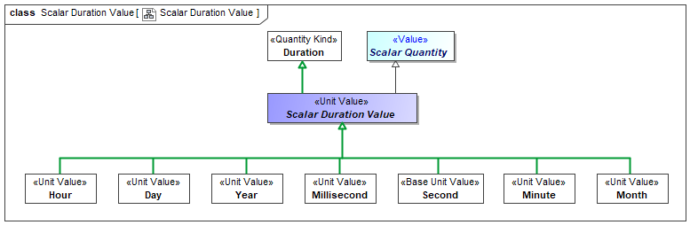

1. Scalar Duration Value

Direct Supertypes

Duration, Scalar Quantity

## Class Second <<Base Unit Value>>

[NIST-SI] The second (symbol: s) is the base unit of time in the International System of Units (SI) and is also a unit of time in other systems of measurement (abbreviated s or sec); it is the second division of the hour by sixty, the first division by 60 being the minute.

[DTV] second: The second is the duration of 9 192 631 770 periods of the radiation corresponding to the transition between the two hyperfine levels of the ground state of the cesium 133 atom.

[IDEAS] Second: A measureNamedNumericallyBy that names a Time with its ValueInSeconds

Direct Supertypes

Scalar Duration Value

## Class Sievert (Sv), <<Base Unit Value>>

The international system (SI) unit for dose equivalent equal to 1 Joule/kilogram. 1 sievert = 100 rem. Named for physicist Rolf Sievert.

Direct Supertypes

Dose Equivalent (Radiation)

## Class Square Feet <<Unit Value>>

Area measured in feet.

Direct Supertypes

Area

## Class Square Meter <<Base Unit Value>>

Area measured in SI meters.

Direct Supertypes

Area

## Class Volt <<Base Unit Value>>

The SI unit of electromotive force, the difference of potential that would drive one ampere of current against one ohm resistance.

Direct Supertypes

Electric Potential

## Class Watt <<Base Unit Value>>

The SI unit of power is the joule per second (J/s).

Direct Supertypes

Power

## Class Yard <<Unit Value>>

A Unit of length equal to 3 feet.[NIST-UNITS]

Direct Supertypes

Length

## Class Year <<Unit Value>>

The period of 365 days (or 366 days in leap years) starting from the first of January, used for reckoning time in ordinary affairs.

[DTV] year: the nominal time unit that is the duration of a time interval required for one revolution of the Earth around the Sun, approximated to an integral number of days

[OWL] xsd:gYear

Direct Supertypes

Scalar Duration Value

# Concept Library::Resources

This package represents concepts concerning resources. A resource is a role of any entity such that it supports or impacts in a process, impacts the objectives of stakeholders or is the basis of the capability of an actor.

As a role, “Resource” is intended to "mix in" with an entity type such as "Person" or "Process" such that the use of that entity may be understood.

Resources that are a Primary Asset are those that are the direct subject of a stakeholder's objectives.

## Diagram: Resource

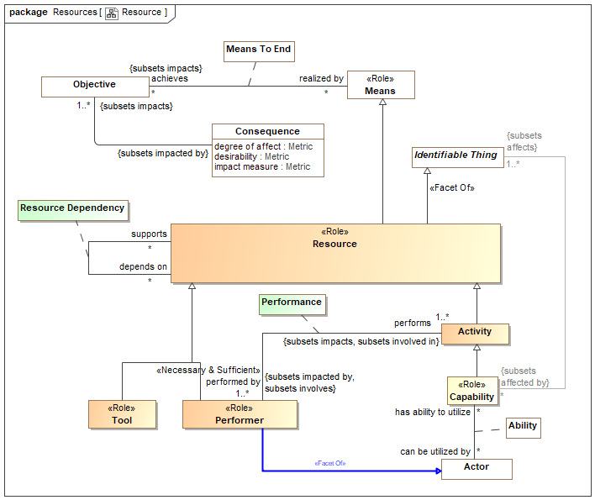

1. Resource

## Diagram: Resource Actions

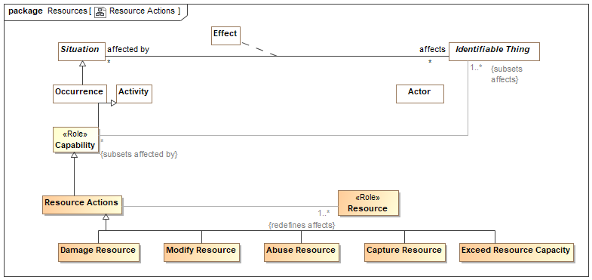

1. Resource Actions

## Class Abuse Resource

An action to misuse a resource.

Direct Supertypes

Resource Actions

## Class Capture Resource

Action to capture or gain control of some resource.

Direct Supertypes

Resource Actions

## Class Damage Resource

An action that causes an resource to no longer completely fulfill its purpose..

Direct Supertypes

Damage, Resource Actions

## Class Exceed Resource Capacity

An action to exceed the capacity of some resource.

Direct Supertypes

Resource Actions

## Class Modify Resource

Action to modify a resource or set of resources.

Direct Supertypes

Resource Actions

## Class Performer <<Role>>

A performer is role of an actor that is a resource to an entity as the performer of activities.

Direct Supertypes

Actor, Resource

## Class Resource <<Role>>

A resource is a role of an entity required for or helpful to any operation, activity, process or capability - directly or indirectly. Sometimes called an "asset".

Direct Supertypes

Identifiable Thing, Means

## Class Resource Actions

An action impacting a potential or realized resource/asset.

Direct Supertypes

Capability

## Association Class Resource Dependency

Relationship between resources where one resource depends on (or uses) another.

A more general concept than [UAF] MapsToCapability: An Abstraction relationship denoting that an Activity contributes to providing a Capability.

[DOLCE] (Subtype of) Dependence

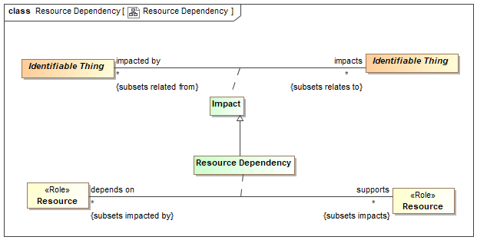

1. Resource Dependency

Direct Supertypes

Impact

Association Ends

supports : Resource [*] *Redefines*: negated within: Context



Resources the subject resource supports or enables.

depends on : Resource [*] *Redefines*: negated within: Context



A resource that is required to support the operation of purpose of another resource.

## Class Tool <<Role>>

The role of some inanimate thing used to facilitate a process or activity by an actor performing a process or activity.

Direct Supertypes

Resource

# Concept Library::Response

## Diagram: Response

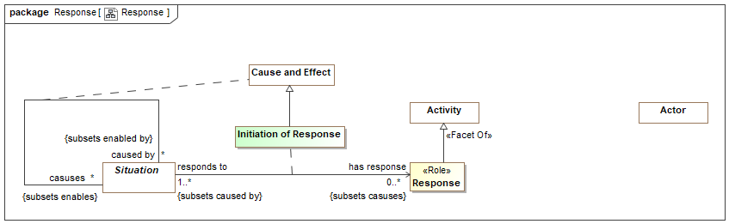

1. Response

## Association Class Initiation of Response

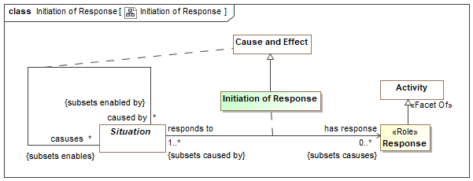

1. Initiation of Response

Direct Supertypes

Cause and Effect

Association Ends

has response : Response [0..*] *Redefines*: negated within: Context



responds to : Situation [1..*] *Redefines*: negated within: Context



## Class Response <<Role>>

A response is an activity performed by an actor as a reaction to (caused by) another situation.

Direct Supertypes

Activity

# Concept Library::Situations

Concepts relative to situations. A situation is a particular configuration of things and their relations including spatial, temporal, and logical connections between those things valid over a period of time. Situations form the basis of all complex, time dependent entities.

## Diagram: Actual Situations

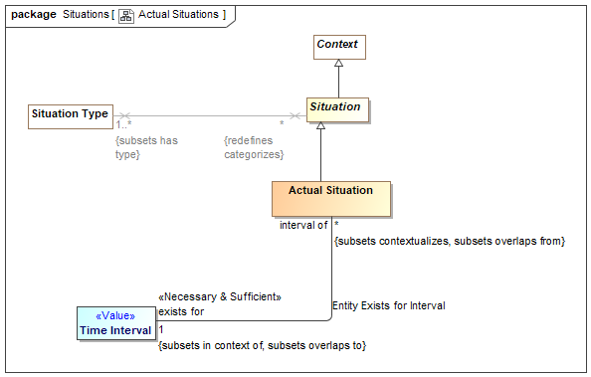

1. Actual Situations

## Diagram: Situation Relationships

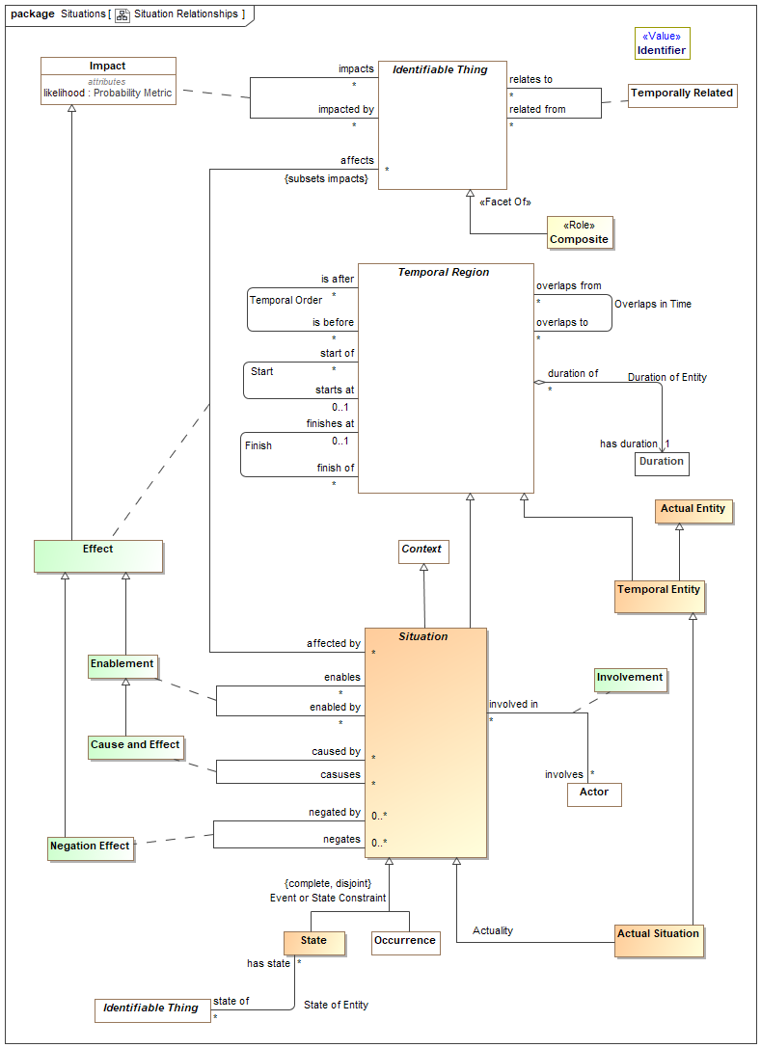

1. Situation Relationships

This diagram shows the primary associations defined for situations as well as its super types: Temporal Entity and Identifiable Entity. The relationships shown here are those deemed defining for the concept of a situation, they are not all the relationships defined for these types.

## Diagram: Situation Timeframes

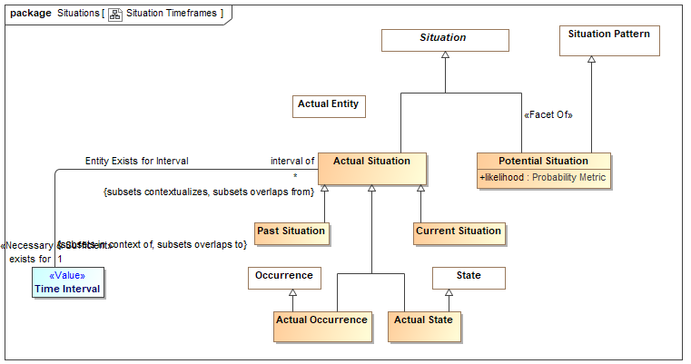

1. Situation Timeframes

## Diagram: Situations

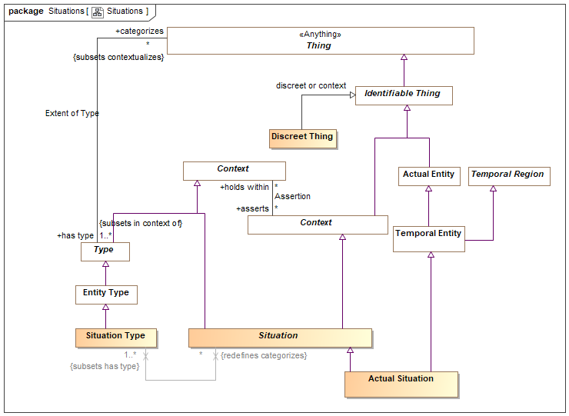

1. Situations

## Class Actual Situation

An actual situation is an individual (particular) situation that actually exists, happened in the past or may exist in some possible world, not a template or process definition. Such situations must exist for a time interval, however there are no constraints on such a time interval - from an instant to the life of the universe.

DTV: Occurrence: state of affairs that is a happening in the universe of discourse

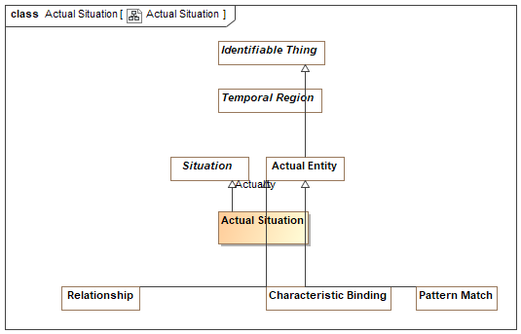

1. Actual Situation

Direct Supertypes

Situation, Temporal Entity

## Class Actual State

A condition that has, will or does exist.

Direct Supertypes

Actual Situation, State

## Association Class Cause and Effect

The causality relation where the <causes> situation is <caused by> a situation.

[FIBO] cause / caused by

[ISO 1087] causal relation: associative relation (3.2.23) involving cause and its effect

NOTE A causal relation exists between the concepts (3.2.1) 'action' and 'reaction', 'nuclear explosion' and 'fall-out'.

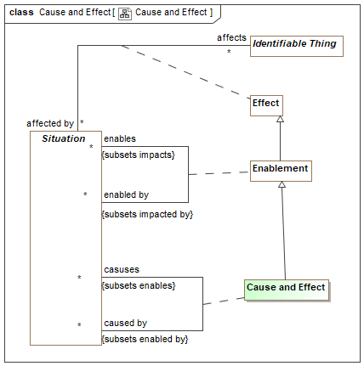

1. Cause and Effect

Direct Supertypes

Enablement

Association Ends

caused by : Situation [*] *Redefines*: negated within: Context



One of situations that causes the subject situation.

casuses : Situation [*] *Redefines*: negated within: Context



A situation caused by another.

## Class Composite Situation

A composite situation includes, other situations as parts.

[Devlin] Situation with compound infon.

Direct Supertypes

Situation

## Class Current Situation

A situation that is actually occurring at the moment. "the moment" is contextual and interpreted within the context of the model.

Direct Supertypes

Actual Situation, Situation

## Class Discreet Thing

A discreet thing is an identifiable thing that may be the subject of temporal relationships but does not inherently include those relationships.

[Devlin] Individual

Direct Supertypes

Identifiable Thing

## Association Class Effect

Any impact on or alteration of an entity by a situation - an effect of the situation.

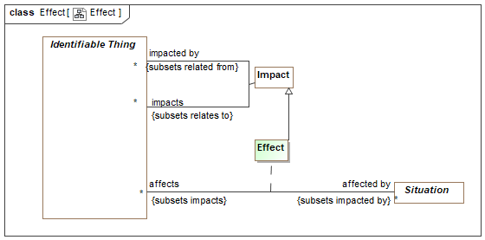

1. Effect

Direct Supertypes

Impact

Association Ends

affects : Identifiable Thing [*] *Redefines*: negated within: Context



Entities affected by a action

affected by : Situation [*] *Redefines*: negated within: Context



Actions that can cause some change in a related entity.

## Association Class Enablement

A situation that enables (is a condition for), another.

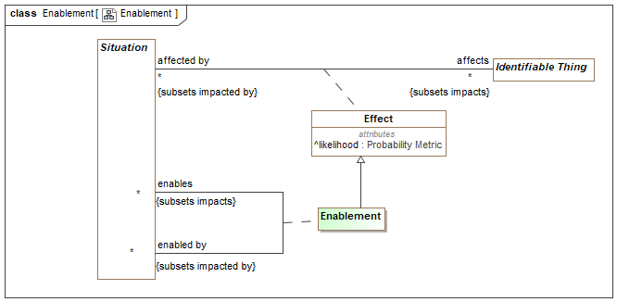

1. Enablement

Direct Supertypes

Effect, Impact

Association Ends

enables : Situation [*] *Redefines*: negated within: Context



A situation that is enabled by another.

enabled by : Situation [*] *Redefines*: negated within: Context



A situation that enables another.

## Association Class Involvement

The relationship between an actor and situations they are involved in.

[DOLCE] Participation

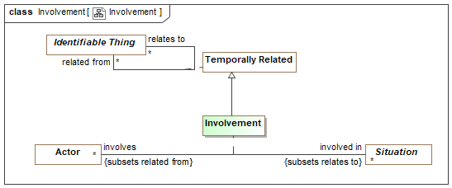

1. Involvement

Direct Supertypes

Temporally Related

Association Ends

involved in : Situation [*] *Redefines*: negated within: Context



Situations in which an actor has any kind of involvement.

involves : Actor [*] *Redefines*: negated within: Context



An actor involved in a situation in any way.

## Association Class Negation Effect

The negative causality relationship - <negated by> prevents or terminates the <negates> situation.

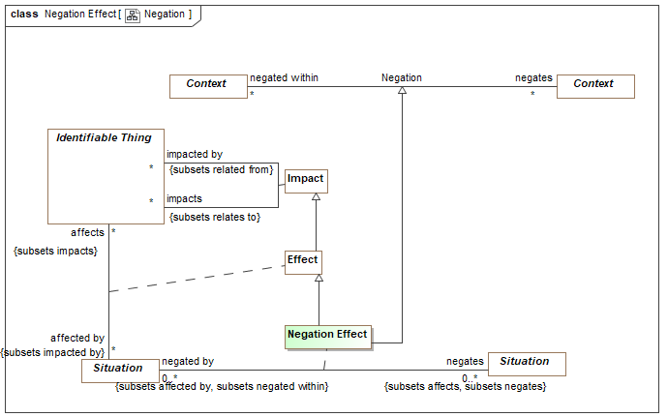

1. Negation

Direct Supertypes

Effect, Negation

Association Ends

negated by : Situation [0..*] *Redefines*: negated within: Context



A situation that prevents or terminates another.

negates : Situation [0..*] *Redefines*: negated within: Context



A situation that is prevented or terminated by another situation.

## Class Past Situation

A situation that has actually occurred in the past (recognizing that all such statements are subject to confidence).

Direct Supertypes

Actual Situation, Situation

## Class Potential Situation

A situation that has not yet happened but has a potential to happen.

DTV: Situation Kind

Direct Supertypes

Situation, Situation Pattern

Attributes

likelihood : Probability Metric



Metric representing the possibility that the containing element represents reality.

## Class Situation

A situation is an identifiable entity composed of an arrangement of entities and the relations between them over a time interval. Situations are may be asserted as true or false in some context. Situations may change over time, unless otherwise constrained. As an identifiable entity, situations may participate in relationships, thus situations are "first class" elements.

[SBVR] "State of affairs"

[SOWA1999] Nexus

[Devlin] Situation with corresponding infon(s).

Direct Supertypes

Context, Context, Lexical Context, Temporal Region

## Class Situation Type

A situation type defines a kind of identifiable arrangement of individuals, assertions and the relations between them over a timespan. As an identifiable entity, situations may participate in other situations and relationships by being bound to properties of those situations or relationships with bindings, thus situations are “first class” entities in a SMIF model.

The roles or behaviors things (any entity or value) may play in a situation are identified as properties of the situation type.

Entity types and roles may also be situation types.

Syn. Type of a state of affairs.

A situation type may have properties such that instances, may bind things to structures based on properties.

Things may be bound to a structure (i.e. play a role in the structure) via properties. Things bound to properties of a structure may change over time, unless otherwise constrained.

[DTV] situation kind: state of affairs that may or may not happen in some possible world

Direct Supertypes

Entity Type

## Class State

A state is a static situation - a particular configuration of entities that is static for a time period, including spatial and logical connections between those things {Snapshot of a Perdurant}

Note that states may be of any length, from an instant to infinity and beyond.

[DOLCE] State

Direct Supertypes

Situation

## Association State of Entity

Relationship between a perdurant (something that exits over time) and a "state" of that entity as a snapshot in time.

Association Ends

state of : Identifiable Thing [*] *Redefines*: negated within: Context



The endurant entity for which the subject state is a snapshot.

has state : State [*] *Redefines*: negated within: Context



A states (or snapshots) of an entity within its lifetime.

# Concept Library::Social Agents

Actor relationships augment the concept of an actor with concepts of identifiers and associations between actors, including organization membership. See also the base actor class.

## Diagram: Social Agent

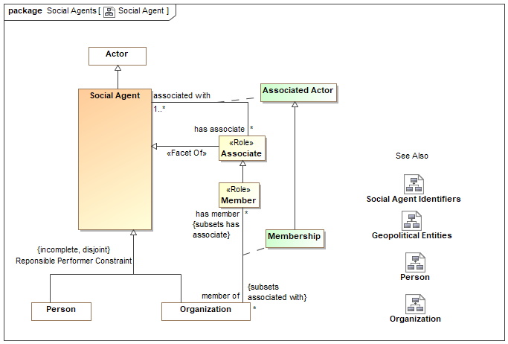

1. Social Agent

Actor associations define the concept of an organization and provide a general framework for associations between actors with the use of an Actor Association.

## Diagram: Social Agent Identifiers

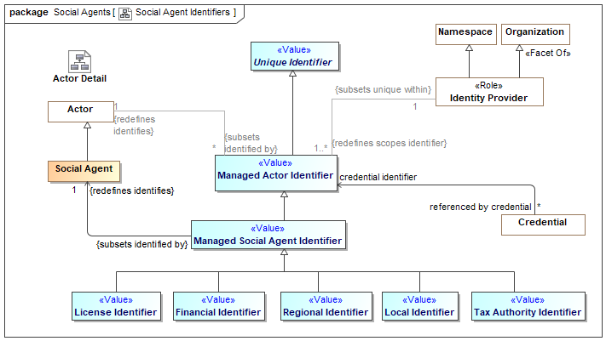

1. Social Agent Identifiers

## Class Associate <<Role>>

Direct Supertypes

Social Agent

## Association Class Associated Actor

An  associated actor relationship defines a connection between an actor and some other actor they are associated with in some way. Subtypes of actor association  provide additional  semantics  about the association. As an association class, Actor Associations  may have properties and other relationships. Actor associations will typicaly have a timeframe.

 [NIEM] PersonOrganizationAssociationType (More specific concept)

 [NIEM] PersonPersonAssociationType (More specific concept)

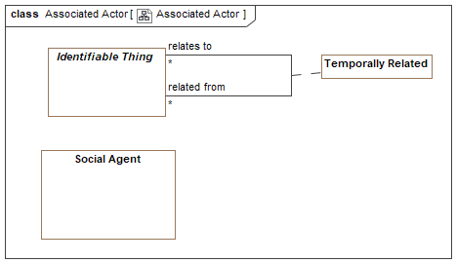

1. Associated Actor

Direct Supertypes

Temporally Related

Association Ends

has associate : Associate [*] *Redefines*: negated within: Context



The actor associated with another.

associated with : Social Agent [1..*] *Redefines*: negated within: Context



Another actor the subject actor is associated with.

## Class License Identifier <<Value>>

[NIEM] An identification that references a license certification or registration of a person or organization for some purpose.

Direct Supertypes

Managed Social Agent Identifier

## Class Local Identifier <<Value>>

An identification assigned at a local level (within an organization or community) to a person or organization.

Direct Supertypes

Managed Social Agent Identifier

## Class Managed Social Agent Identifier <<Value>>

An identifier for a social agent where the identifier is managed by some authority.

Direct Supertypes

Managed Actor Identifier

## Class Member <<Role>>

Direct Supertypes

Associate

## Class Regional Identifier <<Value>>

[NIEM] An identification of a person based on a regional ID.

Direct Supertypes

Managed Social Agent Identifier

## Class Social Agent

An actor that may have responsibilities - people and organizations. Actors in general may include automated entities and even, in some context, animals. Social agent excludes these other kinds of actors by including (at this time) only people and organizations.

What responsibilities a particular person or organization may have at any particular time is the subject of law and social constructs. A social agent is distinguished in that a person or organization may have such responsibilities in their lifetime.

[NIEM] EntityType

[DOLCE] Social Agent

Direct Supertypes

Actor

## Class Tax Authority Identifier <<Value>>

An identifier assigned to a person or organization by a tax authority.

Direct Supertypes

Managed Social Agent Identifier

# Concept Library::Systems

A system is a collection of parts and relationships among these parts that may be organized to accomplish some purpose.

The term ‘system’ can refer to an information processing system but it is also applied more generally. Thus a system may include anything: a system of hardware, software, an enterprise, a federation of enterprises, a business process, some combination of parts of different systems, a federation of systems - each under separate control, a program in a computer, a system of programs, a single computer, a system of computers, a computer or system of computers embedded in some machine, etc.

One of the key strengths of modeling, and one that distinguishes it from implementation technologies like software source code, is that it is an excellent way to represent, understand, and specify systems. [OMG MDA Guide]

## Diagram: System

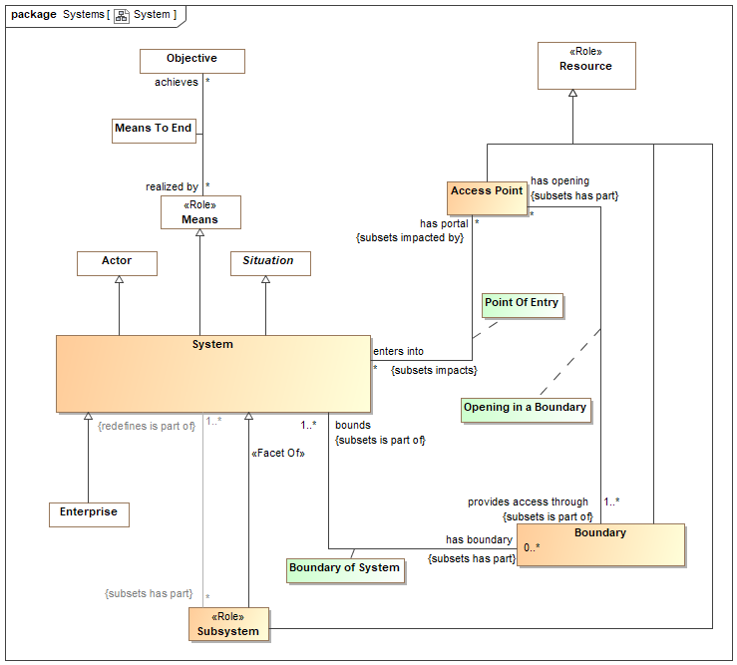

1. System

## Class Access Point

A point of entry into or out of a system such as a door, gate, port, or "interface" into an information system.

Direct Supertypes

Resource

## Class Boundary

Something on the edge of a system that serves to contain or protect components of that system.

Some boundaries protect resources of the system/enterprise and may also be countermeasures.

e.g., Fences, firewalls, skin.

Direct Supertypes

Resource

## Association Class Boundary of System

An "edge" of a system affording some level of protection or containment for the system.

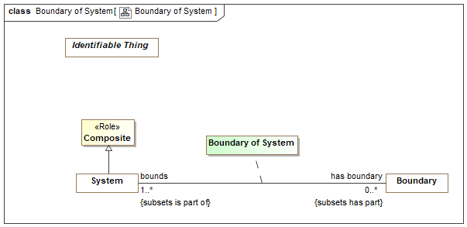

1. Boundary of System

Direct Supertypes

Parthood

Association Ends

has boundary : Boundary [0..*] *Redefines*: negated within: Context



Logical or physical border of a system (or enterprise) that may serve to define, contain or protect the system.

bounds : System [1..*] *Redefines*: negated within: Context



System for which a boundary is an edge.

## Association Class Opening in a Boundary

An access point that provides an opening for passage through a boundary. An opening has the potential to cause a point of entry and a vulnerability.

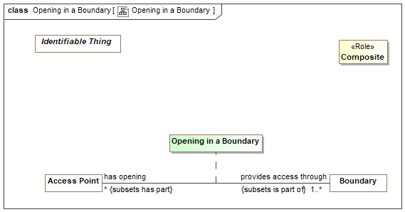

1. Opening in a Boundary

Direct Supertypes

Parthood

Association Ends

provides access through : Boundary [1..*] *Redefines*: negated within: Context



Boundary through which an entry point provides access. e.g., the wall a door goes through.

has opening : Access Point [*] *Redefines*: negated within: Context



A physical or virtual place where access to a system may be provided through a boundary.

## Association Class Point Of Entry

Relationship between a system and a usable entry point into or out of that system. A point of entry has the potential to cause a vulnerability.

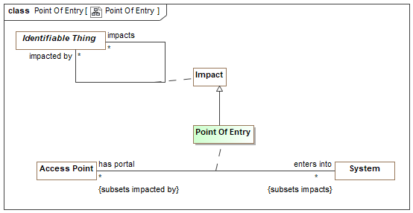

1. Point Of Entry

Direct Supertypes

Impact

Association Ends

enters into : System [*] *Redefines*: negated within: Context



System into which an entry point provides access. E.G. A room a door enters into.

has portal : Access Point [*] *Redefines*: negated within: Context



A point of possible entry into a system.

## Class Subsystem <<Role>>

A role of a system as a part of another system as a resource to the owning system.

Direct Supertypes

Resource, System

## Class System

[OMG MDA Guide] A system is a collection of parts and relationships among these parts that may be organized to accomplish some purpose.

[UAF] An integrated set of elements, subsystems, or assemblies that accomplish a defined objective. These elements include products (hardware, software, firmware), processes, people, information, techniques, facilities, services, and other support elements .

A system is a situation in that it has constituent parts working together for a finite period.

A system is a means in that it may achieve objectives for stakeholders.

Direct Supertypes

Actor, Composite, Means, Situation

# Concept Library::Time & Temporal Entities

The Time package defines the essential concepts of time and the identification of time intervals.

These time concepts are based on the OMG Date Time Vocabulary [DTV] standard but subsets and simplifies DTV for use in defining, federating and exchanging time aspects of entities.

"Temporal Entity" is introduced as an abstraction to capture the common relationships between time elements. Within DTV these relationships are separate for each kind of time element. The relationships defined for Temporal Entity are grounded in DTV Time Interval as each temporal entity exists for a time interval.

Applications that need to reason about time are encouraged to utilize the full DTV semantics. DTV also contains text that more fully elaborates time concepts.

## Diagram: Time

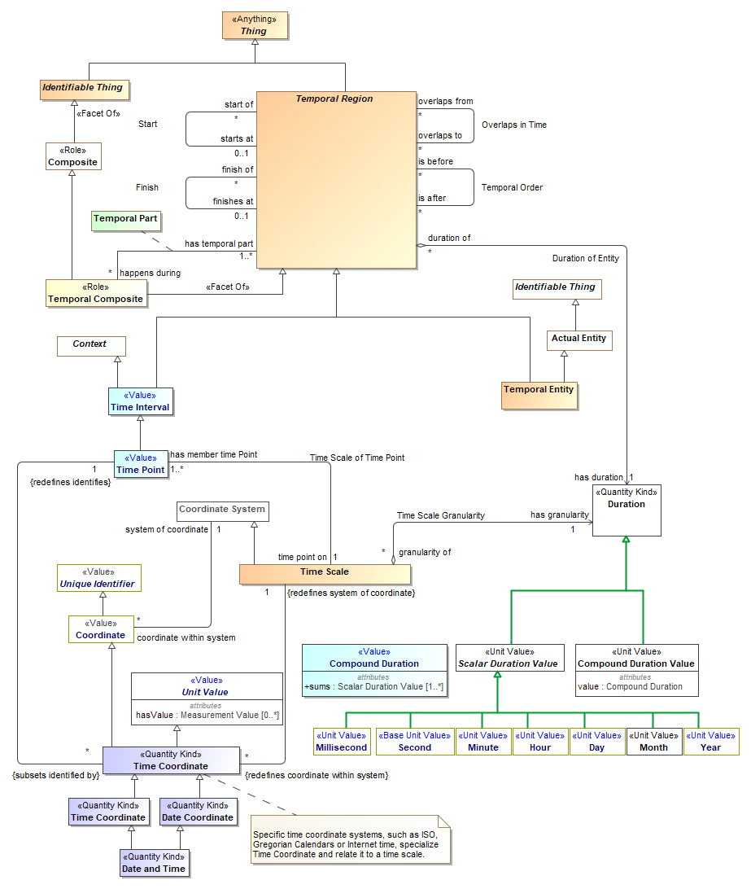

1. Time

## Class Date and Time <<Quantity Kind>>

[FIBO] DateTimeStamp: A DateTimeStamp combines a Date, a time, and a time

Direct Supertypes

Date Coordinate, Time Coordinate

## Class Date Coordinate <<Quantity Kind>>

[FIBO] Date: A Date identifies a calendar day on some calendar.

[NIEM] DateType

Direct Supertypes

Time Coordinate

## Association Duration of Entity

[DTV] time interval [of temporal entity] has particular duration:the particular duration is the duration that is the amount of time in the time interval.

Each time interval [Temporal Entity] has a unique duration attribute that is a measure of its size, i.e., the amount of time the time interval occupies. This attribute is mathematically a function that maps time intervals into durations. This mapping function is sometimes called the “range” of a time interval, and some times called the “measure” of a time interval.

Association Ends

duration of : Temporal Region [*] *Redefines*: negated within: Context



Temporal entity for which a duration is applicable.

has duration : Duration [1] *Redefines*: negated within: Context



Difference between the start and end time. A non-zero positive value representing the amount of time a temporal entity exists.

[DTV] time interval [of temporal entity] has particular duration:the particular duration is the duration that is the amount of time in the time interval.

Each time interval [Temporal Entity] has a unique duration attribute that is a measure of its size, i.e., the amount of time the time interval occupies. This attribute is mathematically a function that maps time intervals into durations. This mapping function is sometimes called the “range” of a time interval, and some times called the “measure” of a time interval.

## Association Entity Exists for Interval

Relationship defining the time interval in which an entity actually exists.

[DTV] occurrence occurs for occurrence interval: the occurrence occurs throughout the occurrence interval and the occurrence does not occur within some time interval2 that meets the occurrence interval and the occurrence does not occur within some time interval3 that is met by the

occurrence interval

[Alen 1983] X is equal to Y: X = Y where X is "interval of" and Y is "exists for". Note that this relates the temporal aspect of "interval of" to the timeframe "exists for".

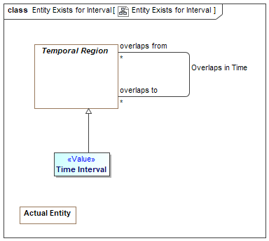

1. Entity Exists for Interval

Direct Supertypes

Overlaps in Time

Association Ends

exists for : Time Interval [1] *Redefines*: negated within: Context



Time interval where an entity may be considered "actual", that is existent in the domain of discourse.

interval of : Actual Situation [*] *Redefines*: negated within: Context



Entity existent for the full extent of a time interval.

## Association Finish

The time something no longer exists (inclusive).

[DTV] time interval1 finishes time interval2

Synonymous Form:time interval2 is finished by time interval1

Definition:time interval1 is a proper part of time interval2 and there exists no time interval3 that is a proper part of time interval2 and that is after time interval1

[IDEAS] endBoundary: A temporalBoundary where the boundary is a end boundary of the whole.

[Alen 1983] X finishes Y: X f Y where X is "finishes at" and Y is "finish of"

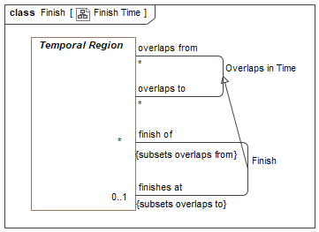

1. Finish Time

Direct Supertypes

Overlaps in Time

Association Ends

finish of : Temporal Region [*] *Redefines*: negated within: Context



Thing which no longer exists at a particular time.

finishes at : Temporal Region [0..1] *Redefines*: negated within: Context



Time something no longer exists. (Inclusive)

## Association Overlaps in Time

Some or all parts of the related temporal entities exist at the same time. Note that "to" and "from" may be arbitrary. By convention, the containing or prior temporal entity is "from".

[DTV] time interval1 properly overlaps time interval2

An [ISO 1087] temporal relation: sequential relation (3.2.24) involving events in time

[DOLCE] (subtype of) Temporal Quality

[Alen] X overlaps with Y: X o Y, where assignment of X and Y is arbitrary.

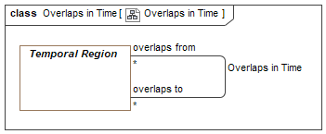

1. Overlaps in Time

Association Ends

overlaps from : Temporal Region [*] *Redefines*: negated within: Context



An overlapping temporal component.

overlaps to : Temporal Region [*] *Redefines*: negated within: Context



An overlapping temporal component.

## Association Start

The time something starts to exist (inclusive).

[DTV] time interval1 starts time interval2

Synonymous Form:time interval2 is started by time interval1

Definition:time interval1 is a proper part of time interval2 and there exists no time interval3 that is a proper part of time interval2 and that is before time interval1.

[IDEAS] startBoundary: A temporalBoundary where the boundary is a start boundary of the whole.

[Alen 1983] X starts Y: X s Y where X is "starts at" and Y is "start of".

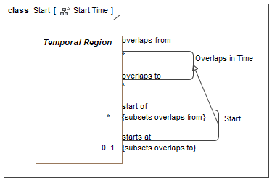

1. Start Time

Direct Supertypes

Overlaps in Time

Association Ends

start of : Temporal Region [*] *Redefines*: negated within: Context



Thing which begins to exist at a particular time.

starts at : Temporal Region [0..1] *Redefines*: negated within: Context



Time somethings begins to exist. (inclusive).

[FIBO] hasStartDate

## Class Temporal Composite <<Role>>

Direct Supertypes

Composite, Temporal Region

## Class Temporal Entity

An actual entity existing for a duration in time.

Direct Supertypes

Actual Entity, Temporal Region

## Association Temporal Order

A relationship representing ordering of temporal entities in time where the <starts at> of <is after> is greater than or equal to the <finishes at> of <is before>. Related things do not overlap in time.

[DOLCE] (subtype of) Temporal Quality

[DTV] "time interval1 is properly before time interval2": the time interval1 is before the time interval2 and the time interval1 is before a time interval3 and the time interval3 is before the time interval2

[DTV] time interval1 finishes duration after time interval2: The end of one time interval is duration after the end of the other time interval.

[IDEAS] beforeAfter: A couple that asserts one individuals' temporal extent is completely before the temporal extent of another.

An [ISO 1087] temporal relation: sequential relation (3.2.24) involving events in time

[Alen1983] X takes place before Y: X<Y where X is "is before" and Y is "is after".

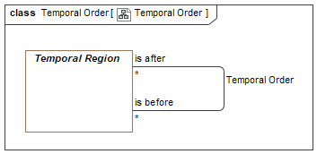

1. Temporal Order

Association Ends

is after : Temporal Region [*] *Redefines*: negated within: Context



A temporal entity that starts after the <is before> entity ends.

is before : Temporal Region [*] *Redefines*: negated within: Context



A temporal entity that ends after the <is after> entity starts.

## Association Class Temporal Part

The time interval of <has temporal part> is within the time interval of <happens durring>.

[DTV] time interval1 is proper part of time interval2: the time interval1 is a proper part of the time interval2 and a time interval3 is a proper part of the time interval2 and a time interval4 is a proper part of the time interval2 and the time interval3 is before the time interval1 and the time interval1 is before the time interval4.

[IDAS] temporalWholePart: A wholePart that asserts the spatial extent of the (whole) individual is co-extensive with the spatial extent of the (part) individual for a particular period of time.

[Alen 1983] X during Y: Xd Y where X is "happens during" and Y is "has temporal part"

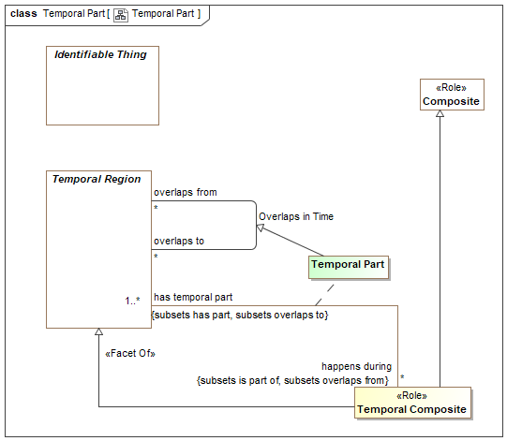

1. Temporal Part

Direct Supertypes

Overlaps in Time, Parthood

Association Ends

happens during : Temporal Composite [*] *Redefines*: negated within: Context



A situation with overlapping duration (overlapping temporal extent).

has temporal part : Temporal Region [1..*] *Redefines*: negated within: Context



Sub-durations of anything that happen - a temporal part.

## Class Temporal Region

A temporal region is anything that has a timespan. Temporal regions may have temporal relationships with other temporal regions. Temporal regions may be identifiable or values.

[SOWA1999] Continuant

[Devlin] Temporal Location

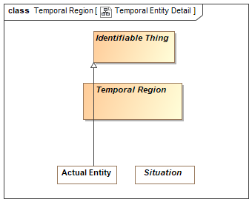

1. Temporal Entity Detail

Direct Supertypes

Thing

## Class Time Coordinate <<Quantity Kind>>

A designation of a particular time.

Direct Supertypes

Time Coordinate

## Class Time Interval <<Value>>

A time interval is a temporal region and a value that is only segment of time and may have a value representation.

[DTV] "time interval" : segment of the time axis, a location in time.

Note:Every time interval has a beginning, an end, and a duration, even if not known. Every time interval is “finite”, a bounded segment of the Time Axis. The beginning or end of a

time interval may be defined by reference to events that occur for a time interval that is not known.

Note:Time intervals may be ‘indefinite’, meaning that their beginning is ‘primordiality’ or their end is ‘perpetuity’, or both (‘eternity’). This vocabulary assumes that indefinite

time intervals exist and have some duration, but their duration is unknown.

[IDEAS] PeriodOrInstant: An Individual whose spatial extent is infinite, but whose temporal extent is finite or zero.

[UML] TimeInterval

[NIEM] DateRangeType

[DOLCE] Temporal Region

Direct Supertypes

Context, Temporal Region

## Class Time Point <<Value>>

A time point is a time interval deemed atomic on a time scale. As all points in time may be further subdivided into a finer granularity of time, each point in time is also a time interval on some other scale.

The duration of a time point is the same as the granularity of the time scale of the time point.

[DTV] time point: concept that specializes the concept 'time interval' and that is a member of a time scale.

[IDEAS] CalendarPeriod: A Period that corresponds to a recognized date or time.

Direct Supertypes

Time Interval

## Class Time Scale

A time scale is a way to reckon time as a series of consecutive time points identified by time coordinates. e.g. Time scale defined by the Gregorian calendar.

[DTV] time scale: regular sequence that each member of the regular sequence is a time point

Direct Supertypes

Coordinate System

## Association Time Scale Granularity

[DTV] Time scale has granularity: The granularity of the time scale is the duration of the time points of the time scale.

Association Ends

has granularity : Duration [1] *Redefines*: negated within: Context



[DTV] the smallest duration that can be distinguished with a given time scale

granularity of : Time Scale [*] *Redefines*: negated within: Context



Duration of each time point on a time scale.

## Association Time Scale of Time Point

Relationship defining the time scale on which a time point is defined. e.g. December 7th, 1944 is defined on a Gregorian Calendar time scale.

Association Ends

time point on : Time Scale [1] *Redefines*: negated within: Context



Time scale used for defining a time point.

[DTV] time scale has time point:

has member time Point : Time Point [1..*] *Redefines*: negated within: Context



Time point defined within a time scale

# Concept Library::Time & Temporal Entities::ISO Time Scale

## Diagram: ISO Time

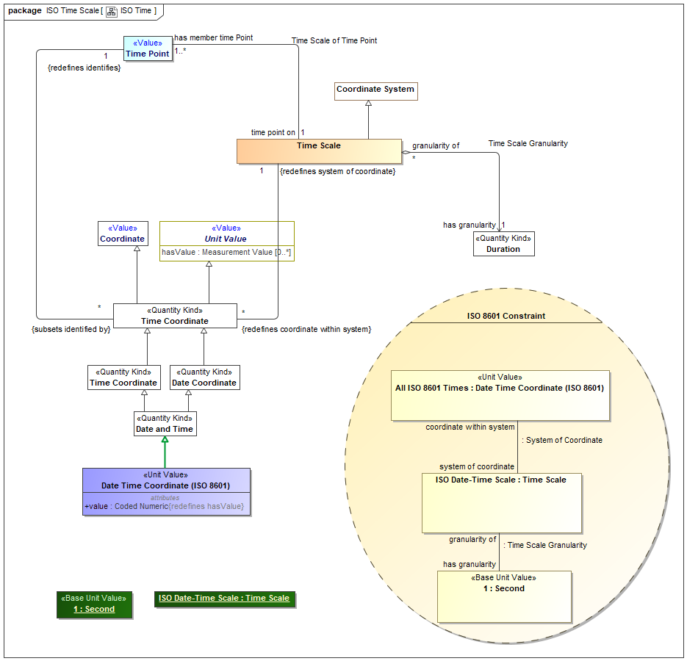

1. ISO Time

## Class Date Time Coordinate (ISO 8601) <<Unit Value>>

[UAF] A date and time specified in the ISO8601 date-time format including timezone designator (TZD): YYYY-MM-DDThh:mm:ssTZD.

Direct Supertypes

Date and Time

Attributes

value : Coded Numeric



A text string representing a date and time specified in the ISO8601 date-time format including timezone designator (TZD): YYYY-MM-DDThh:mm:ssTZD.

# Concept Library::Time & Temporal Entities::XSD Time Scale

XSD Representations of date and time

## Diagram: XSD Time Scale

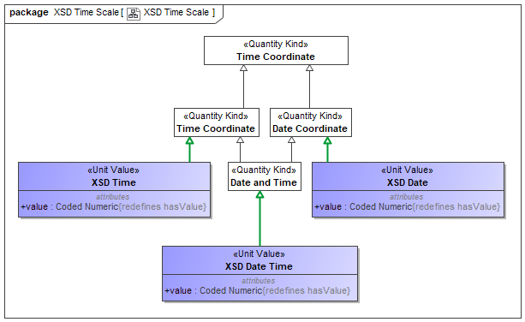

1. XSD Time Scale

## Class XSD Date <<Unit Value>>

An XSD representation of a date

[OWL] xsd:date.

Direct Supertypes

Date Coordinate

Attributes

value : Coded Numeric



A text string representing a date and time specified in the ISO8601 date-time format including timezone designator (TZD): YYYY-MM-DDThh:mm:ssTZD.

## Class XSD Date Time <<Unit Value>>

An XSD representation of a date and time

[OWL] xsd:dateTime

Direct Supertypes

Date and Time

Attributes

value : Coded Numeric



A text string representing a date and time specified in the ISO8601 date-time format including timezone designator (TZD): YYYY-MM-DDThh:mm:ssTZD.

## Class XSD Time <<Unit Value>>

An XSD representation of a time

[OWL] xsd:time

Direct Supertypes

Time Coordinate

Attributes

value : Coded Numeric



A text string representing a date and time specified in the ISO8601 date-time format including timezone designator (TZD): YYYY-MM-DDThh:mm:ssTZD.

# Concept Library::Vendors and Producers

Concepts relating to manufacturers and manufactured things.

## Diagram: Vendors and Producers

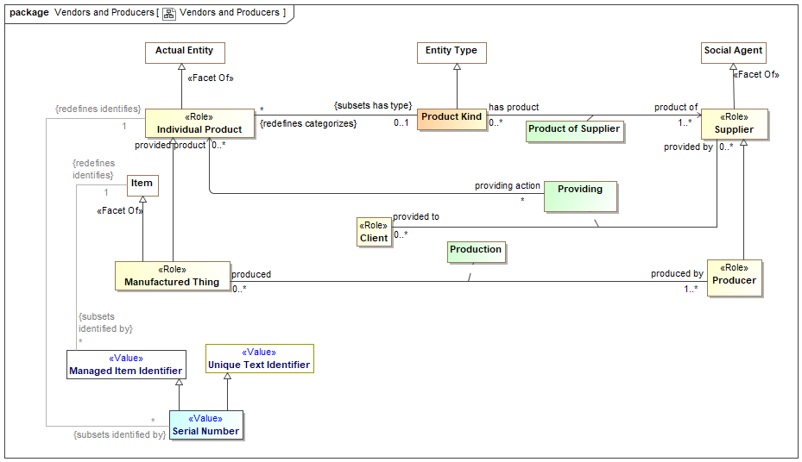

1. Vendors and Producers

## Class Client <<Role>>

The role of a responsible performer receiving goods or services from a provider.

[FIBO] Client: a party that acquires, or agrees to acquire, ownership (in case of goods), or benefit or usage (in case of services), in exchange for money or other consideration under a contract of sale

## Class Individual Product <<Role>>

A specific item or service purchased, sold or offered for sale.

[FIBO] Product: A commercially distributed good that is (1) tangible property, (2) the output or result of a fabrication, manufacturing, or production process, or (3) something that passes through a distribution channel before being consumed or used.

Direct Supertypes

Actual Entity

## Class Manufactured Thing <<Role>>

Role of a thing as being made or manufactured.

Direct Supertypes

Individual Product, Item

Attributes

revision : Primitive Value



The revision of a product or good.

## Class Producer <<Role>>

Maker of goods or products, usually for sale. Syn: Manufacturer.

[FIBO] Producer: the manufacturer of a product, also called maker.

Direct Supertypes

Supplier

## Class Product Kind

A set of similar items or services produced by or delivered by suppliers.

Direct Supertypes

Entity Type

## Association Class Product of Supplier

A kind of product or service offered by a supplier.

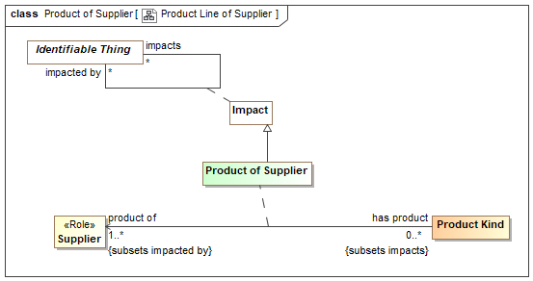

1. Product Line of Supplier

Direct Supertypes

Impact

Association Ends

has product : Product Kind [0..*] *Redefines*: negated within: Context



Product line provided by a manufacturer.

product of : Supplier [1..*] *Redefines*: negated within: Context



Manufacturer of a product line

## Association Class Production

The making of a <produced> thing <produced by> a producer.

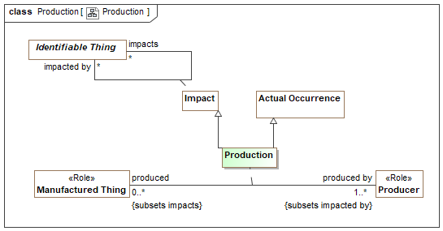

1. Production

Direct Supertypes

Actual Occurrence, Impact

Association Ends

produced by : Producer [1..*] *Redefines*: negated within: Context



Entity which manufactured or created an item.

produced : Manufactured Thing [0..*] *Redefines*: negated within: Context



A products or good made by a manufacturer.

## Association Class Providing

The providing of a product or service to a consumer.

[FIBO] supplies

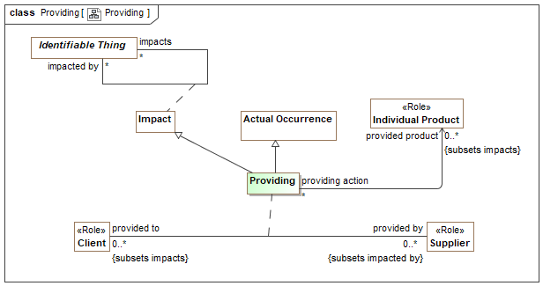

1. Providing

Direct Supertypes

Actual Occurrence, Impact

Association Ends

provided by : Supplier [0..*] *Redefines*: negated within: Context



Supplier of a product or service.

[FIBO] isSuppliedBy

provided to : Client [0..*] *Redefines*: negated within: Context



Consumer who receives a product or service.

## Class Serial Number <<Value>>

An identifier of an item provided by its producer or supplier.

Direct Supertypes

Managed Item Identifier, Unique Text Identifier

## Class Supplier <<Role>>

A person or organization that sells products or services.

[FIBO] a party that supplies goods or services

Direct Supertypes

Social Agent

# OnticHealthGeneric::Occurrences

## Diagram: Occurrences

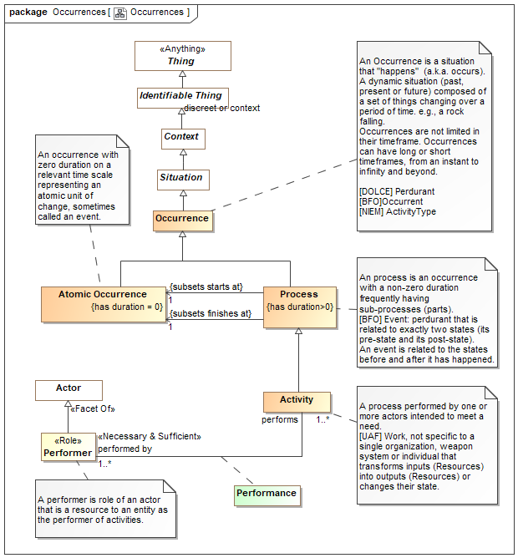

1. Occurrences

# OnticHealthGeneric::Situations

## Diagram: Situation Kinds

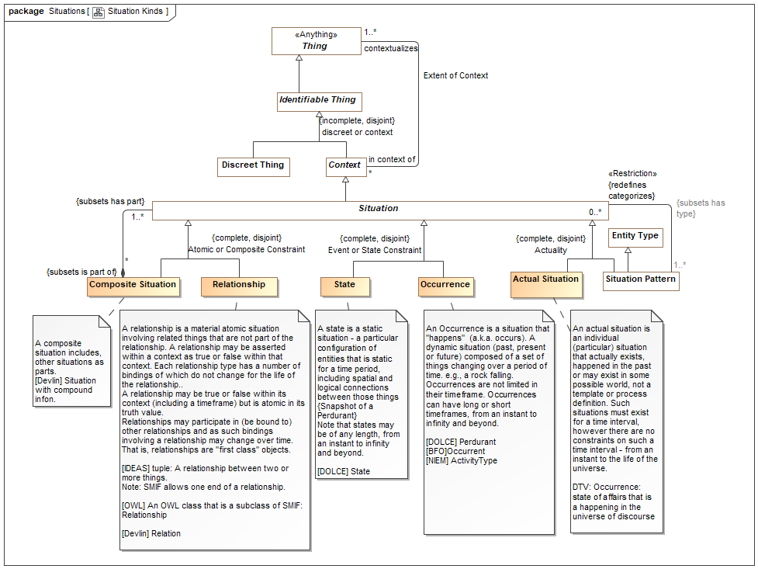

1. Situation Kinds

## Diagram: Situation Temporal

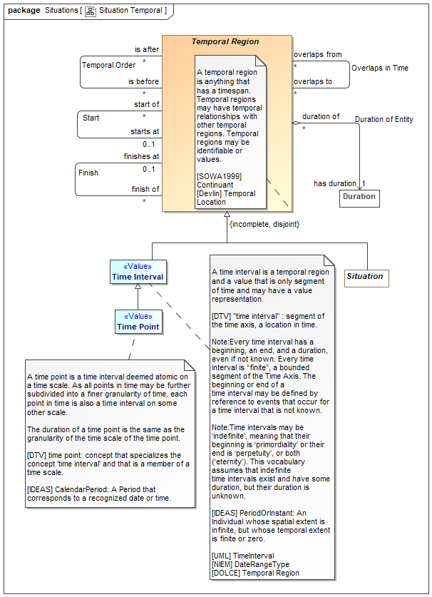

1. Situation Temporal

## Diagram: Situation Top

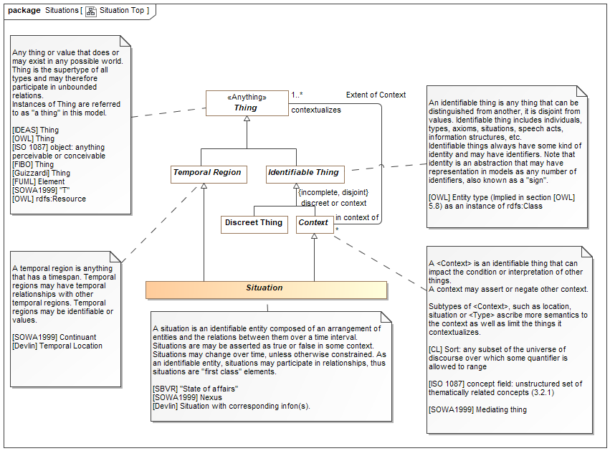

1. Situation Top

# OnticHealthGeneric::Statements

## Diagram: Statement Classification

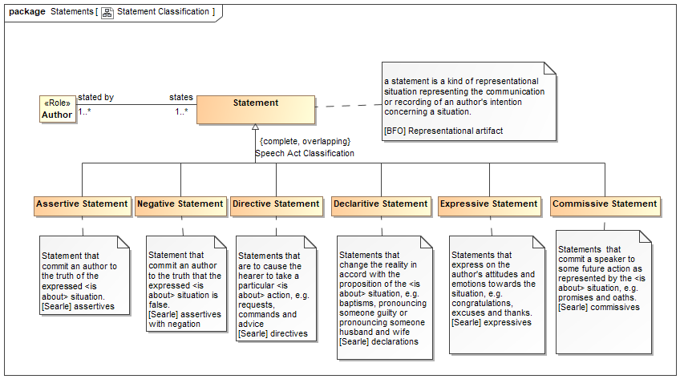

1. Statement Classification

## Diagram: Statements

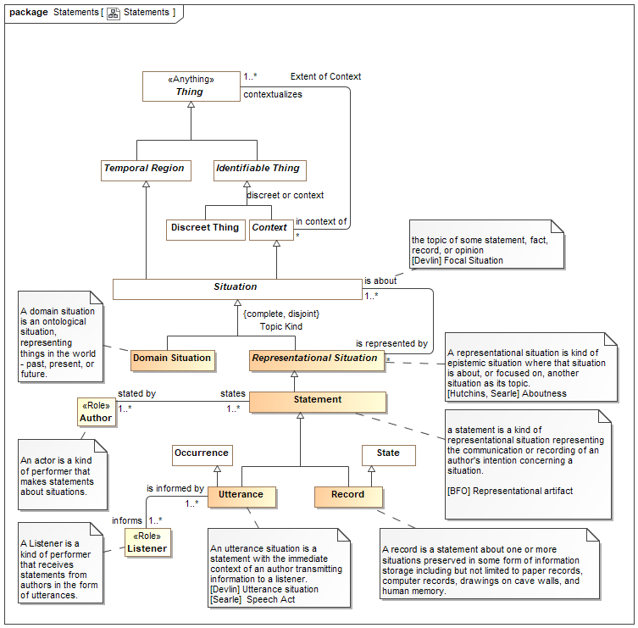

1. Statements

## Class Assertive Statement

Statement that commit an author to the truth of the expressed <is about> situation.

[Searle] assertives

Direct Supertypes

Statement

## Class Author <<Role>>

An actor is a kind of performer that makes statements about situations.

Associations

states : Statement [1..*]



## Class Commissive Statement

Statements that commit a speaker to some future action as represented by the <is about> situation, e.g. promises and oaths.

[Searle] commissives

Direct Supertypes

Statement

## Class Declaritive Statement

Statements that change the reality in accord with the proposition of the <is about> situation, e.g. baptisms, pronouncing someone guilty or pronouncing someone husband and wife

[Searle] declarations

Direct Supertypes

Statement

## Class Directive Statement

Statements that are to cause the hearer to take a particular <is about> action, e.g. requests, commands and advice

[Searle] directives

Direct Supertypes

Statement

## Class Domain Situation

A domain situation is an ontological situation, representing things in the world - past, present, or future.

Direct Supertypes

Situation

## Class Expressive Statement

Statements that express on the author's attitudes and emotions towards the situation, e.g. congratulations, excuses and thanks.

[Searle] expressives

Direct Supertypes

Statement

## Class Listener <<Role>>

A Listener is a kind of performer that receives statements from authors in the form of utterances.

Associations

is informed by : Utterance [1..*]



## Class Negative Statement

Statement that commit an author to the truth that the expressed <is about> situation is false.

[Searle] assertives with negation

Direct Supertypes

Statement

## Class Record

A record is a statement about one or more situations preserved in some form of information storage including but not limited to paper records, computer records, drawings on cave walls, and human memory.

Direct Supertypes

State, Statement

## Class Representational Situation

A representational situation is kind of epistemic situation where that situation is about, or focused on, another situation as its topic.

[Hutchins, Searle] Aboutness

Direct Supertypes

Situation

## Class Statement

a statement is a kind of representational situation representing the communication or recording of an author's intention concerning a situation.

[BFO] Representational artifact

Direct Supertypes

Representational Situation

Associations

stated by : Author [1..*]



## Class Utterance

An utterance situation is a statement with the immediate context of an author transmitting information to a listener.

[Devlin] Utterance situation

[Searle] Speech Act

Direct Supertypes

Occurrence, Statement

Associations

informs : Listener [1..*]



# OnticHealthGeneric::Top level

## Diagram: Context



1. Context

## Diagram: Types

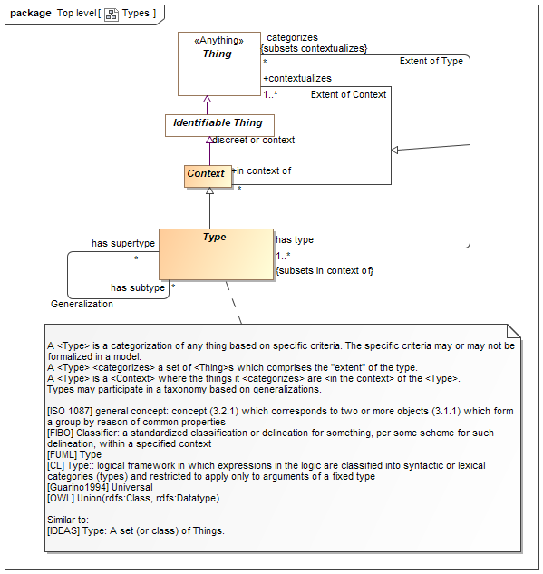

1. Types